### Week 1 P2 Introduction

#### Introduction to Image Processing and OpenCV

* course will cover:
  + fundamental image processing concepts, leveraging the powerful OpenCV library
  + traditional image processing algorithms
  + convolution neural networks (CNNs) and its variants
  + exploring convolutional neural networks (CNNs) and advanced computer vision tasks
* image processing
  + a method to perform some operations on an image, in order to get an enhanced image or to extract some useful information from it
  + ex: photoshop to change colour, resolution, rotation…
  + common tasks:
    - color processing
      * adjusting colour space, brightness…
    - noisy reduction
      * removing random brightness or colour defects
    - edge/corner detection
      * identify boundaries of objects
    - transformations
      * scaling, rotation, translation
* computer vision
  + a field of AI that trains computers to interpret and understand the visual world
  + computer relies on deep learning models to understand an image
  + convolutional neural networks (CNNs)
    - reduces dimensions of image
    - thats the reason we use it over other deep learning models

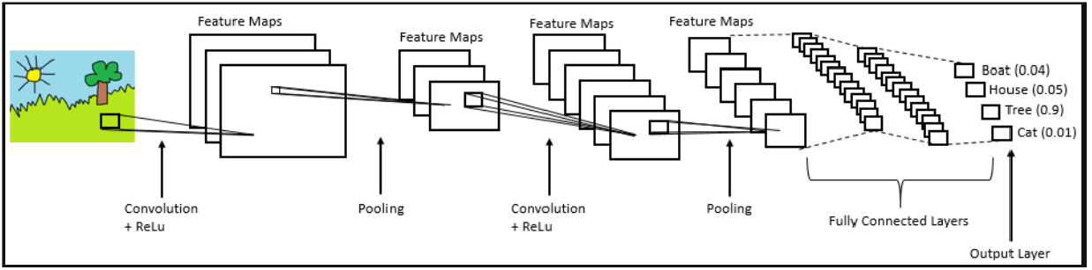

* key tasks in computer vision (CV)
  + image classification
    - assigning a label to an image from a fixed set of categories
    - serves as a building block for more complex tasks
  + object detection
    - identify objects within an image
      * boat, house, tree, cat
  + segmentation
    - dividing an image into parts that have a strong correlation with objects or areas of interest
    - same colour to identify similar object categories
    - 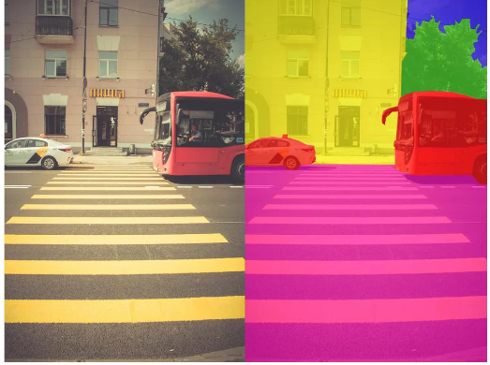
* applications of CV
  + healthcare
    - detect cancer from CT scans
      * use CNN to classify arsenic concentration levels in cells
      * cells exhibit different appearances depending on arsenic exposure
      * number of control images compared to other classes will result in label imbalance
        + a large number in one class and another class that is underrepresented
      * training image vs validation image
        + data set is split into 3 parts
        + training

use this image to train neural network

* + - * + validation

after each training we use this to validate performance

* + - * + test

after training, use these to test the performance of the neural network

* + - * validation acc = acc during training
      * test acc = acc during test

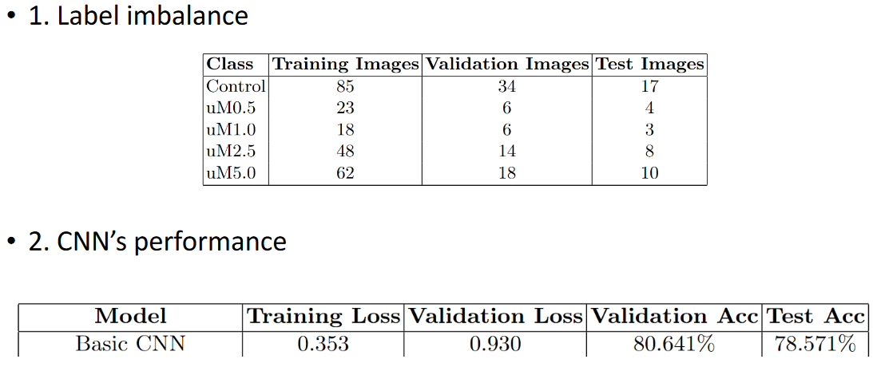

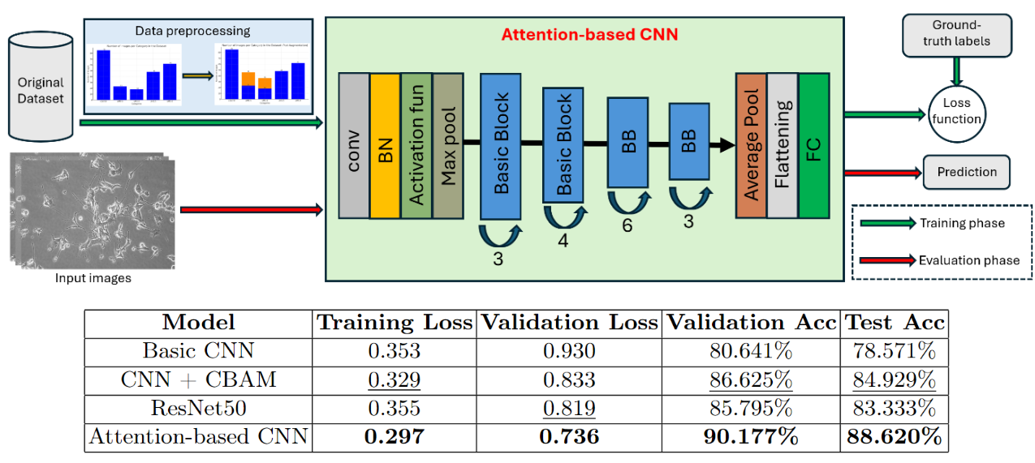

* + - * OpenCV to generate symbols for underrepresented categories
        + Data Preprocessing part (orange part of blue bars)
        + data augmentation (the generation of the underrepresented categories)
      * attention mechanism
        + helps CNN to find the focus of the image (text on a blank page, instead of looking at the empty parts of the page)
      * basic block
        + avoid loss of features
  + autonomous vehicle/robotics
    - make sense of surroundings by detecting obstacles
  + surveillance and security
    - monitoring systems are able to recognize unusual behaviour automatically
      * OpenCV
  + agriculture
    - manage farms through drones
* will use python with PyTorch (deep learning platform API (application programming interface))
* need a GPU for CNN
  + if dont have a gpu, can email prof to use computer server

### Week 2 P1 Setting Up The Environment, Review Python

#### Python and Setting Up the Environment

* interpreted language = execute line by line
  + vs compiled (C/C++) as a whole
* installing packages/libraries (terminal)

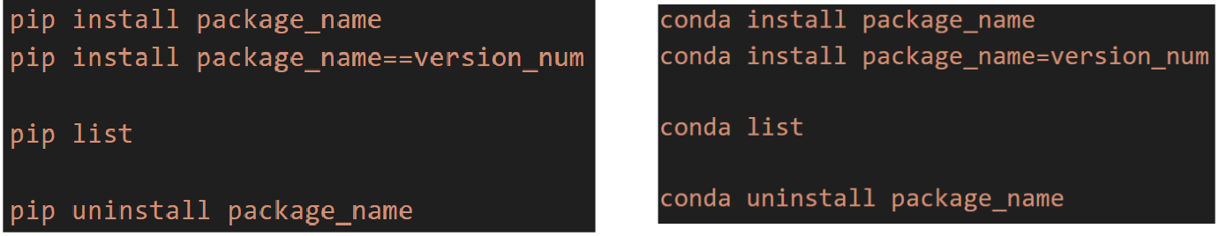

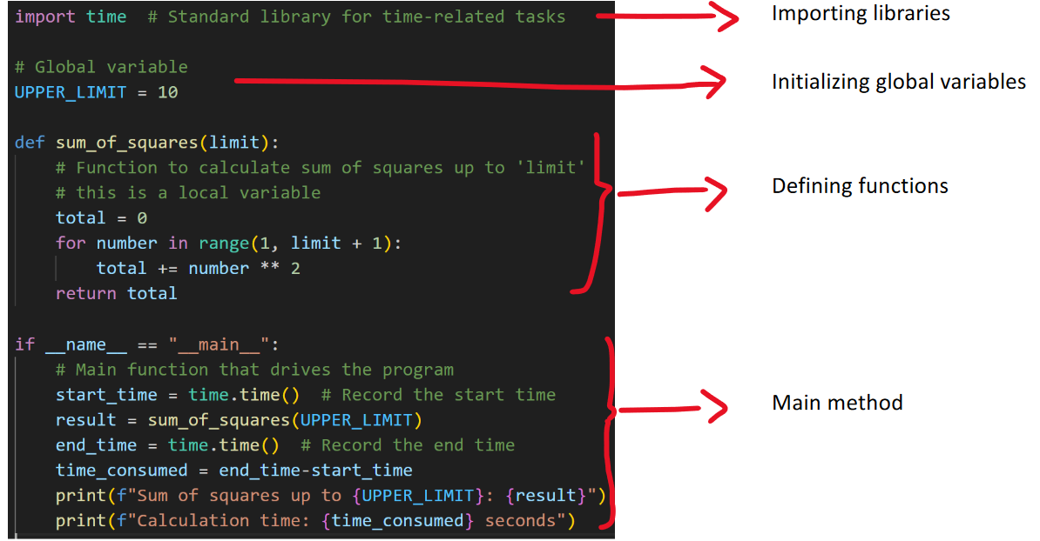

* function call has to be after the function is defined, because interpreted language line by line
* python is dynamically typed language, meaning you dont have to declare the type of the variable when you create it
* 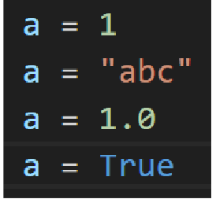
* int → string → float → boolean
* 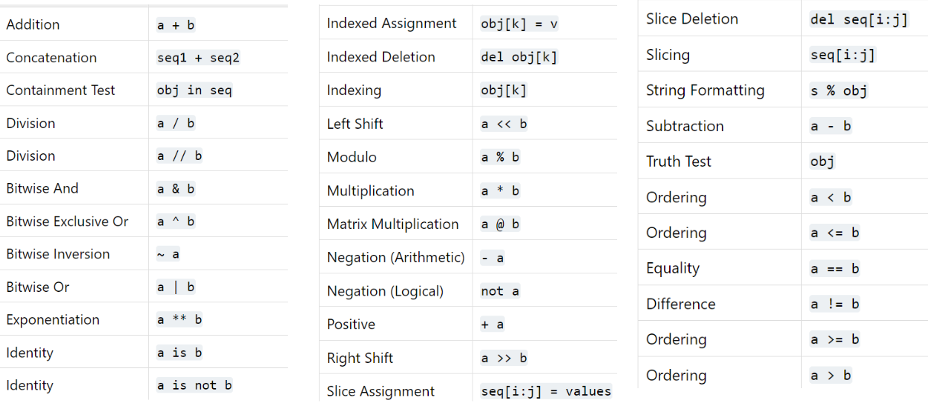
* / → float
* // → quotient truncated division
* 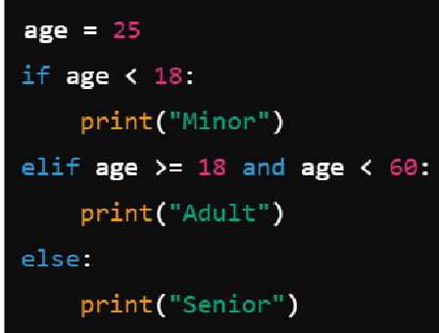
* 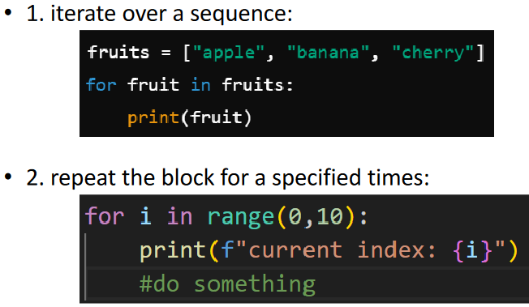
* 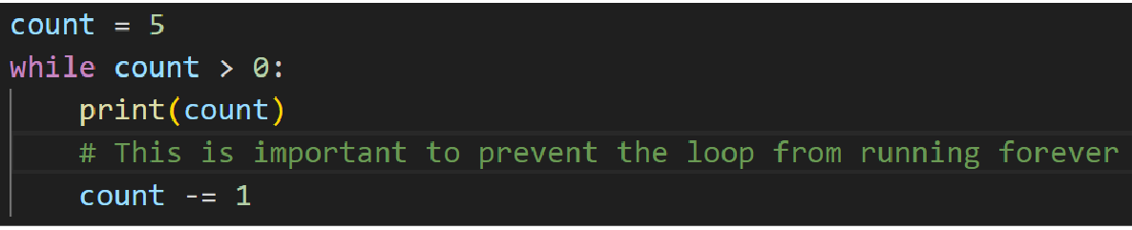
* 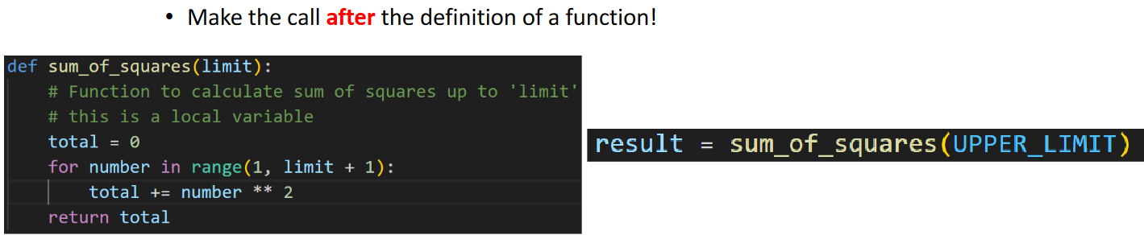
* can use relative or absolute path for python file
* “with” is helpful for closing file object and handling
* 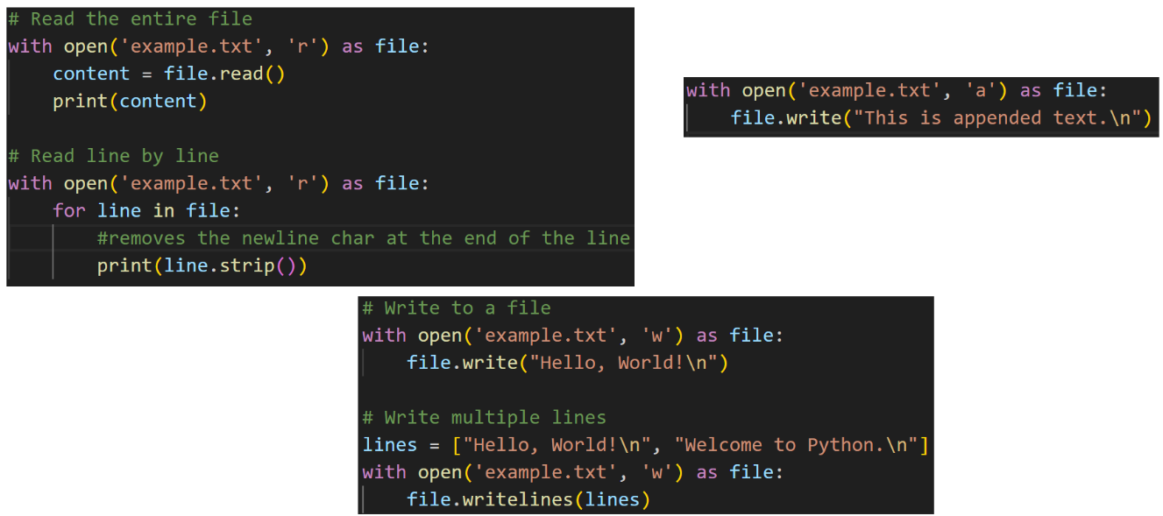
* 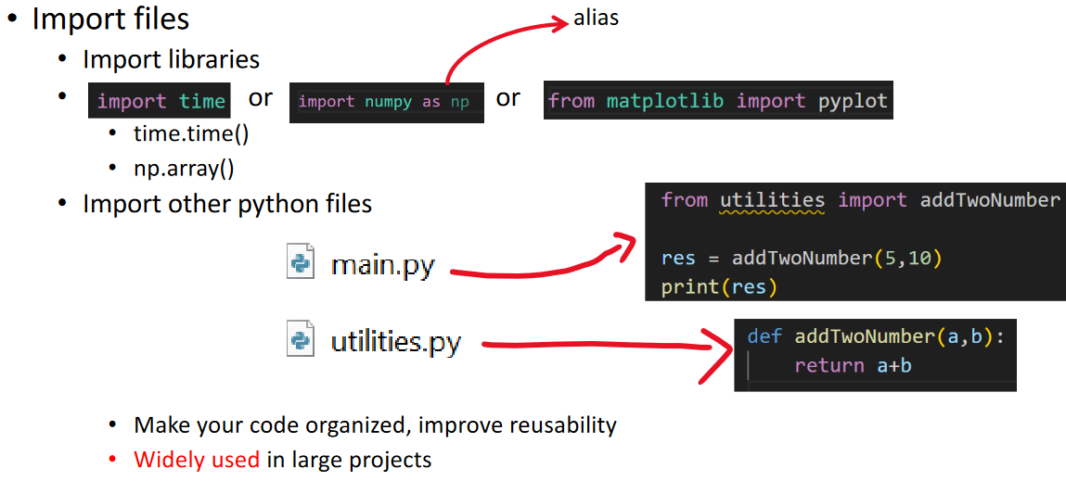
* from matplotlib import pyplot → only import the one function from the library
* from PYTHON_FILE_NAME import FUNCTION_NAME → to import a function from another python file
* -------------------------
* normalize:
  + (x - min) / (max - min)
  + means that everything will fall into a range of 0 to 1
  + [1, 100, 1000]
    - 1 - 1 / (1000 - 1) = 0 / 999 = 0
    - 100 - 1 / (1000 - 1) = 99 / 999 = 0.099
    - 1000 - 1 / (1000 - 1) = 999 / 999 = 1
  + used for preprocessing images

#### Deep Learning Framework

* deep learning framework
  + a software library specifically designed to assist in the development, training, and deployment of deep learning models
  + they provide tools that simplify the complex mathematics and algorithms involved in building neural networks
  + key features:
    - abstraction of complex operations
      * lots of math calculations
      * CNN uses convolution
      * loss function uses back propagation
    - GPU acceleration
      * GPU is hardware, so we want a manager (deep learning framework) to manage it for us
    - Pre-built layers and models
      * one or two lines to implement a deep learning model without the details
    - model training and evaluation tools
      * powerful tools to help validate the performance of the neural network
* we will use PyTorch as deep learning framework
  + for CPU only
    - conda install pytorch torchvision cpuonly -c pytorch
  + for GPU
    - conda install pytorch torchvision cudatoolkit=11.3 -c pytorch
  + torchvision extends pytorch’s capabilities to computer vision
  + cuda allows users to use GPU
    - check compatibility <https://en.wikipedia.org/wiki/CUDA>
    - look at list of GPUs, and you can install that version or a later version (ex 6.1 for 1070ti, so can use 11.8 as well)
  + to validate:
    - python (type this first to enter python)
    - import torch
    - print(torch.__version__) (two underscores)
    - print(torch.cuda.is_available())
  + so for some reason its not working for me because i did CPU only

### Week 2 P2 Intro to OpenCV

#### Introduction to OpenCV

* OpenCV = Open Source Computer Vision Library
  + powerful and reliable library for performing image processing and computer vision tasks
  + available in both python and C++ with different syntaxes
* applications
  + image processing
  + object detection and recognition
  + video processing
  + ML and DL integration
* why use OpenCV?
  + comprehensive library for CV
  + real-time performance
  + cross-platform compatibility
  + free and open source
  + extensive community and documentation
* learning roadmap:
  + background knowledge
    - color space, what is an image, coordinations
  + using OpenCV to draw some shapes
    - familiar with OpenCV
  + image transformation
    - flip, rotate, resize, crop
  + some traditional CV algorithms
    - SIFT, sobel filter, harris detection
  + several practical projects
    - tracking your face
* <https://docs.opencv.org/4.x/d6/d00/tutorial_py_root.html>

#### Setting up the Environment

* pip install opencv-python
* python
* import cv2
* print(cv2.__version__) (two underscores)

#### An Example

* download and run the face_detector.py file
  + works

#### Topics for the Project

* (Easy) Fruits Classification
* (Medium) Face Recognition
* (Hard) Depth Estimation
* (Presented) Insect Classification
* (Presented) Artwork Analysis

<https://pillow.readthedocs.io/en/stable/reference/Image.html>

<https://scikit-image.org/>

### Week 3 P1 OpenCV Basic Operations

#### Understanding Images

* image
  + a collection of visual information that can evoke emotions, convey ideas, or represent reality
  + numerical data, represented in the form of arrays
    - for different colour spaces, the dimensions of the array are different
      * RGB image = 3D
      * grayscale = 2D
  + smallest unit = pixel

##### colour spaces:

* + RGB
    - 3 channels, Red, Green Blue
    - range 0-255
    - pixel A = (255,0,0) → pixel is red colour
      * 8 bits to represent one channgel
    - used in monitor, cameras, and other digital devices to display images
  + BGR
    - channel order is reversed
    - OpenCV uses BGR instead of RGB by default
  + HSV
    - cylindrical colour space
    - 3 components:
      * Hue
        + represents colour type, measured in degrees
        + 0deg = red, 120deg = green, 240deg = blue
        + (0,360) in nature, (0-179) in OpenCV

360 would be 9 bits, so 179 for 8 bits, to keep consistency

* + - * Saturation
        + represents the purity of the colour
        + 0% → gray
        + 100% → full colour
        + (0,255) in OpenCV

8 bits to represent channel

* + - * value
        + the height
        + represents the brightness of the colour
        + 0% → black
        + 100% → brightest colour
        + (0,255) in OpenCV
    - used in colour-based image processing where its easier to separate colour information from brightness
    - 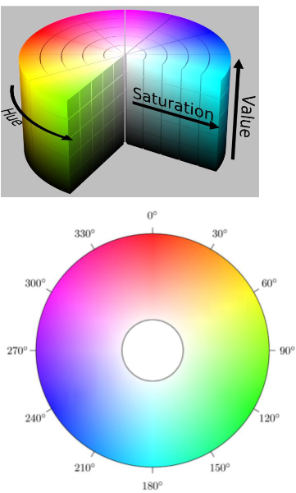
  + grayscale
    - only one channel
    - each pixel represents a shade of gray
    - insensity of the gray ranges from black to white, 0-255
    - used when colour information is not necessary
      * like when trying to identify shapes btw trees and houses
* the coordination of an image
  + coordinate system
  + top left corner = 0,0 = origin
  + x-axis = horizontal, y-axis = vertical
  + 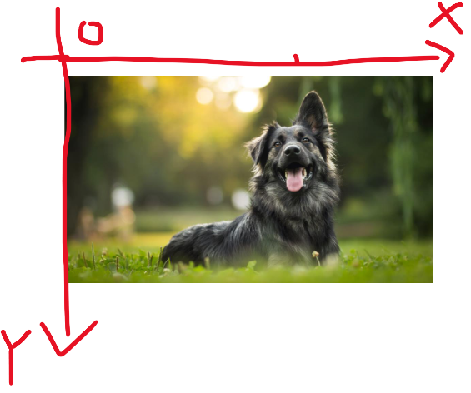
  + 5x3 = height x width
  + 0,0 0,1 0,2
  + 1,0 1,1 1,2
  + 2,0 2,1 2,2
  + 3,0 3,1 3,2
  + 4,0 4,1 4,2
* colour space conversion
  + BGR to grayscale
    - grayImg = cv2.cvtColor(image, cv2.COLOR_BGR2GRAY)
  + BGR to HSV
    - hsvImg = cv2.cvtColor(image, cv2.COLOR_BGR2HSV)
  + HSV to BGR
    - image = cv2.cvtColor(image, cv2.COLOR_HSV2BGR)
  + grayscale to BGR
    - image = cv2.cvtColor(image, cv2.COLOR_GRAY2BGR)
    - used mapping 1 channel to 3 channel for separate operation for each channel
      * 1 convolution layer vs 3 convolution layers

#### Reading / Saving Images

##### read from image

* + cv2.imread(‘path’)
    - read file and return array representation
  + cv2.imshow(‘title of the window’, img)
    - open window to display img
  + cv2.waitKey(delay)
    - user input to terminate window
  + cv2.destroyAllWindows()
    - close image windows
  + access pixel at pos x=1, y=5
    - img = cv2.imread(“image.jpg”)
    - print(img[5,1])
      * output: [14 18 19]
      * height, width
      * pixel (x,y) → img(y,x)
      * img[5,1] = [255,0,0]
        + BGR, pixel is blue
      * img[5,1] = 0
        + grayscale, pixel is black

##### read from video

* + video is a series of frames
  + video = cv2.VideoCapture(‘path’)
    - return opened video file
  + video.isOpened()
    - check if video file was successfully opened
  + ret, frame = video.read()
    - read the next frame. ‘ret’ indicates whether frame was successfully read or not
    - ret is boolean
    - frame is current frame
  + if cv2.waitKey(25) & 0xFF == ord(‘q’)
    - wait for 25ms btw frames and user input
      * if no user input, return null
      * continue the loop
      * otherwise, exit while loop
        + with ‘break’
    - bitwise AND, not conditional AND
      * calculate the 2 values then compare to ord(‘q’)
    - 0xFF
      * 8 bits, 11111111
      * mask leading bit, only extract last 8 bits
      * ASCII 8 bits to represent each letter
      * compare last 8 bits of user input with ASCII of ‘q’
      * if match, user pressed ‘q’ within time window
  + video.release()
    - frees resources

##### read from webcam

* + similar to read from video
  + cv2.VideoCapture(integerValue)
    - 0 → default webcam
    - 1 → another webcam
    - 2 → …
* saveImage

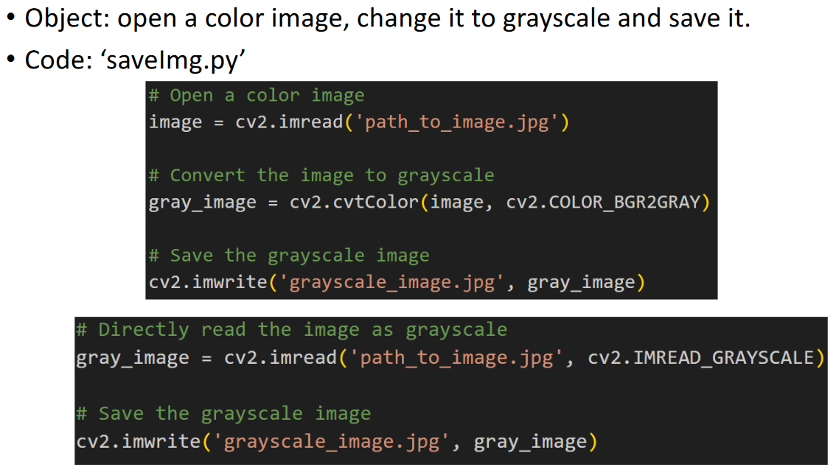

* saveVideo

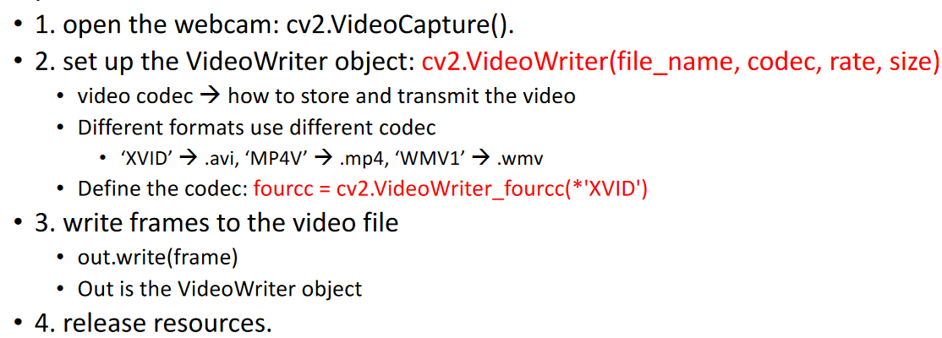

#### Case Study: Drawing Shapes

* 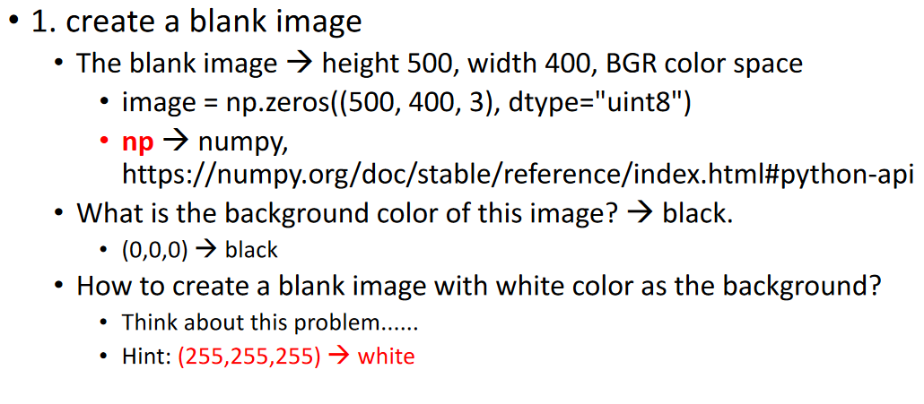
* 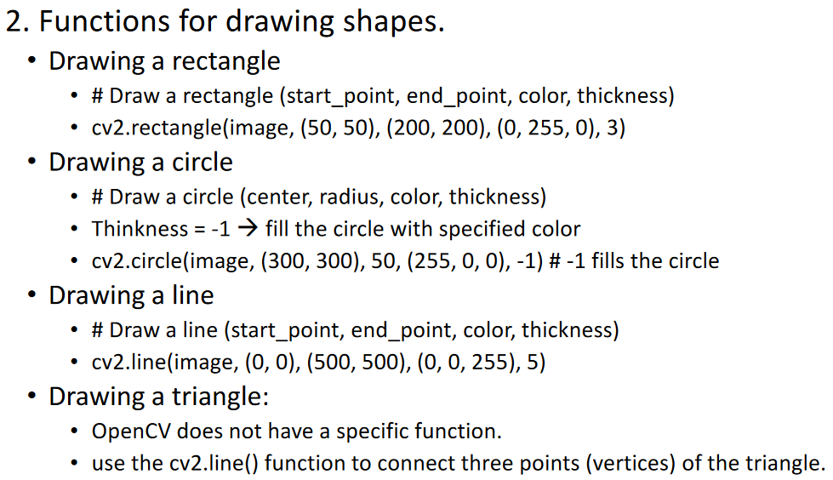
* 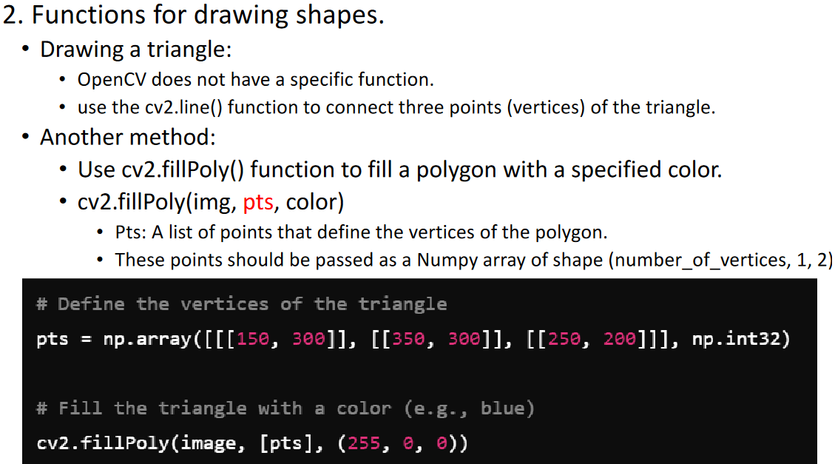
* 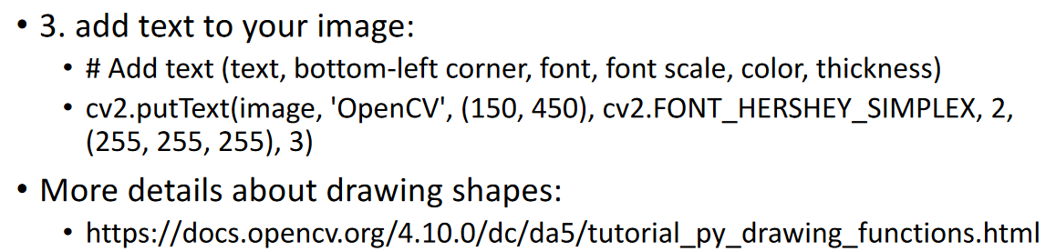

### Week 3 P2 OpenCV Image Transformation

#### Display multiple images in a single display

* Case 1: Side by side
  + np.hstack(image1, image2)) → stack two images horizontally
  + 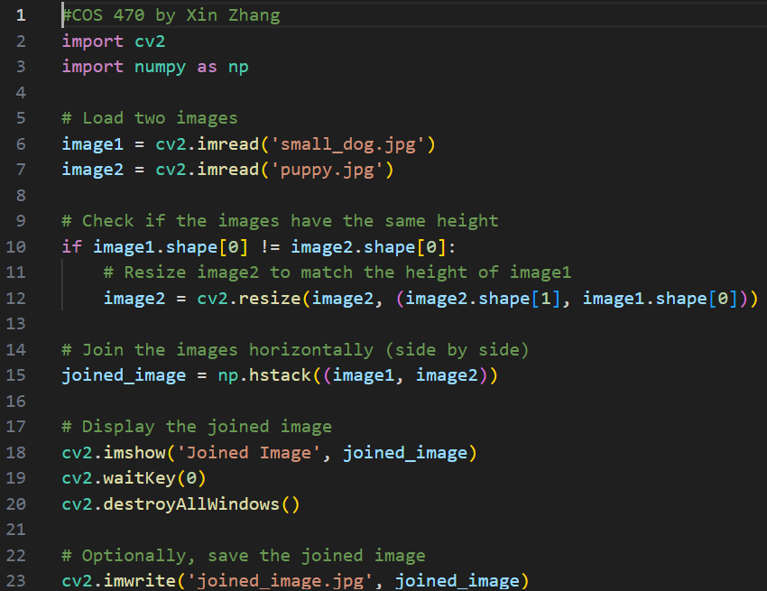
  + if images are different sizes, need to take account for that
* Low resolution → high resolution = upsampling
* high resolution → low resolution = downsampling
* resize() is most common method to upsample or downsample
* 3 steps:
  + scaling factor
    - scale_x = new width / original width
    - scale_y = new height / original height
  + map pixel positions
    - original position (x,y) → new position (x*scale_x, y*scale_y)
  + interpolation
    - downsample = skip step
    - 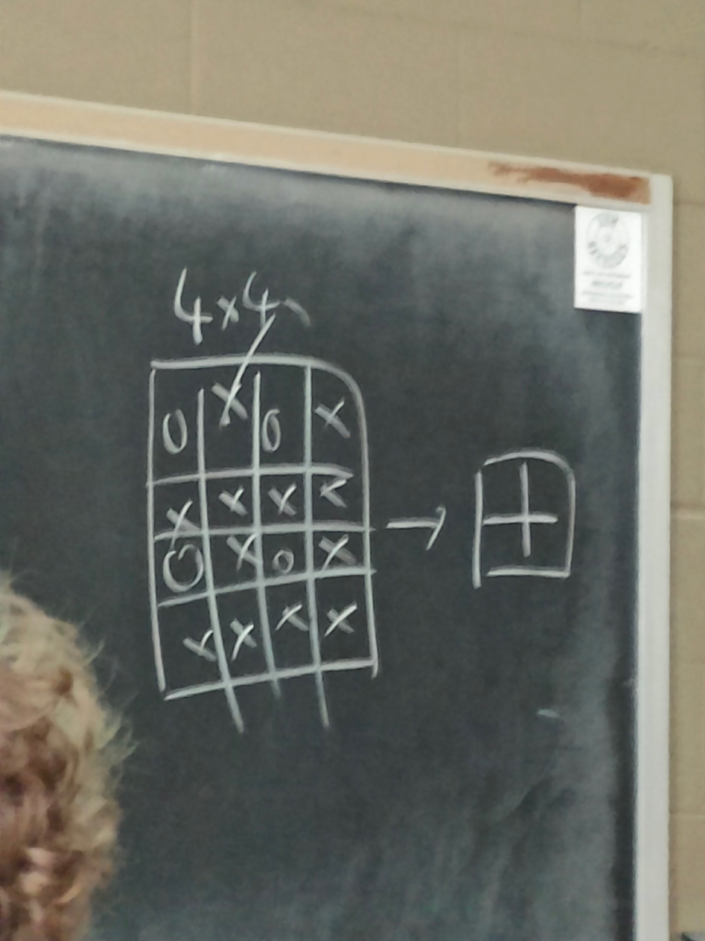
      * can also take the average of the pixels instead
    - upsample = necessary
      * two common strategies
        + nearest

take the value of the nearest pixel

* + - * + bilinear (default OpenCV strategy)

new pixel is a weighted average of the four closest pixels from the original image

resized_image = cv2.resize(image, (new_width, new_height), interpolation=cv2.INTER_LINEAR)

set interpolation parameter to use different interpolation algorithms

* + - * 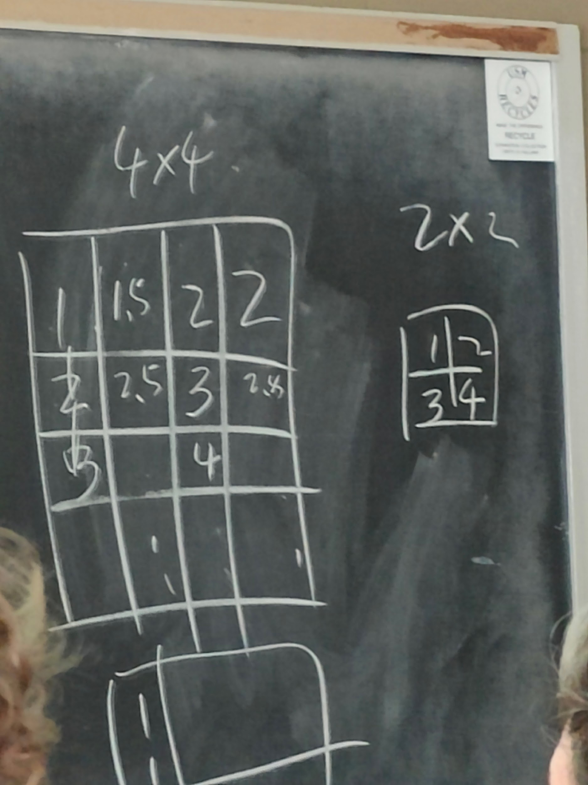
* Case 2: display 4 images in a 2x2 grid
* 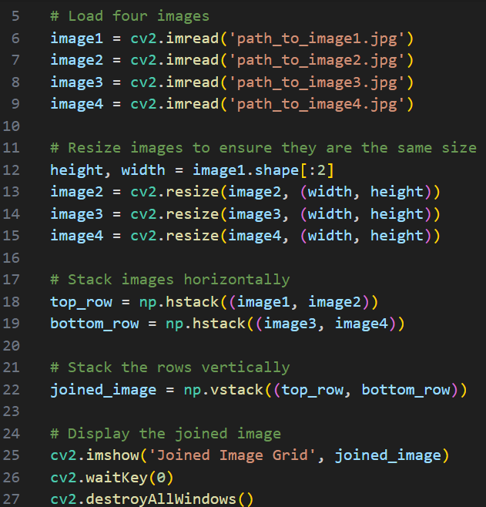

#### basic image transformation

* image transformation
  + refers to a set of operations that manipulate an image to achieve a specific result
* frequently used transformations:

##### colour space transformation

* + - BGR → HSV
    - BGR → Grayscale

##### geometric transformation

###### scaling

* + - * cv2.resize()

###### translation

* + - * shift image in x or y dircetion
      * define translation matrix
      * 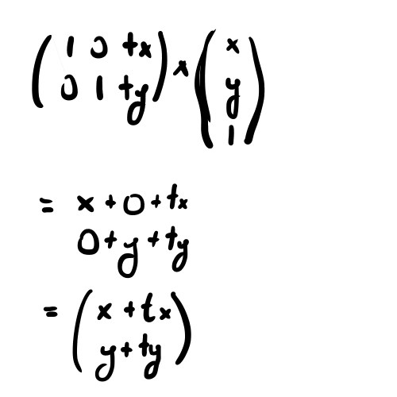
      * pixel x=1, y=1
      * tx = displacement along x axis, ty = displacement along y axis
      * original pixel x,y → new position x*,y*
      * 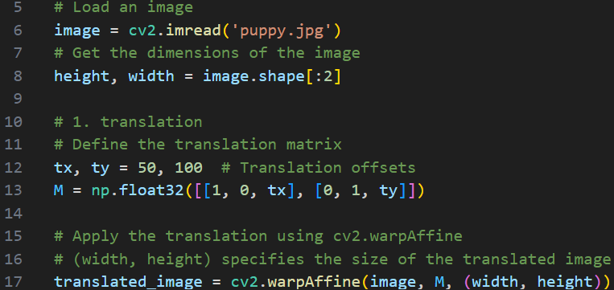

###### rotation

* + - * turning an image around a specific point, usually the center of the image, by a certain angle
      * 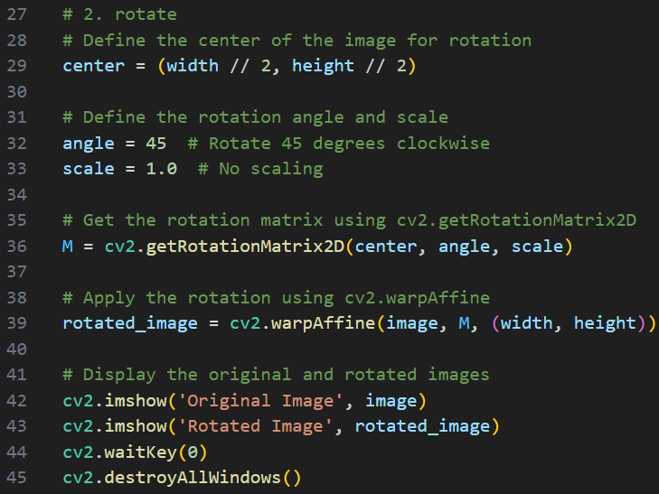

###### affine transformation

* + - * map points from one location to another while maintaining parallelism
        + define source and destination points

choose 3 points in original image and their corresponding locations in the output image

calculate the affine transformation matrix

apply the affine transformation

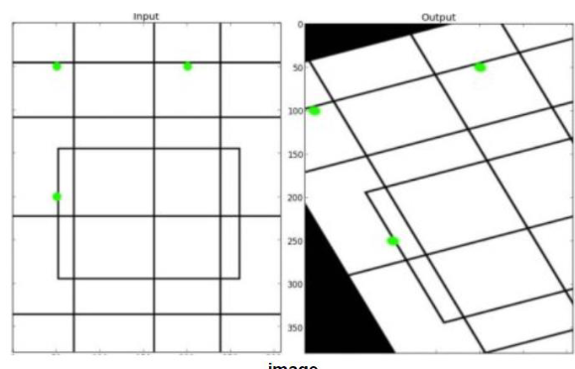

* 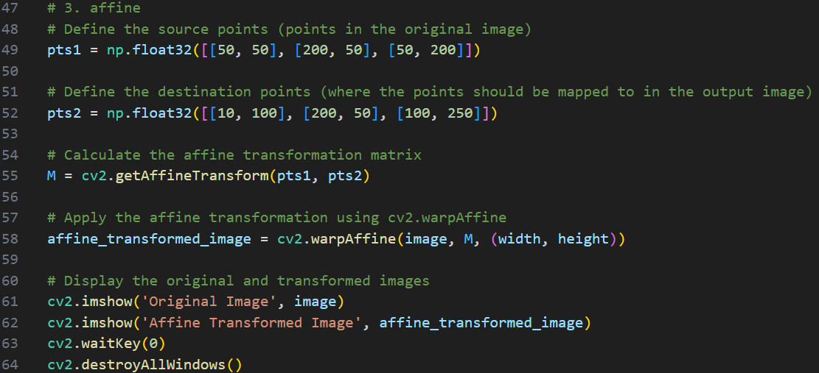

###### perspective transformation

* + - * change the perspective of an image , simulating the effect of viewing it from a different angle
      * 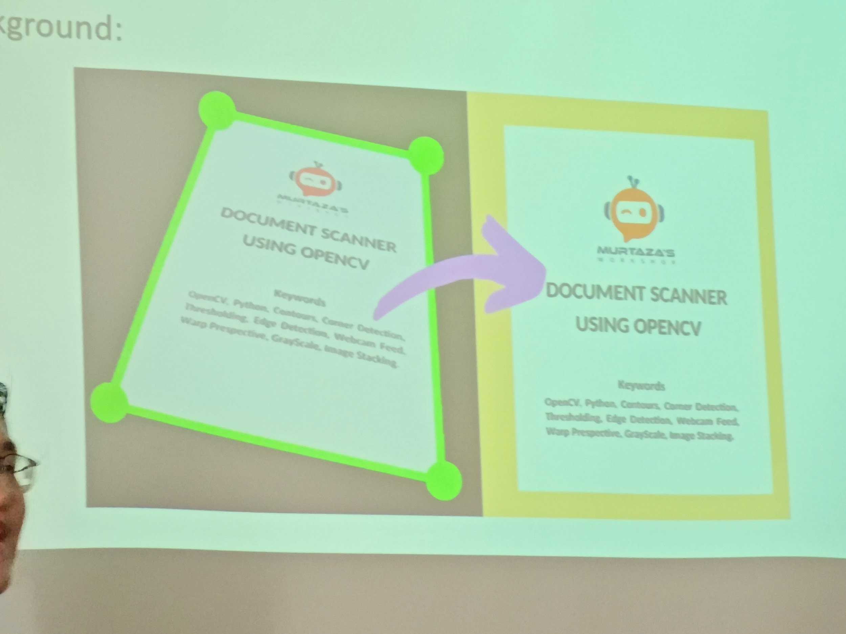
      * define the source and destination points
        + choose four points in the original image and their corresponding locations in the output image
      * calculate the perspective transformation matrix
        + cv2.getPerspectiveTransform() → 3x3 matrix
      * apply the perspective transformation
        + cv2.warpPerspective()
* 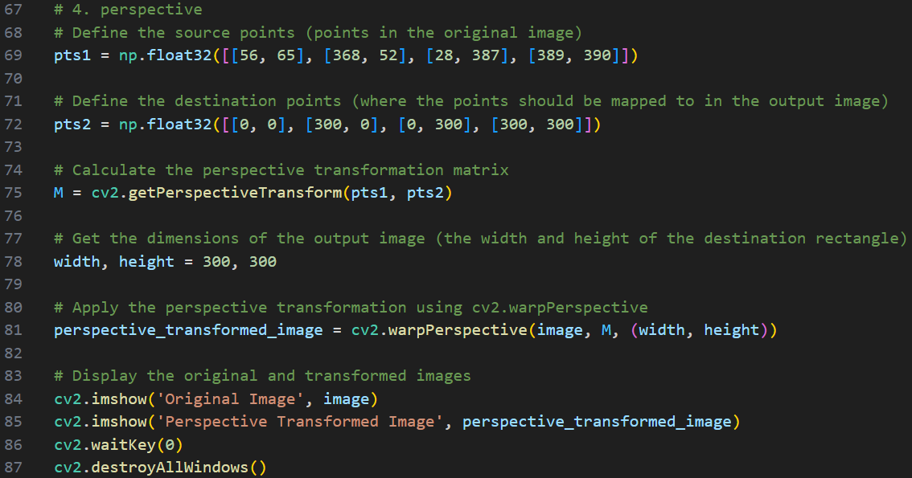
* 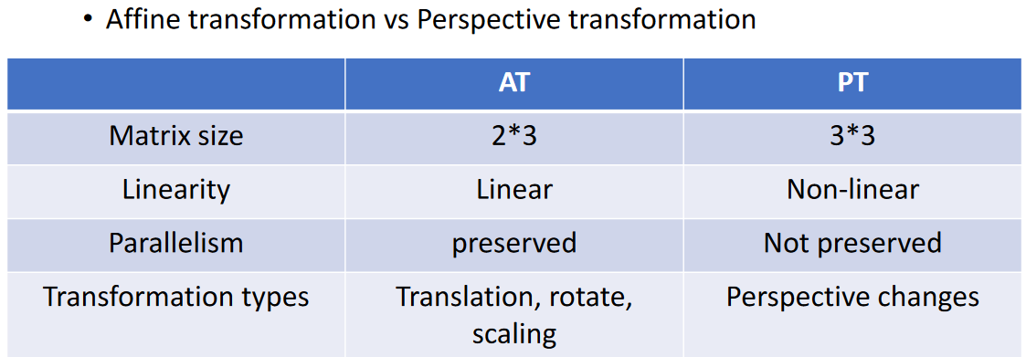
* affine transformation vs perspective transformation
* loss function for deep learning:
  + introduce non-linear factor to the calculation

##### image thresholding

* + create binary images from grayscale images
  + convert pixels in an image to either white or black, based on a threshold value
  + used for:
    - preparation for more complex tasks (edge detection (focus on corners of image), object detection, etc)
    - noise reduction
    - improvement of computational efficiency
* types of thresholding:

###### simple thresholding

* + - applies a global threshold value to the entire image
* 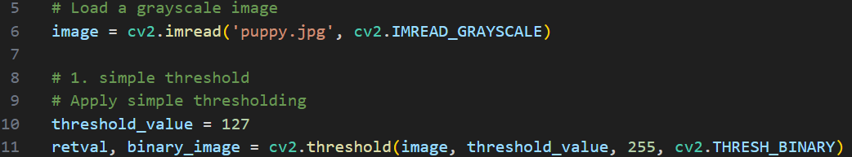

###### adaptive thresholding

* + - threshold value is calculated based on a small region around each pixel, allowing for better results in images when the lighting in the image is not uniform
    - for 11: region size
    - for 2: larger threshold = negative value, smaller threshold = positive value
* 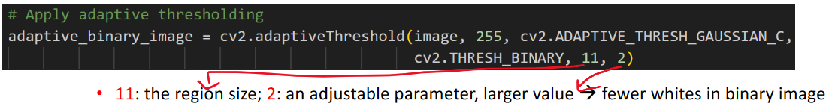
  + - threshold value is calculated from a gaussian-weighted sum
      * central pixels contribute more, corner pixels contribute less
      * 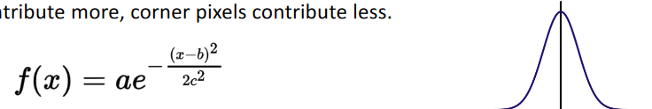
      * also called “normal distribution”
    - 3x3 gaussian filter:
      * 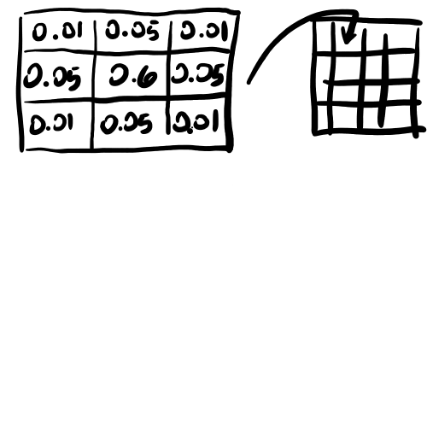
      * then multiply the original image matrix (the pointed to region as many times as there are regions in the image) by the gaussian filter

###### otsu’s transformation

* + - automatically detect optimal threshold value for entire image based on histogram
    - uses statistical concepts like variance, mean, and probability distribution to calculate the optimal threshold
* 

#### image transformation applications

* + preprocessing
    - ensure all images are of the same size
    - convert the colour space to improve performance
      * focus on shape of object instead of color of object
  + data augmentation
    - enhance the generality of the CNN
      * adjust feature positioning
      * looking for the number 5:
        + position of 5 in center of picture means it will have good performance
        + position of 5 in corner of picture means it will have bad performance

translate the digit 5 to the center of the image

* + - * rotation, flipping, etc.
        + several variances of image to make CNN more robust
    - increase the robustness of the CNN
* Case study:
  + transform an image into a different perspective
    - identify the corners of the image and then change the perspective from angled to flat
    - find the corners manually

### Week 4 P1 Edge Detection

#### Edges

* edge = transition in intensity within an image
  + the boundaries of objects or regions within the image
* eyes detect edges by sharp transitions in colour
* edge detection works by detecting changing in pixel intensity
  + sharp contrast between adjacent pixel values
* edge detection use cases:
  + object detection and recognition
    - helps recognize and classify objects
    - shape information
      * house vs tree
  + feature matching algorithms
    - 2 pictures binocular
      * match person to person, match tree to tree
  + image compression
    - in extreme compression, we dont care who is who, just how many people are in an image
    - dont focus on details, only focus on abstract things
      * image of classroom, how many students in the room
  + medical imaging

#### edge detection algorithms

##### sobel operations

* + - vertical (2 weight), horizontal (2 weight), neighbours (1 weight)
    - edge detection technique
    - emphasizes edges and transitions in intensity by calculator the gradient (derivative) of the image intensity function
      * f’(x) = (f(x1) - f(x0)) / (x1 - x0)
    - EX:
      * calculate transition in each node
      * 1D array = [10,10,20,20,40,30,30,10,10]
      * solution: |curr - prev| + |next - curr| = next - prev
      * 2D array: up, down, left, right, (sometimes diagnonals)
      * solution: Grad(x) = right - left, Grad(y) = bottom - top
        + gradient of node: sqrt(Grad(x)^2 + Grad(y)^2)
    - optimizations:
      * smooth gradient
        + Grad(x) = Grad(x) + Grad(x top) + Grad(x bottom)
        + Grad(y) = Grad(y) + Grad(y left) + Grad(y right)
        + not really sure what this does?
      * add a weight
        + G(x a,b) = 1*G(x a,b-1) + 2*G(x a,b) + 1*G(x, a+1,b)
        + G(y a,b) = 1*G(y a-1,b) + 2*G(y a,b) + 1*G(y, a,b+1)
    - source code uses convolution to calculate gradient
      * [1 0 1] [1 1 1]
      * [1 1 1] x [1 1 1] = 1 + 0 + 1 + 1 + 1 + 1 + 0 + 0 + 1 = 6
      * [0 0 1] [1 0 1]
      * left = matrix work on (input), right = kernel (filter)
      * calc convolution of left matrix
      * element-wise multiplication
      * 0,0 * 0,0 + 0,1 * 0,1 + etc. = 6
      * convolution reduces dimensions, thats its advantage, disadvantage is the loss in information
      * stride = 1, meaning move to right by 1 position when moving kernel / filter
      * padding = surround input matrix in 0’s

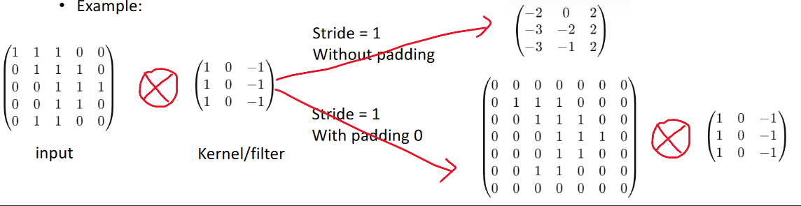

* + - * stride = 1, padding = 0 gives G(x) component
      * G(y) component would be rotate the kernel / filter by 90deg
      * sobel gradient = sqrt(G(x)^2 + G(y)^2)
      * SOBEL KERNEL:
      * 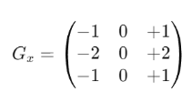
      * 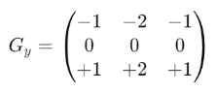
* 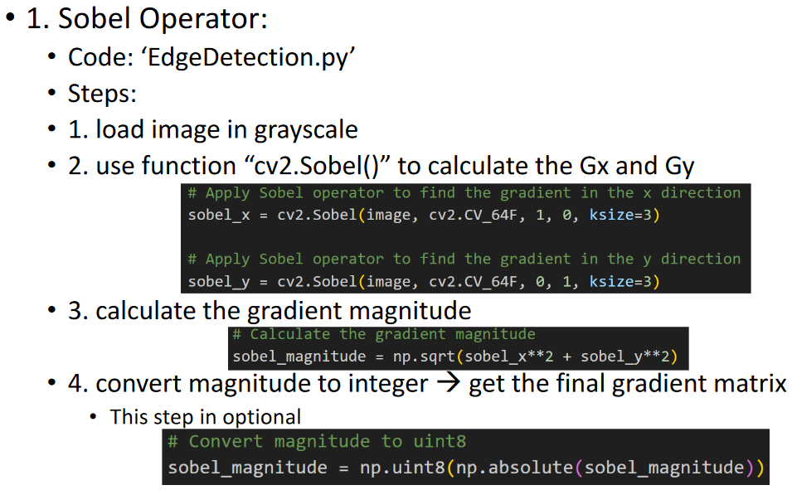
  + - * and then put all this into a 2D array

##### canny edge detector

* + - known for its ability to detect a wide range of edges in images while minimizing noise and avoiding false edges
    - 1. minimize noise
      * noise = random variations in the intensity of a pixel that can obscure or distort the actual content of the image
        + pixel with 255 value surrounded by a bunch of 10 value pixels
        + 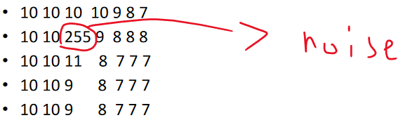
      * convolve image with gaussian filter
        + averages pixels in the neighbourhood of each pixel, weighted as a gaussian function
        + smooths image by reducing sharp transitions in intensity
        + 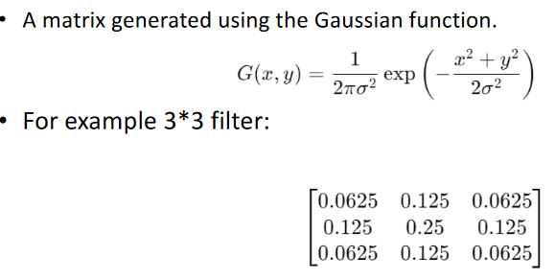
        + 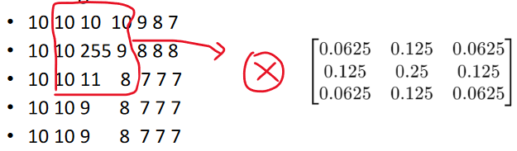
    - 2. apply sobel
      * calculate gradient matrix and gradient direction
* 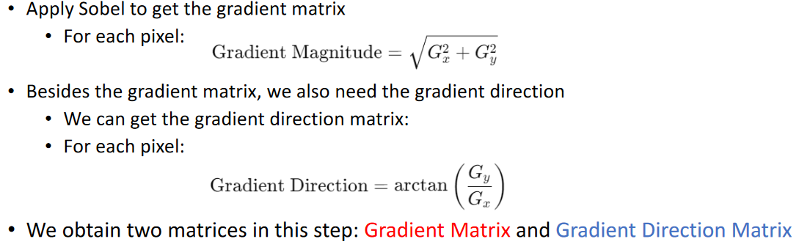
  + - * 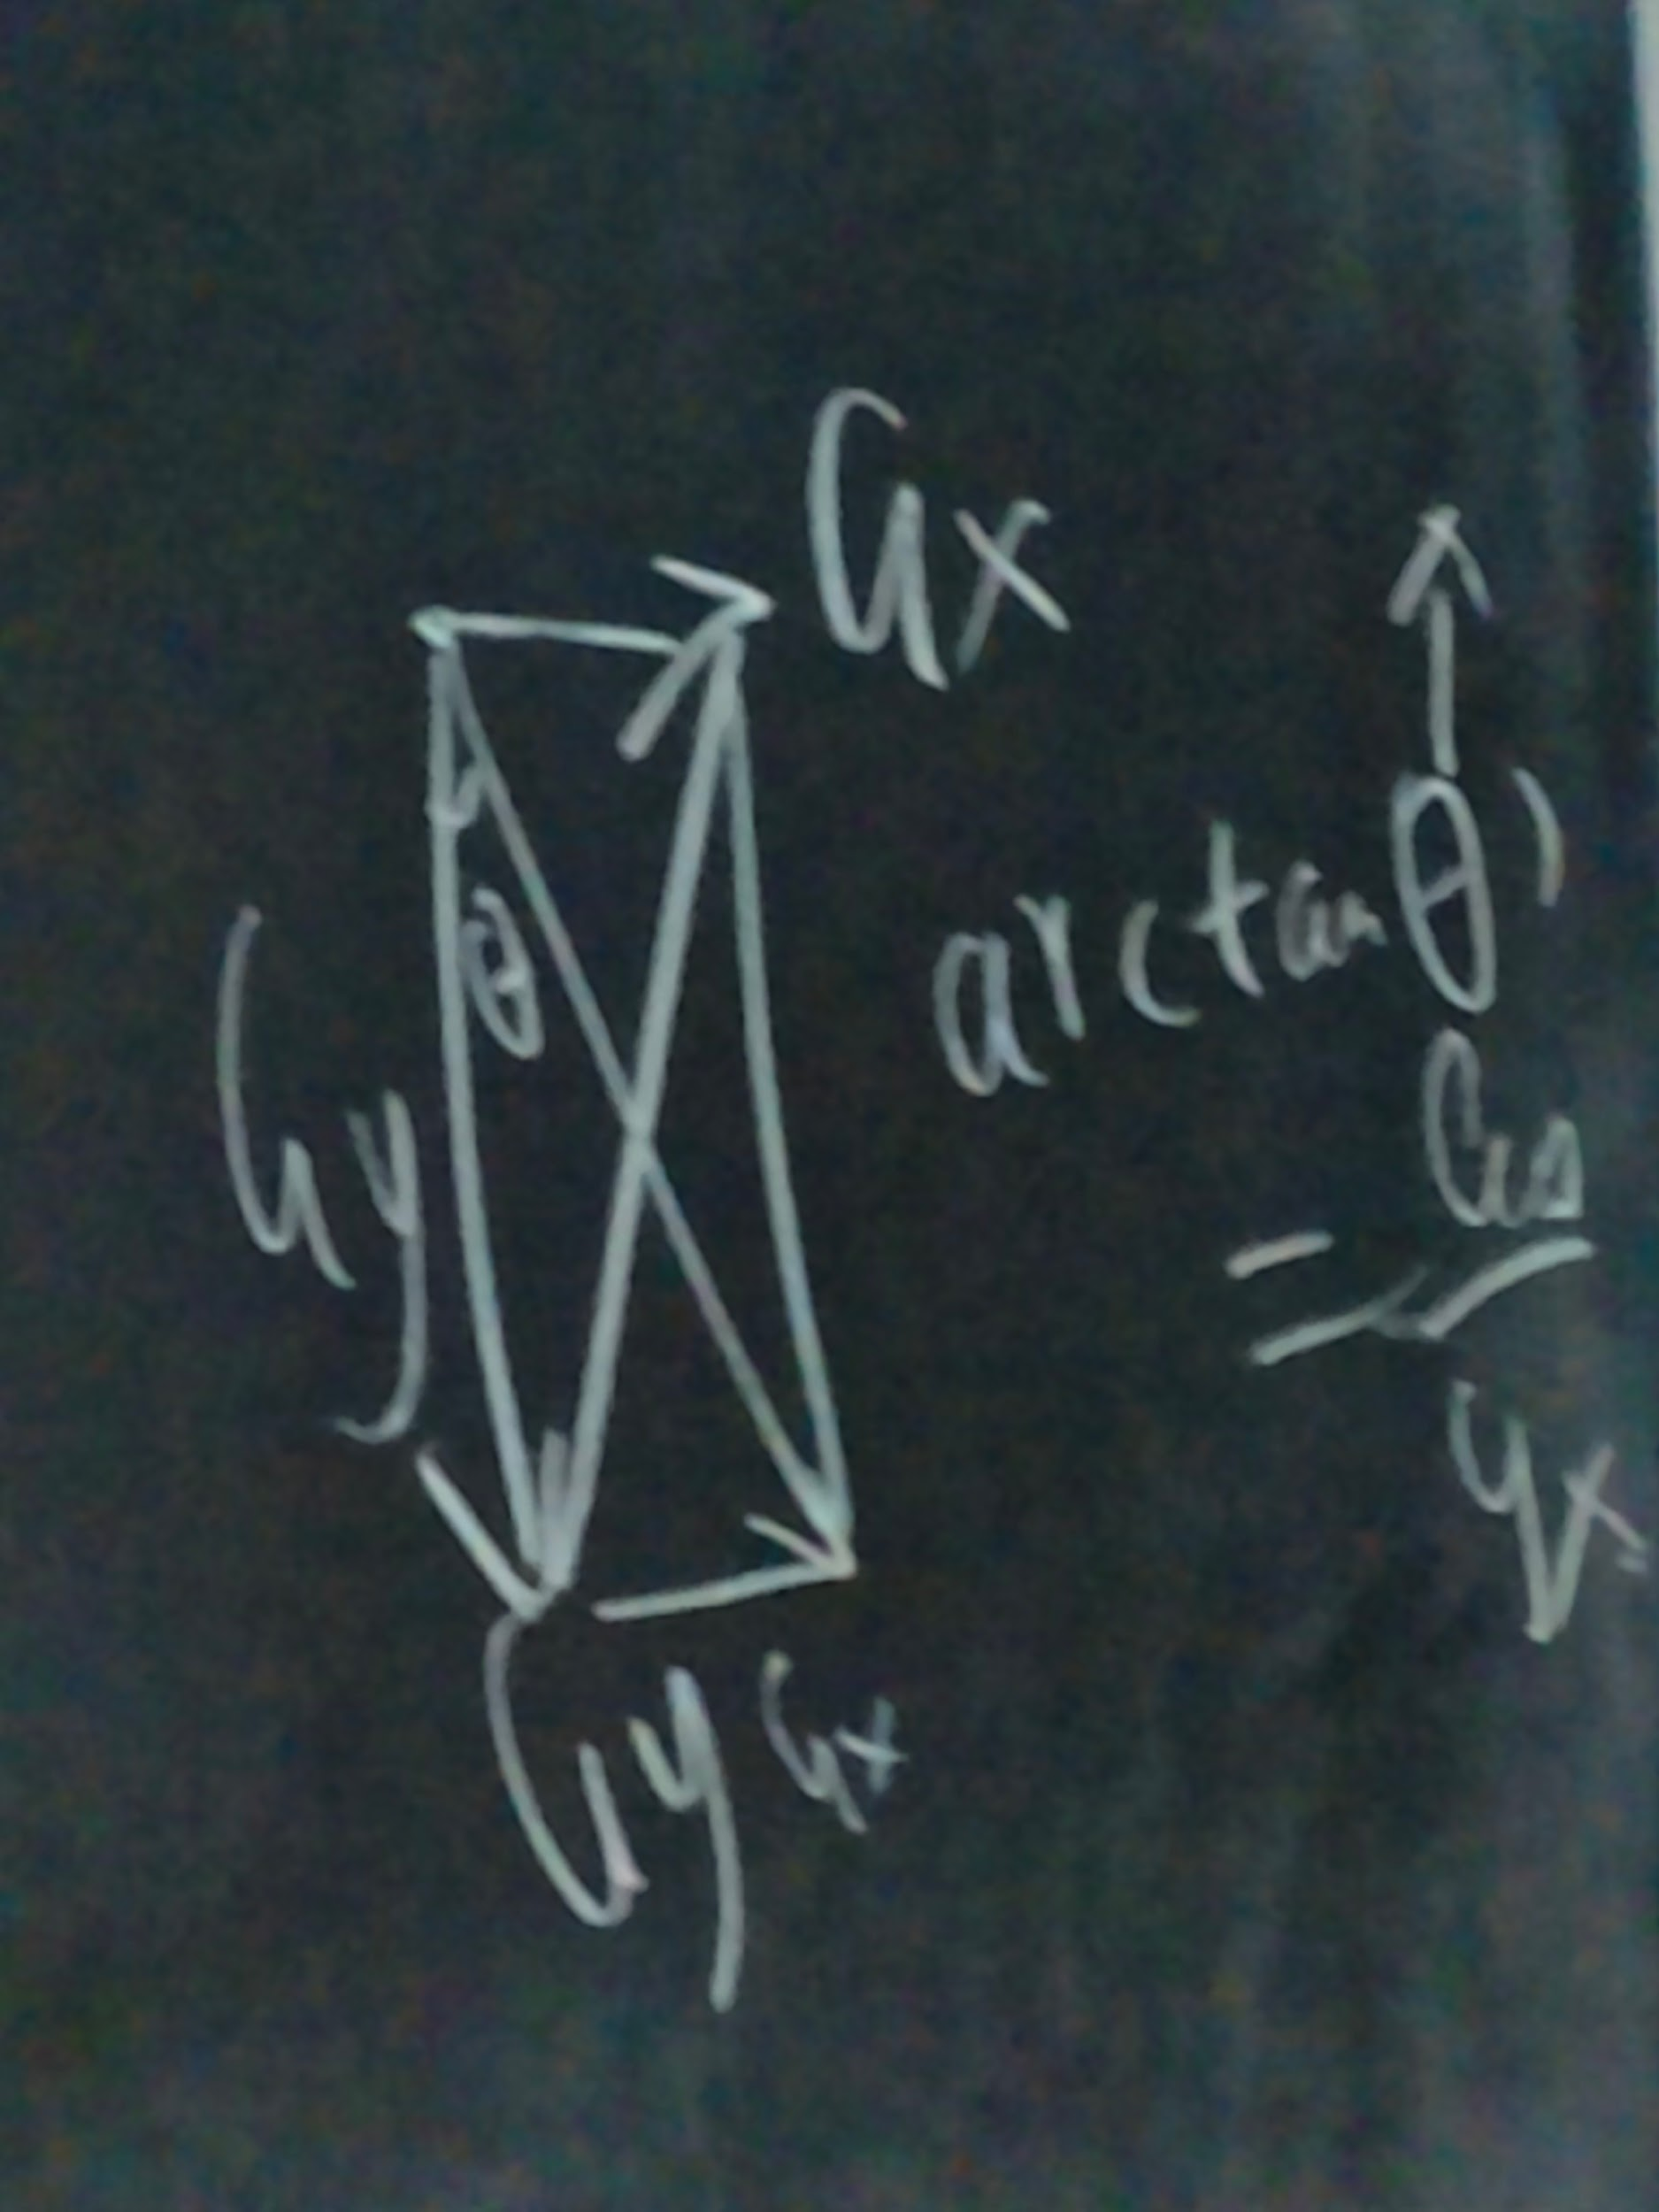
    - 3. non-max suppression
* 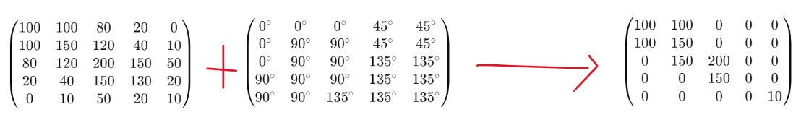
  + - 4. double thresholding
* 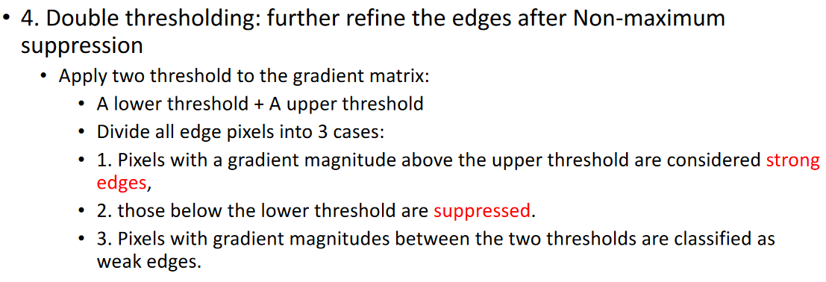
  + - 5. edge tracking
* 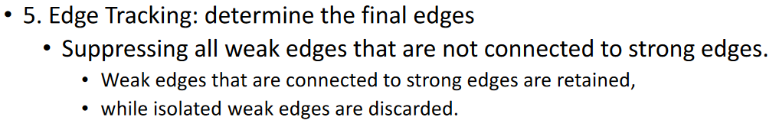
* 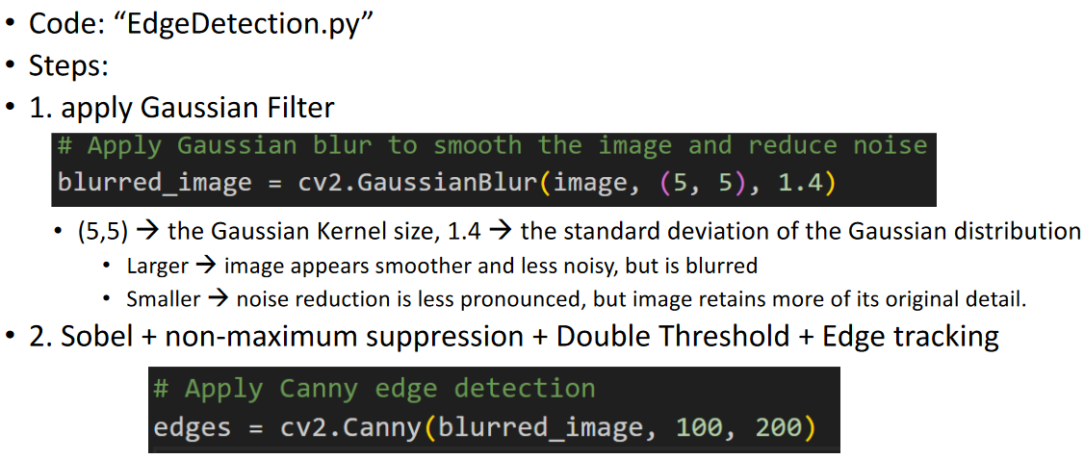

##### laplacian detection

* + - he didnt talk about it because he said it was too hard to explain
    - sobel vs laplacian just use different kernels
      * sobel is first derivative
      * laplacian is second derivative

#### application: Contours in OpenCV

* + contour = a closed curve joining all continuous points that have the same colour or intensity
    - edge that must end back at its starting point
  + find the contours from the edges
    - edge matrix = created from sobel or canny
    - mode = method used to retrieve contours and the hierarchy between contours
      * EX: CCOMP returns two layers of array
        + 1st layer is internal contours

contours inside of contours

* + - * + 2nd layer is external contours

contours that contain contours

* + - * + [A, [B]]
      * EX: LIST returns a flat array
        + all contours without hierarchy
        + [A, B]
    - method = how contours are stored in memory
      * CHAIN_APPROX_NONE = something
      * CHAIN_APPROX_SIMPLE = return corners
* 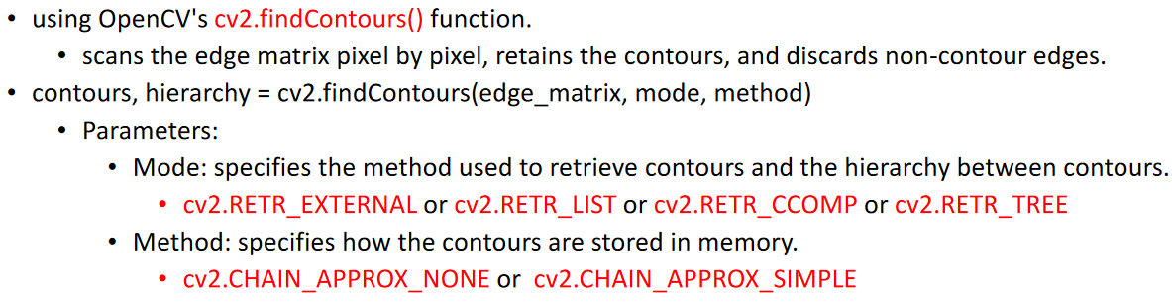
* 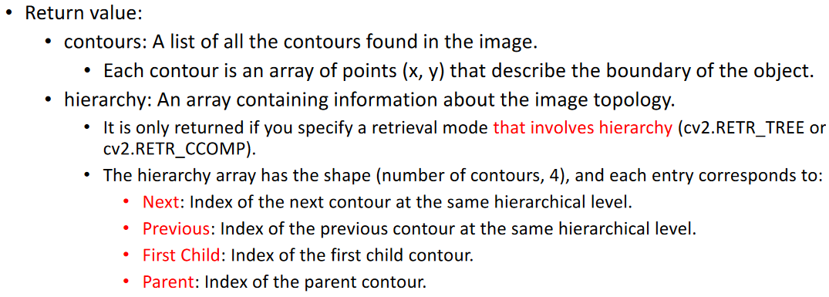
* 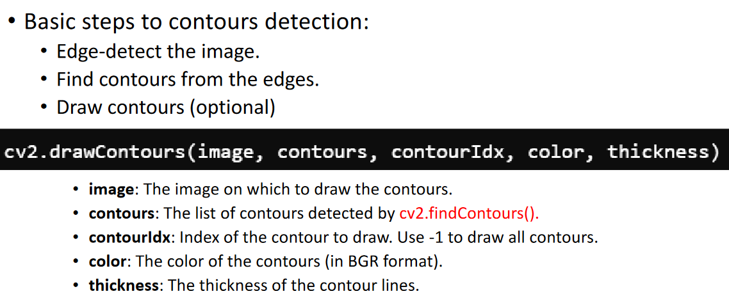

##### contour approximation

* 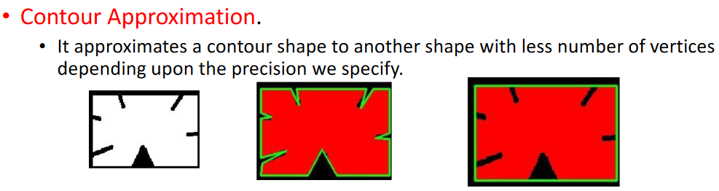
* 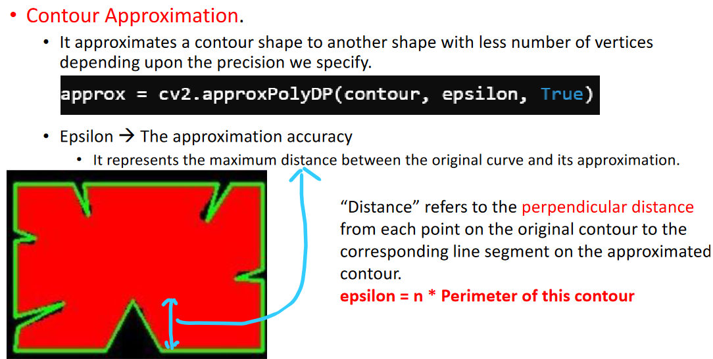
  + - epsilon = noise toleration

##### detect and categorize shapes in an image

* + - detect the edge
    - find the contour
    - check how many corners
      * cv2.CHAIN_APPROX_SIMPLE
      * 3 corners = triangle
      * 4 corners = square
      * >4 corners = circle
* 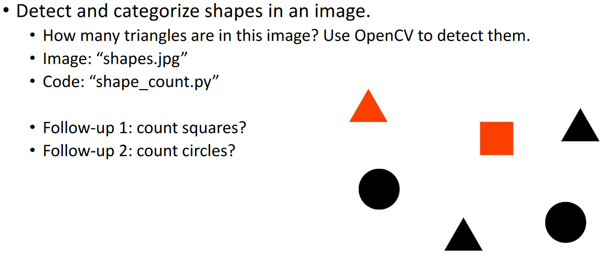

##### detect corners on playing card for perspective change

### Week 5 P1 Feature Detection: Corner

#### feature

* + distinctive attribute within an image that is useful for identifying patterns, objects, or other relevant information
  + points, edges, textures, shapes, colours, or regions within an image
* feature detection
  + process of identifying and extracting features from an image
  + process of identifying and isolating specific characteristics or attributes from an image that are relevant for analysis
    - in a movie, dont care about every frame and pixel, just care about the story
    - extract useful information
    - discard useless information
* EX:
* 
  + extracted features: tree, house
  + use sentences to describe the features
    - left is a tree, right is a house

#### types of feature detection

* + corner detection
    - corner
      * points in an image where two or more edges intersect or meet
      * usually corresponds to significant features of objects within an image
      * robust against rotation, scaling, and translation
    - contours is not a good feature to use when changing perspective of an image
      * 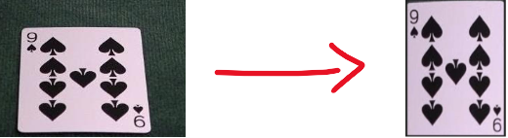
      * trapezoid to rectangle
    - corners are good features to track because they stay the same
    - three corner detection algorithms:

##### Harris Corner Detector

* + - * identifies points where the image gradient has significant changes in multiple directions
      * difference btw sobel:
        + sobel uses x and y axis, then magnitude btw the two (Gx, Gy)
        + harris uses x, y, and all diagonals (1deg, 2deg, 3deg?)
      * 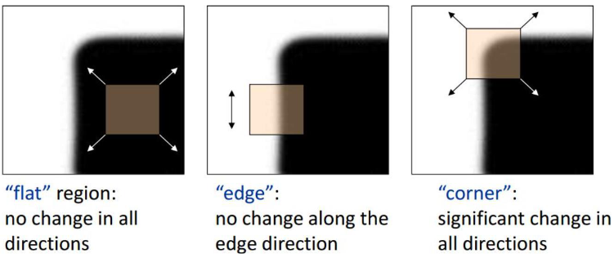
  + 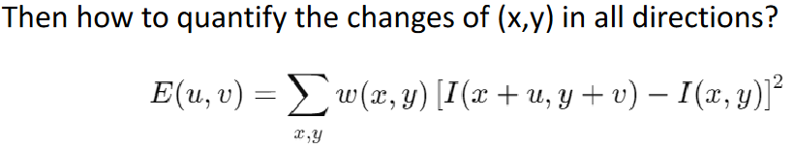
    - * (u,v) stands for any possible displacement
      * W(x,y) is a window function that assigns weights to pixels around (x,y)
        + usually gaussian window (higher weights to pixels closer to the center)
      * [I(x+u,y+v) - I(x,y)]^2 is just one direction
      * to detect a corner
        + E(u,v) will be large in all directions
        + if large in only some, edge
        + if small, flat
      * practical implementation: Harris Response Score
* 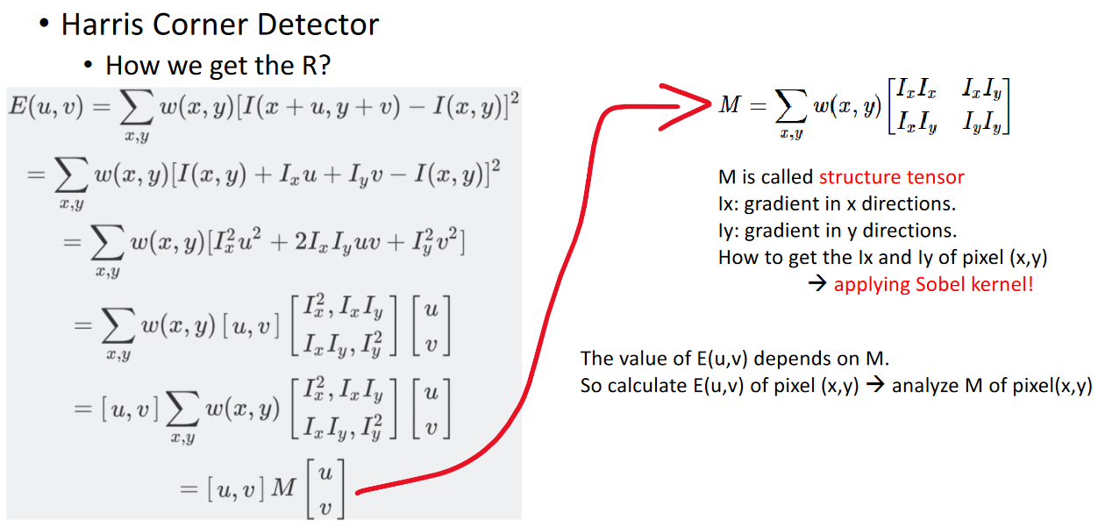
  + - * to make sure E is large in all directions, M has to be large in all directions to find a corner, M is basically the scaling factor
      * apply sobel kernel to calculate Ix and Iy
      * Ix (harris) = Gx (sobel), same thing
      * SOBEL KERNEL:
      * 
      * 
      * function diagram for M(Ix,Iy), find the geometric interpretation
      * 2x2 has 2 eigenvalues, 3x3 has 3 eigenvalues
        + we are only using 2
      * shape of circle is dependent on the eigenvalues
        + small eigenvalues means small circle
      * 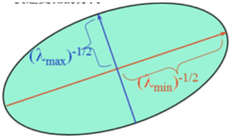
      * both eigenvalues being larger than threshold = corner
      * one being larger than threshold = edge
      * both eigenvalues being smaller than threshold = flat region
      * 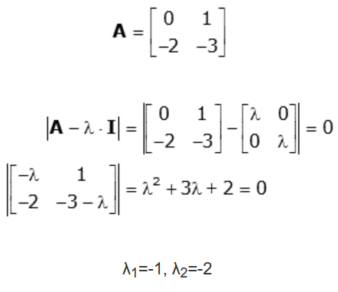
* 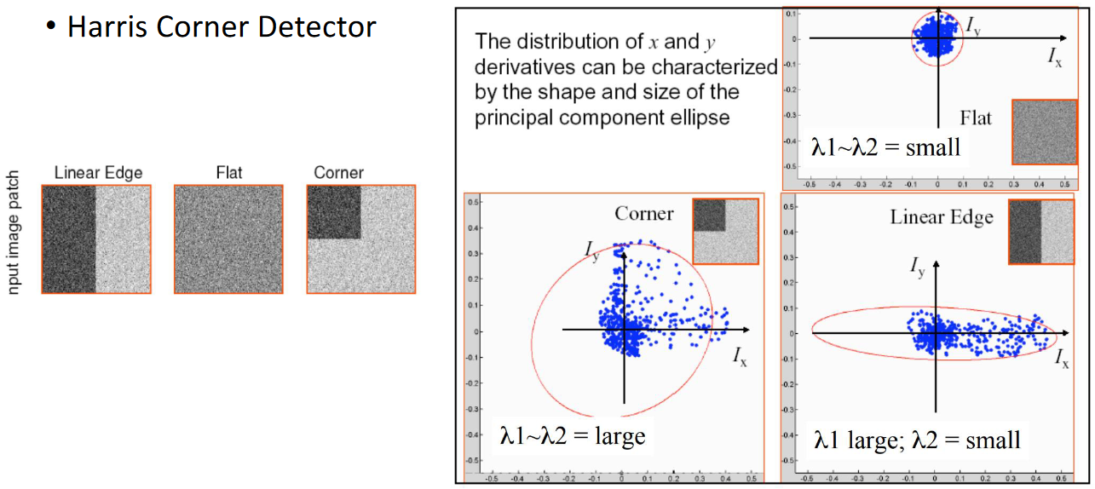
  + - * 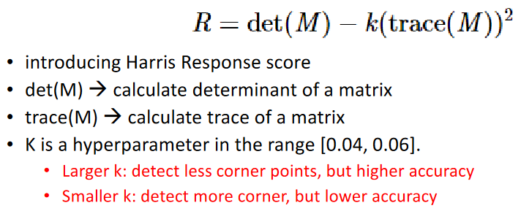
      * R = harris response score
      * 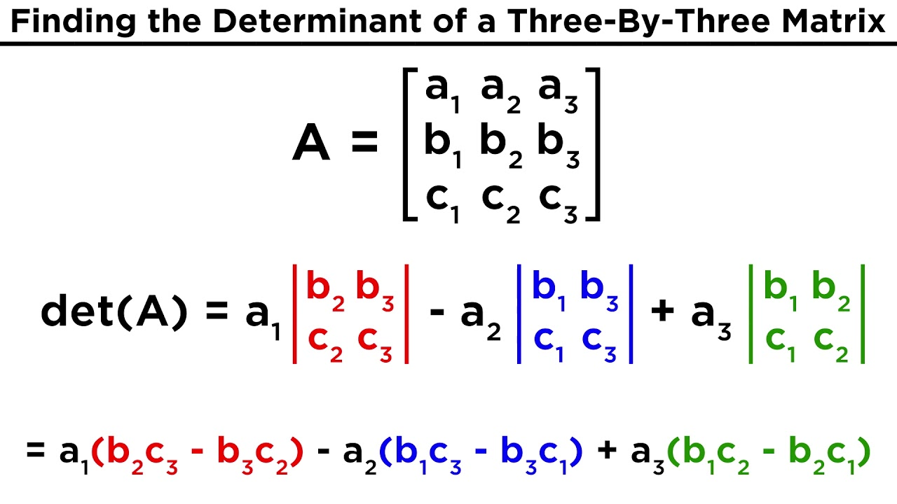
      * 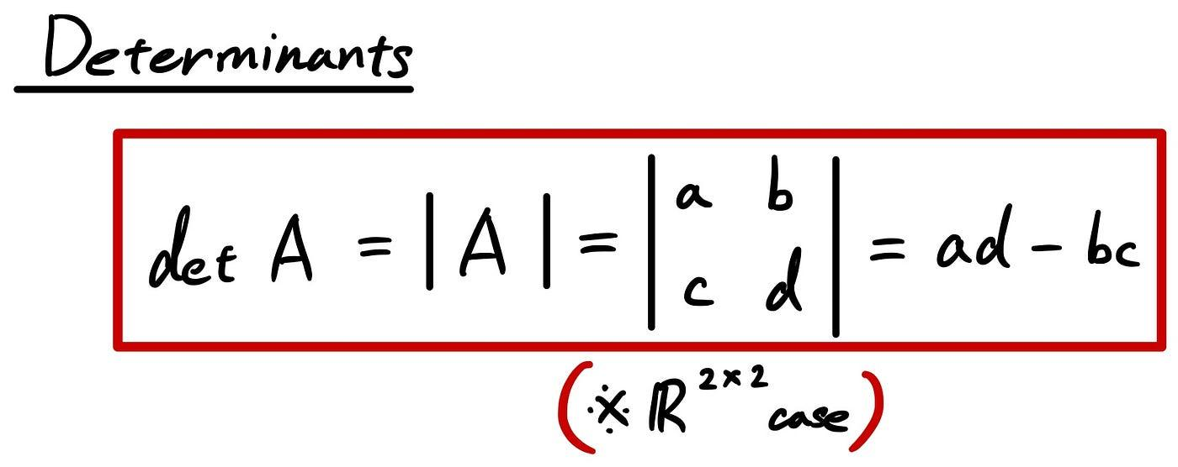
      * 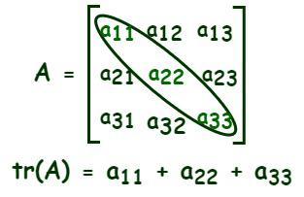
      * determinant = eigenvalue1 x eigenvalue2
      * trace = eigenvalue1 + eigenvalue2
      * R = (eigenvalue1 x eigenvalue2) - k(eigenvalue1 + eigenvalue2)^2

###### implementation

* + - * convert to grayscale
      * construct M matrix, for each pixel:
        + compute Ix and Iy with sobel filter
        + compute Ix^2,Iy^2,IxIy
        + apply gaussian filter for Ix^2,Iy^2

creates M matrix

* + - * + call numpy API to calculate R value
      * threshold for R value
        + pixels above threshold are corners
      * non-maximum suppressing to eliminate weak corners
        + for each corner, compare its R to its neighbours (3x3)
        + if corner is local maximum, it stays a corner
        + if not, it is suppressed

##### Shi-Tomasi Corner Detection

* + - * improvement on Harris
      * simplifies R to:
      * 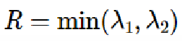
      * if R > threshold, pixel = corner
        + ensures both eigenvalues are large
* 
  + - * image = grayscale image
      * maxCorners = specifies the maximum number of corners to return
      * qualityLevel:
        + threshold = qualityLevel * (larger eigenvalue)
        + compare R with this threshold
      * minDistance = minimum possible Euclidean distance between returned corners

##### FAST Corner Detection (Features from Accelerated Segment Test)

* + - * faster than Harris or ST, meaning useful for real-time video processing and applications that require high-speed feature detection (ex: robots and object tracking)
      * sensitive to image noise, because noise can create false corners
      * pixel p has a set “n” of contiguous pixels in a circle around p that are all brighter than p+t or darker than p-t
        + n <= # of pixels in circular ring around p

if radius of circle = 3, # pixels in circular ring = 16

ex: n = 12

* + - * + p = pixel that is considered to be a corner
        + t = adjustable threshold parameter
      * 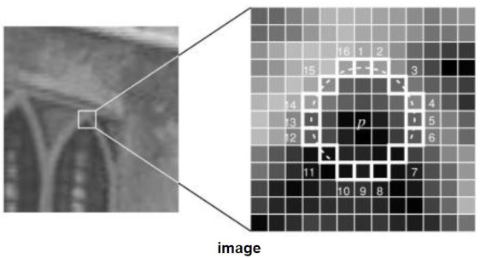
      * first it checks pixels 1, 5, 9, and 13 in the circle, has to have at least 3 of the 4 pixels pass the brightness/darkness condition
      * then if that passes, the full set of pixels is tested for the brightness/darkness condition and at least 12 of the 16 need to pass
  + 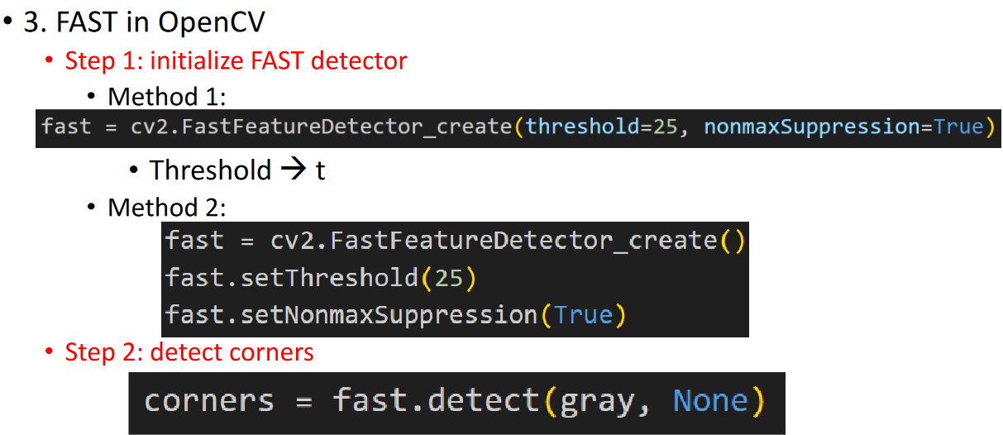
    - * corners are invariant for rotation, scaling, and translation
      * corners detected by harris, ST, and FAST are not scale invariant
      * corner itself is invariant, but corner detected by these methods are not scale invariant
        + these algorithms rely on the neighbours
        + gradients rely on the neighbours
  + 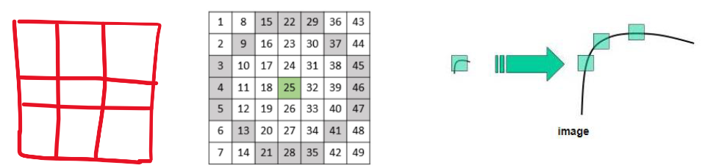
    - * + when you zoom in or out, the neighbours will change
      * to detect scale-invariant features, we need to use keypoint detection

##### corner detection use cases

* + - * simple feature matching
        + when real-time performance is required

ex: video processing

* + - * shape analysis
        + trying to detect different shapes through corner detection
      * camera calibration
        + allows you to get camera parameters

ex: 3D model reconstruction from a 2D image

* + - * + <https://docs.opencv.org/4.x/dc/dbb/tutorial_py_calibration.html>

### Week 5 P2 Feature Detection: Keypoint

#### keypoint

* + a point of interest within an image that holds significant information about the texture, colour, or form
  + corners belong to keypoint
* keypoint detection algorithm: SIFT

#### edge vs corner vs keypoint

* 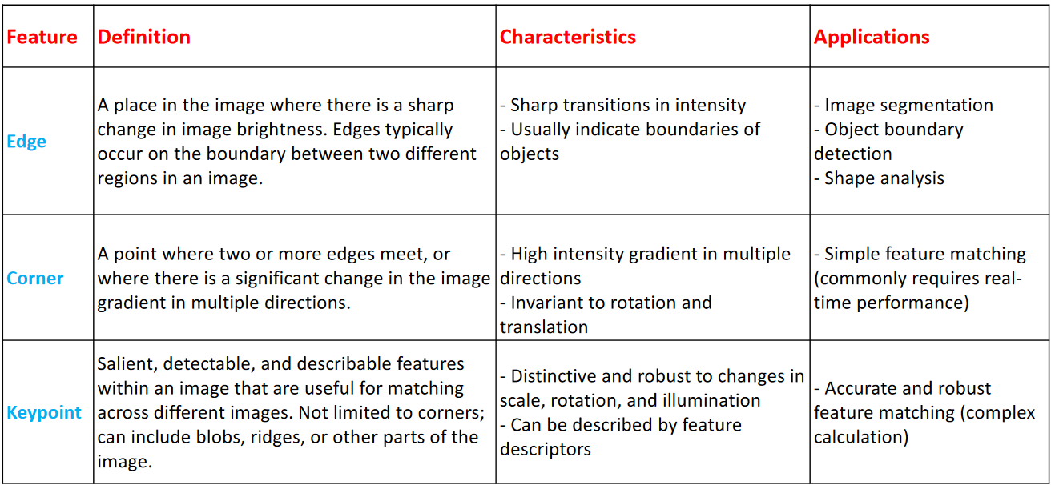

#### SIFT: Scale Invariant Feature Transform

* + used to detect scale invariant features
  + useful for when images are very complex

##### step 1. scale-space extrema detection

* + - construct scale-space

###### strategy 1:

* + - * reducing the size of an image is equivalent to increasing its distance from the eyes
      * different image size → different distance → different scale
      * to make an image smaller or change its resolution:
        + DownSample() or resize
      * 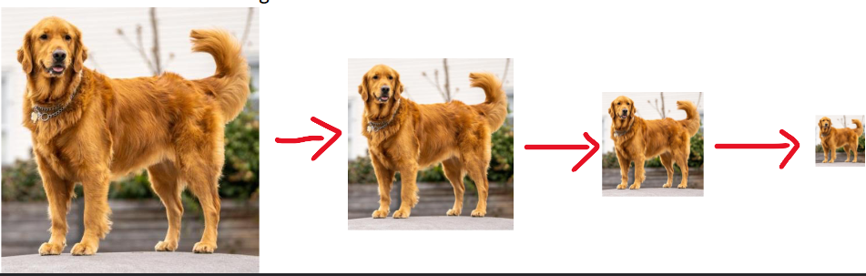

###### strategy 2:

* + - * shifting your focus from the image to others is another kind of scale change
      * focus loss → the image becomes blurry
      * use focus loss (blur) to simulate scale change:
        + gaussian filter
        + gaussian kernel convolution
        + the larger the standard deviation, the more the image is blurred
      * 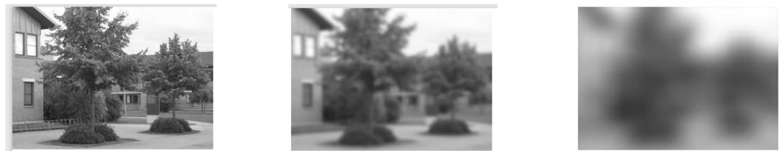
      * 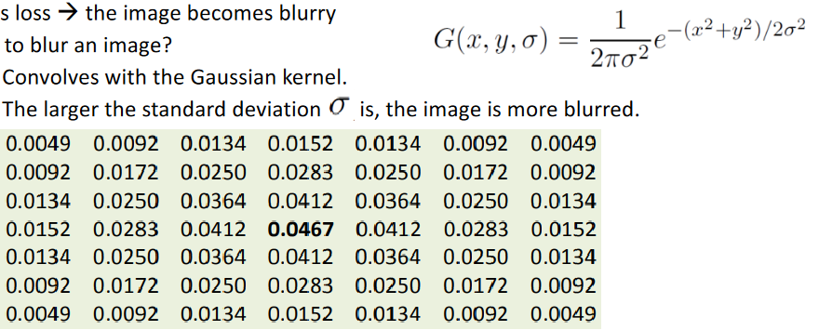

###### scale-space steps:

* + - * 1. combine the two strategies
        + original image → blur at different sigma (standard deviation) levels
        + scaled down image a lil → blur @ diff sigma levels
        + scaled down image a lil more → blur @ diff sigma levels
        + etc.
        + Several Octaves = different resolutions
        + for each octave, apply different gaussian kernels
        + ex: 4 octaves, 5 different gaussian kernels
        + creates the scale space
      * 2. detect extrema (largest or smallest values)
        + calculate the DoG (difference of gaussian)
        + 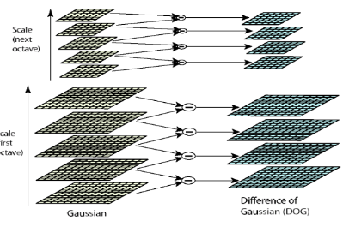
        + compare each pixel in the DoG image to its neighbours in the same and adjacent scales
        + involves comparing a pixel to its 8 neighbours in the current scale and 9 neighbours in the scales above and below, making a total of 26 comparisons
        + if value is largest or smallest, it is an extrema
        + 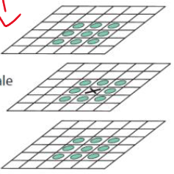
        + Octave 1: 50x50

DoG 1:

extrema = (30,30)

DoG 2:

extrema = (20,20)

* + - * + Octave 2: 25x25

DoG 1:

extrema = (5,5)

DoG 2:

extrema = (6,6)

* + - * + interpolation (map octave 2 to octave 1):

upscale

add all the extrema to the list of extrema

* + - * + 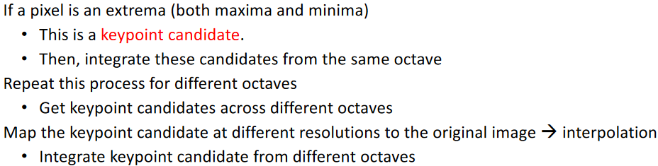
    - initial image keypoints (lots of false keypoints)
    - 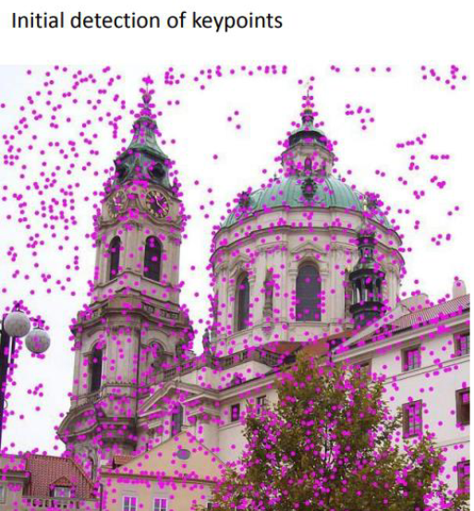

##### step 2. keypoint localization

###### contrast each candidate

* + - use threshold
    - contrast (x,y,sigma) < 0.03 → weak point → discard
* 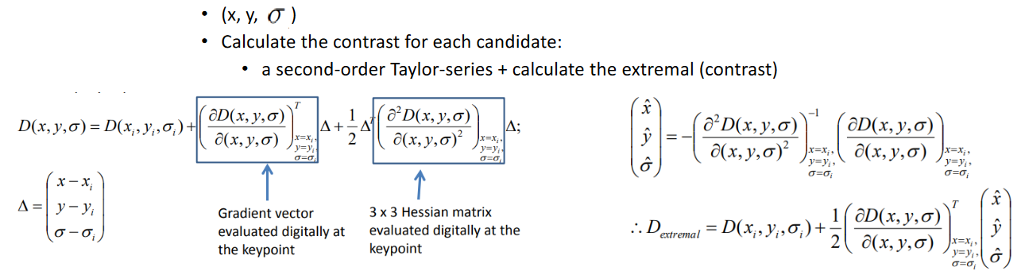
  + - 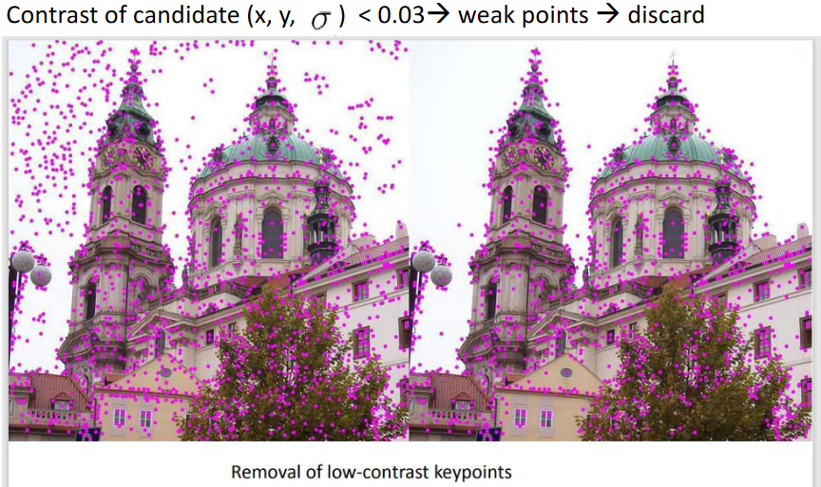

###### remove edges

* + - * keypoints on edges tend to be less useful due to commonality and lack of distinctiveness
      * DoG has higher response for edges
      * for each candidate, calculate the second order derivative and construct the Hessian Matrix
        + use 2nd order derivative instead of 1st order derivative that is used in Harris Corner Detection
        + 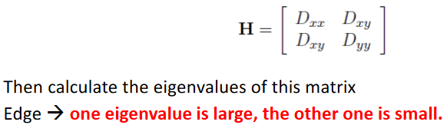

##### step 3. orientation assignment

* + - ensure keypoints are rotation-invariant
    - calculate orientation of the keypoints and its neighbours
    - used in Canny Edge Detector
    - count the frequency of the range of degrees (0 to 45deg, 45 to 90deg, etc)
    - 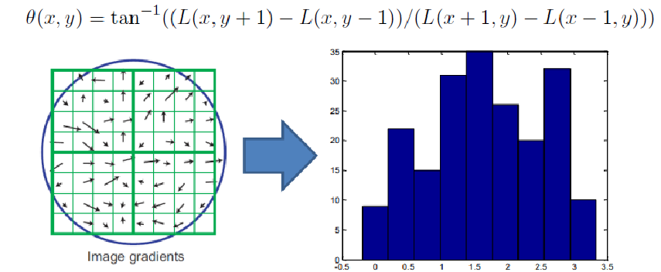
    - L = gradient, G = gradient, I = gradient, doesnt matter
    - assign the highest histogram range as the orientation of this keypoint
    - this ensures the keypoint is rotation-invariant because the neighbours rotate with the image

##### step 4. keypoint descriptor

* + - currently, keypoint has 3 pieces of information: (location, scale, orientation)
    - further enhance keypoint, SIFT generates feature descriptor for every keypoint
    - 8*8 window → 16 cells
    - for each cell (2*2), calculate 8-bin (8 different 45deg ranges) histogram
    - dimension of array for descriptor will be 128 bc 16cells and 8bins
    - vector containing 128 elements
    - describes the conditions around the keypoint
* 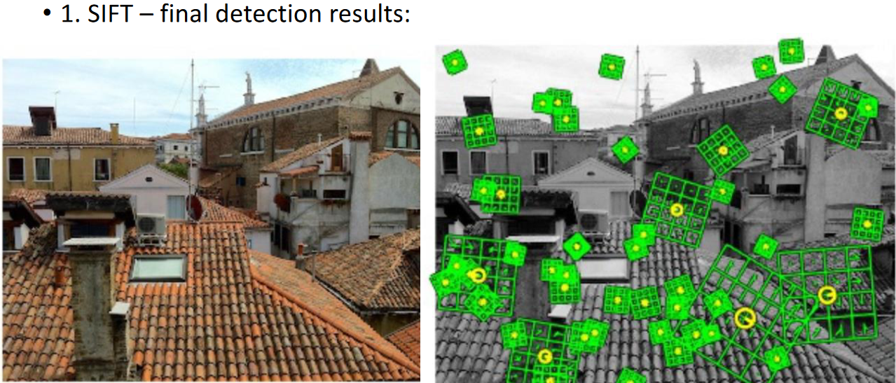

##### use:

* + 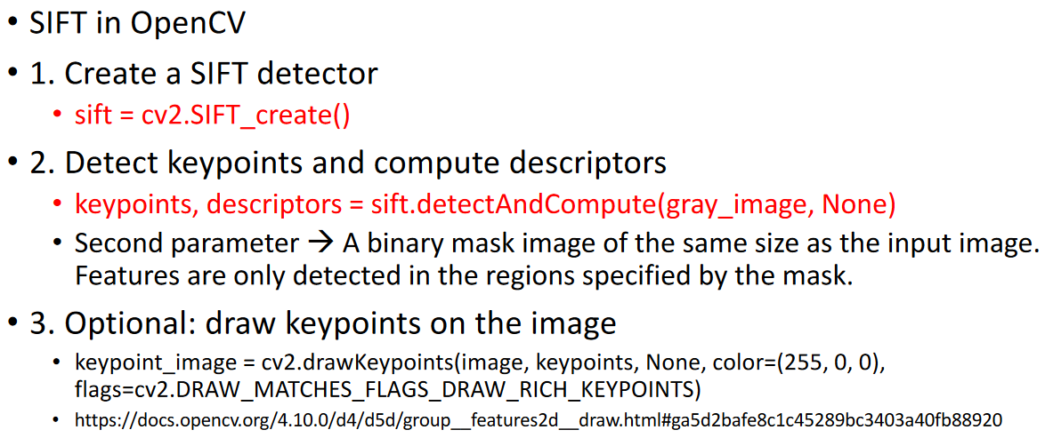
    - location and orientation and descriptor of key points
    - green chart is matrix, yellow circle is radius and direction
  + 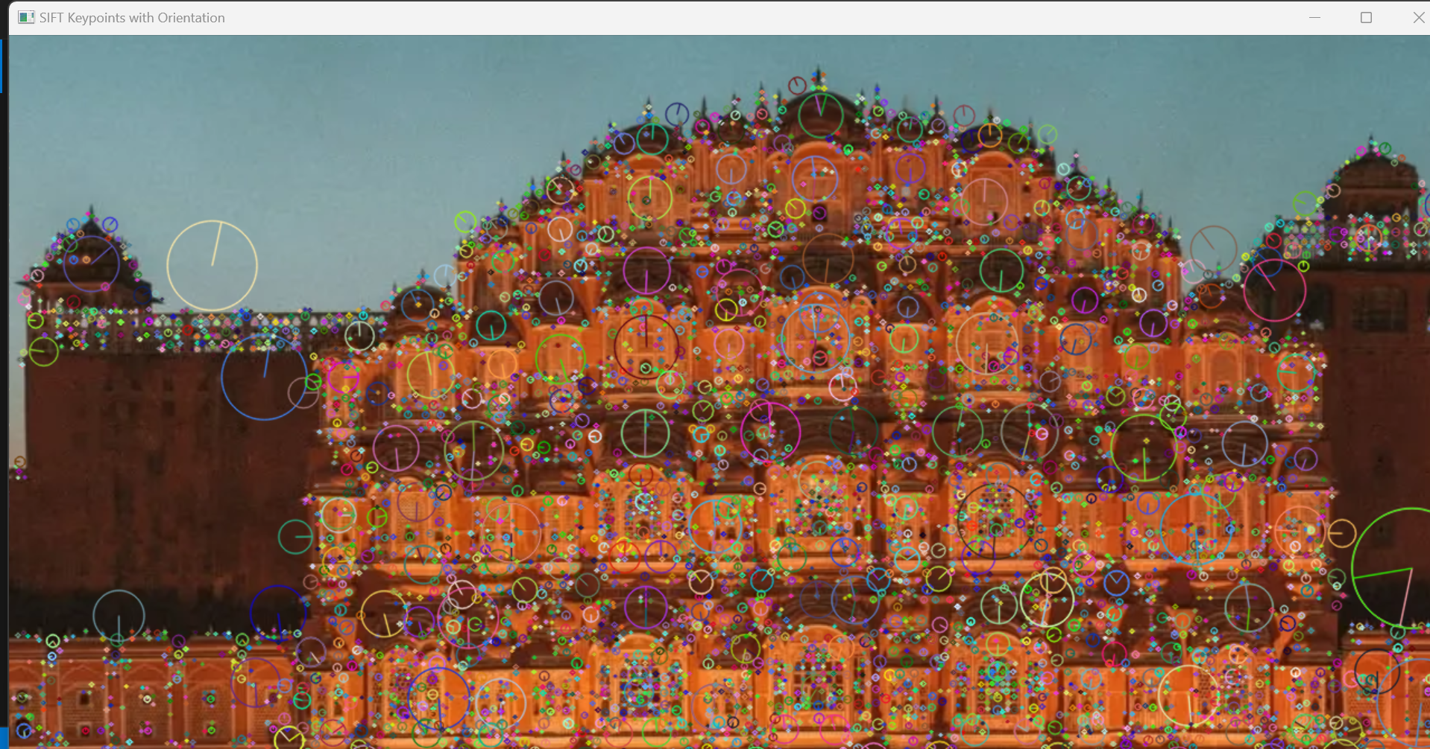
  + circle: center is location of key point
    - radius specifies direction of keypoint
    - value of radius = scale
    - when creating the scale space (step 1) when detecting extrema, we get location of key points and scale of key points. if scale is large, circle will be large. if scale is small, circle will be small. orientation of radius is orientation of key points. the descriptor isnt drawn, but it would be a matrix around the key points.

##### summary

* + - detect scale-invarient keypoints:
    - 1. scape-space extrema detection
      * construct scale space
      * detect extrema
    - 2. keypoint localization
      * use math to define detection results to eliminate weak candidates
    - 3. orientation of assignment
      * gradient direction of cell and neighbours
      * arctan(theta Gx/Gy)
    - 4. keypoint descriptors
      * 64 neighbours
      * 4*4 cells
      * for each cell, 8 bins from histogram
      * 128 dimension array for keypoint descriptor

#### SURF: Speeded Up Robust Features

* sped-up version of SIFT
  + Why faster?
  + • 1. works on integral images instead of the original images
  + • 2. more compact descriptor, 64-dimensional (configurable to 128)
  + • SURF is faster, whereas SIFT sometimes offers better accuracy.
  + 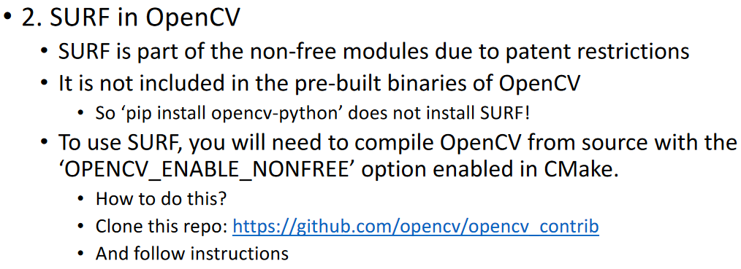

#### keypoint detection use cases

* + used in stereo vision
    - case 1: pics taken at same time from different perspectives
      * binocular camera
    - case 2: pics taken at same perspective from different times
      * taking a video with a camera
    - case 3: different perspective, different times
  + uses:
    - 1. depth estimation
      * see assignment 3
    - 2. 3D reconstruction
      * 2d image = grayscale
      * 3d reconstruction = 3d image = grayscale image + depth information
    - 3. panorama stitching
      * extract key points, match keypoints, align images

### Week 6 P1 OpenCV and Machine Learning

* OpenCV integrates with numerous machine learning and deep learning frameworks

#### 1. OpenCV with Deep Learning

* + how to integrate OpenCV with pre-trained deep learning models:
    - <https://docs.opencv.org/4.x/d2/d58/tutorial_table_of_content_dnn.html>
    - DNN module
    - using DNN module to load pre-trained DL models from almost all frameworks
    - Tensorflow: readNetFromTensorflow()
    - • Caffe: readNetFromCaffe()
    - • Pytorch: readNetFromONNX()
      * • ONNX = open neural network exchange
      * ONNX is intermediary btw pytorch and openCV
  + ex: object detection
    - Download pre-trained model:
      * https://github.com/onnx/models/blob/main/validated/vision/classification/resnet/model/resnet50-v1-7.onnx
    - • Download the classes.txt:
    - • Map the class id to class name.
      * https://github.com/BigWZhu/ResNet50/blob/master/imagenet-classes.txt?ref=blog.roboflow.com
    - • Code: object-detection.py
    - • Follow-up question:
    - • can you modify the code to enable real-time detection from a webcam?
  + ex: gender detection
  + use OpenCV to preprocess image datasets
    - before training a network, use OpenCV to perform image transmformations to augment the datasets
    - generealize the model
    - generating additional samples for underrepresented categories
* 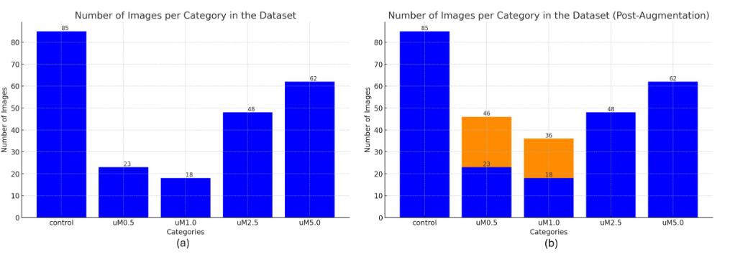

#### 2. OpenCV with Traditional Machine Learning

* + kNN, SVM, K-means cluster (?)
    - read after class
  + for real-time image processing, use Haar Cascade Classifiers
    - real-time face detection
    - uses ML concepts like cascade images, haar-like features, and adaboost learning algorithm to perform face detection
  + advantages
    - faster than CNN
  + disadvantages
    - limited robustness and accuracy compared to CNN
  + face_detector_final.py
    - face_cascade.detectMultiScale(gray, scaleFactor=1.1, minNeighbors=5, minSize=(30, 30))
      * construct scale space
      * simulate distance, scalefactor = 1.1 means reduce size by 10% each time
      * minNeighbours, large value = big window, small value = small window
      * minSize want to eliminate small faces
  + haar cascade can also detect eyes
    - Step:
    - • 1. Load the pre-trained Haar Cascade models for face and eyes
    - • 2. Read video stream from webcam
    - • 3. Detect faces to identify ROI (region of interests)
    - • 4. Detect eyes
    - • Code: eye_detection.py

### summary

* + what is an image
    - 2d or 3d arrays, “np” library
      * 2d = x and y, each pixel is 0 - 255
    - colored image = 3 colours (R G B)
      * each pixel has 3 values
    - to deal with image, we use numpy library to deal with high dimension arrays
  + colour space
    - BGR, grayscale, HSV, conversions
  + basic image transformations
    - affine transformation, perspective transformation
    - affine = linear, parallel lines are still parallel after transformation
    - perspective = non-linear, parallel lines are no longer parallel after transformation
  + edge detection
    - intensity changes in x and y axis
  + corner detection
    - special edge, edge meets at the corners
    - at the corners, will be large intensity change in all directions, not just x and y axis
    - harris, shi-tomasi, FAST
  + keypoint detection
    - SIFT
  + OpenCV and ML/DL
    - pretrained models
    - pretrained resnet for image classification
    - pretrained googlenet for gender
  + projects:
    - • Draw something (lec 4, draw a house)
    - • Scan documents (lec 6, birdview)
    - • OCR text recognition (Assignment 2 Task 2)
    - • Object measurement (Assignment 2 Task 1)
    - • Real-time face detection (lec 9)
    - • Object detection (lec 9)
    - • Feature matching (Assignment 3 Task 1)
    - • Distance estimation (Assignment 3 Task 2)

### Week 6 P2: Special Topic -- How To Do Research

#### importance of research

* + companies have research departments
  + can get you a teaching job
  + helps to solve problems youve never seen
  + ex: industrial revolution, machines take over tedious human jobs, revolutionized
  + research and be boring and unrewarding if you waste time and dont have any result to show
  + research is interesting, like entrepreneurism or starting a business, because the 1 time you succeed makes all the 100 times you failed

#### key steps of research

* + EX: MONOCULAR DEPTH
  + start from a motivation
    - can come from a gap in knowledge, social need, personal interest…
    - applications require distance measurement
      * when you are moving
      * AI or robotics
    - traditional distance measurement methods
      * tape measure
      * LIDAR, RADAR
    - disadvantages of traditional methods
      * heavy, expensive, we want it to cost less money for the same results, while also weighing less
    - how to overcome the disadvantages
      * ?
  + identify the problem
    - problem statement should be clear and well defined
      * I want to use vision-based techniques to obtain distance information
        + point out technique you want to use

vision based method

* + - * + point out problem you want to solve

how to get distance information

* + - * + input and output

input an image, output is a distance map

* + literature review
    - what has been done
    - what findings have been established
    - where there are still gaps or inconsistencies in knowledge
    - learn from others’ methods
      * read others papers
      * study their source code
      * ask authors for help
    - identify the limitations of their methods
      * improve on their methods, because theirs isnt going to be perfect
      * maybe they only do lab, and dont do testing
      * maybe they only talk about best case and not average case
      * maybe they only focus on easy examples and not edge cases
      * test their methods on other data sets to make sure theyre generalized enough
      * <https://scholar.google.com/>
        + click PDF on the right, not the link, to be able to access the paper
      * <https://arxiv.org/>
        + research paper library where everyone can submit without peer review
        + quality of paper cannot be guaranteed, so be careful
    - refine your problem
      * what are the categories of vision-based distance measurement methods
        + stereo, monocular…
      * advantages and disadvantages
        + stereo: explainable, affected by camera parameters

calibration draft

limited by corner detection

2 image in, 1 image out

* + - * + monocular

straightforward

unexplainable (CNN is a black box)

1 image in, 1 image out

industry doesnt want to use it because unreliable and black box, but other researchers think it has higher accuracy (?)

* + - * + common potential issue

large model, huge parameter space, computational load is heavy

* + - * using a monocular camera for real-time and robust distance detection
        + vision → monocular
        + large model usage creates slow speed, but AI driving needs to act quickly, so needs real-time feedback
        + some AI driving scenarios cant be predicted, so needs to be robust enough to deal with all scenarios
  + formulate hypothesis
    - using a monocular camera for real-time distance detetcion
      * encoder and decoder structure
      * downsample encoder, down sample, convolution to extract features
      * upsample decoder, extract features, same size image as input
  + design experiments to test hypothesis
    - indoor and outdoor, 2 data sets
      * KITTI (outdoor)
      * NYU-V2 (indoor)
    - compare to others work
      * base lines found in research portion that was already done
  + analyzing experimental result
    - after conducting experiments, analyze the data to see if they support your hypothesis
    - table, line chart, 2d/3d histograms, etc.
    - 2 options after analyzing results:
      * confirm hypothesis
        + paper can be written
      * reject hypothesis
        + start back at hypothesis step
        + if CNN is too deep, features Tree and House can become T and H
        + try 2: skip connections
        + try 3: too much noise, focus on attention mechanism

calc CBAM attention

calc SE attention

normal skip

* + - * + try 4: performance improved, but can still improve more

modify loss function to improve accuracy

not the first one to try this

others used gradients for each pixel

siow, only x and y

professor used gradient windows

fast, also includes diagonals

* + write a paper and submit your paper to conferences and journals
    - title, abstract, intro, related work, proposed method, experiments, conclusion, resources
    - <https://www.overleaf.com/project>
      * online, great for collaboration
  + submit paper to conferences or journals
    - <https://www.myhuiban.com/>
    - conference = short review process
    - journal = longer review process
    - if rejected, improve proposal then submit to another conference or journal

#### research stories

* + quantum programming
    - doesnt recommend this because way too hard and time consuming
  + computer vision
    - image classification with partial labels
    - binocular / monocular depth estimation
    - cnn robustness analysis

### Week 7 P2:

#### ML/DL

* Deep Learning = DL
  + processes data and creates patterns for use in decision making
  + categorized based on architectures of neural networks used, tailored to specific types of data and tasks
  + 1. CNNs (convolutional neural network) → image
  + 2. RNNs (recurrent neural network) / LSTM (long short-term memory networks) → for text and speech
  + 3. DNNs (deep neural network) → a wide range of domains and tasks
* Machine Learning = ML
  + types:
  + 1. traditional machine learning
    - statistical learning methods
    - random forest
    - kNNs
  + 2. deep learning:
    - DNN
    - CNN
    - RNN
  + DL is a subset of machine learning
* Convolutional Neural Network (CNN)
  + 1. understand the datasets
    - what is training/validation/testing set?
    - what are commonly used image datasets?
  + 2. understand CNN structure
    - CNN components?

#### CNN datasets

* dataset
  + collection of data used to train, validate, and test machine learning models
  + every data point in the dataset typically has a corresponding label
    - image / data point (of a dog)
    - label: dog
    - image / data point (of a street)
    - label: depth map
  + labels have a lot of different formats
  + when we talk about CNN, we are talking about supervised learning, which always has datasets. unsupervised learning may not have datasets.
* training set:
  + used to train the machine learning models
  + largest portion of dataset, 60-80% of the total data
  + provides the raw material from which the learning algorithm can learn the model’s parameters
  + training set is like the slides/textbooks of a course
* validation set:
  + used to provide unbiased evaluation of a model fit on the training dataset.
  + often about 10-20% of the dataset
  + validation set is optional
  + validation set is like in-class practice
* test set:
  + used after training and validation sets
  + used to evaluate model fit on the training dataset.
  + only used once a model is completely trained
  + final measure of how well the model is expected to perform on unseen data
  + often about 10-20% of the dataset
  + test set is like the final exam of a course
* the quality of datasets limit the accuracy of a neural network
  + high quality datasets lead to more accurate and robust models
  + low quality dataset is like studying a textbook with lots of errors or missing sections
  + reasons for low quality dataset:
    - inaccurate
      * wrong labeled data
    - incomplete
      * missing data
    - imbalanced
      * too many of one image
* most commonly used image datasets (used for our classification problems)
  + MNIST
    - 10 categories
    - recognize handwritten digits
    - <https://yann.lecun.com/exdb/mnist/>
  + CIFAR-10
    - 10 categories
    - object recognition in natural scenes
    - each image has one label
    - <https://www.cs.toronto.edu/~kriz/cifar.html>
  + ImageNet
    - >20,000 categories
    - large scale visual recognition challenges
    - >14MM images with labels
      * each image has one label
    - <https://www.image-net.org/>
  + MS COCO
    - object detection, segmentation
    - includes bounding box and objects
    - each image has
      * multiple objects
      * annotations include bounding boxes
      * segmentation masks
    - <https://cocodataset.org/#home>
    - 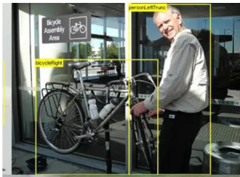
    - 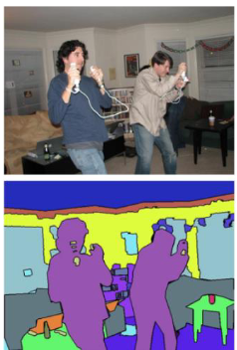
  + LFW
    - face recognition (name of person)
    - face validation (two images are the same person?)
  + KITTI / NYU-V2
    - distance information

#### CNN components

* convolutional kernel
  + matrix that is used to perform convolution operation on images
  + matrix slides over the input data to apply a dot product at each position
  + output of this operation forms a feature map
  + extracts features and reduces the dimensions
  + 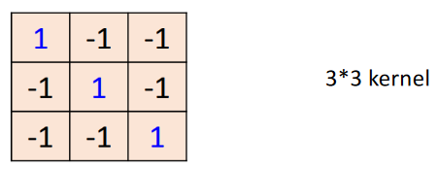
  + 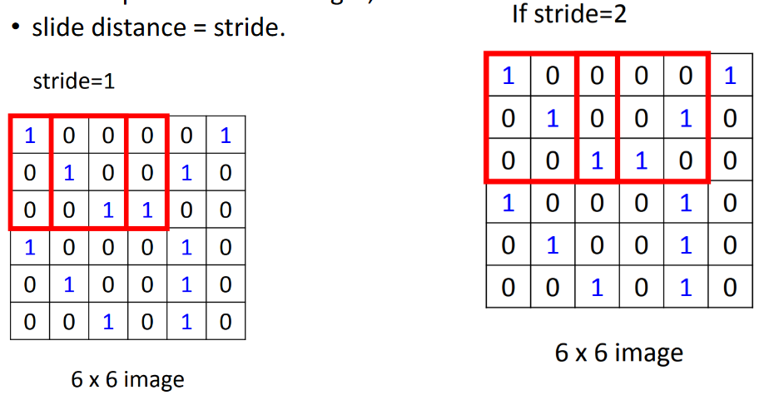
  + 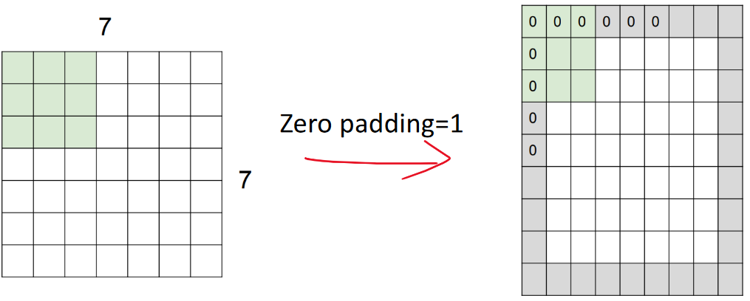
  + convolutional operation:
    - element-wise multiplication and summation
    - input: image
    - output: feature map
    - steps:
      * convolutional operator is slid across width and height of input data
      * at each position, value of operator and values of the part of the input data re multiplied element-wise
      * result of multiplications are summed to produce a single output value
      * repeated for every position where operator fits on input data, forming a feature map
  + operator slides from top-left corner, then left, then down after row is complete, ending with bottom-right corner
    - if kernel cannot completely fill the elements required from the input data, that single sample is deleted and not used
  + zero padding is used to obtain the border’s information of the image
  + Input: 6*6*1, stride=1, zero padding=1, kernel is 3*3, what is the output
    - output: 6x6 map
    - 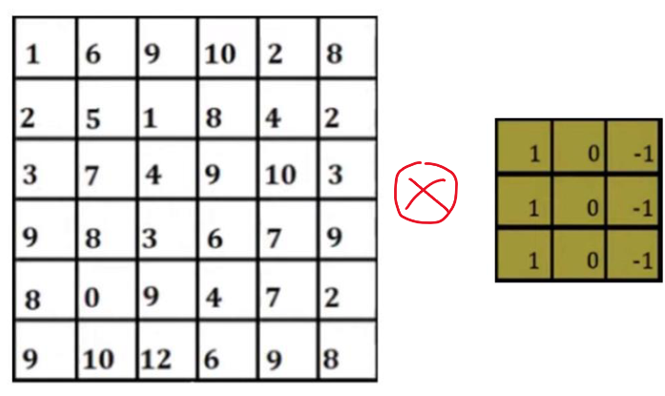
    - top left corner:
      * 0*1 = 0, 0*0 = 0, 0*-1 = 0
      * 0*1 = 0, 1*0 = 0, 6*-1 = -6
      * 0*1 = 0, 2*0 = 0, 5*-1 = -5
      * value = -6 + -5 = -11
    - 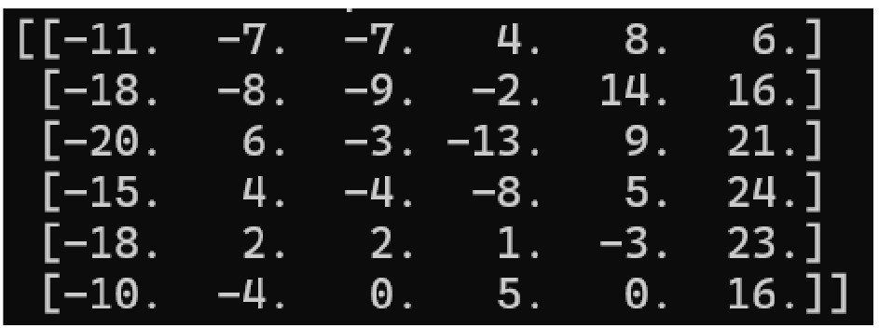
  + Input: 7*7*1, stride=2, zero padding=2, kernel is 5*5, what is the output?
    - output: 4x4 map
  + purpose of convolutional kernel is to reduce dimensions
  + high cost value of dataset means it didnt learn well
    - EX: LOSS = 100
    - to make this better, modify parameters of kernel
  + kernel size and padding is chosen beforehand, called hyperparameters
    - how do we initially decide on the hyperparameters?
      * its a process of fine tuning the neural network
      * ex: initial 5x5 kernel, if not good try 4x4, etc.
  + 3D image and kernel, EX: RGB image
    - sum the outputs across all the channels to obtain the final output at each position
    - if the image and kernel create multiple Z axis maps instead of only 1…
      * need to use 3D convolution
    - padding zeroes pads ONLY THE X AND Y AXES, not the Z axis normally
    - 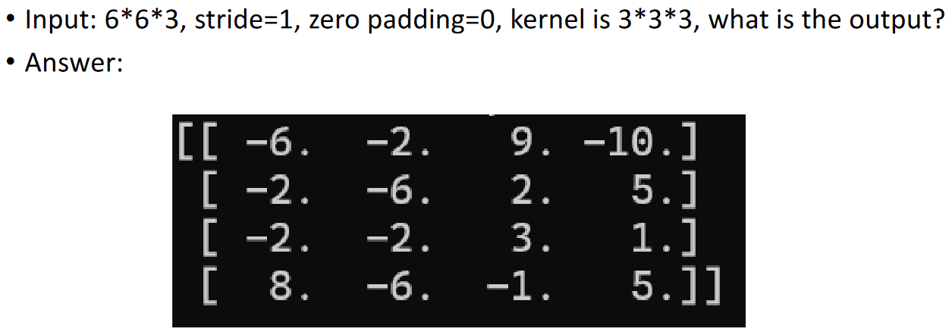
    - 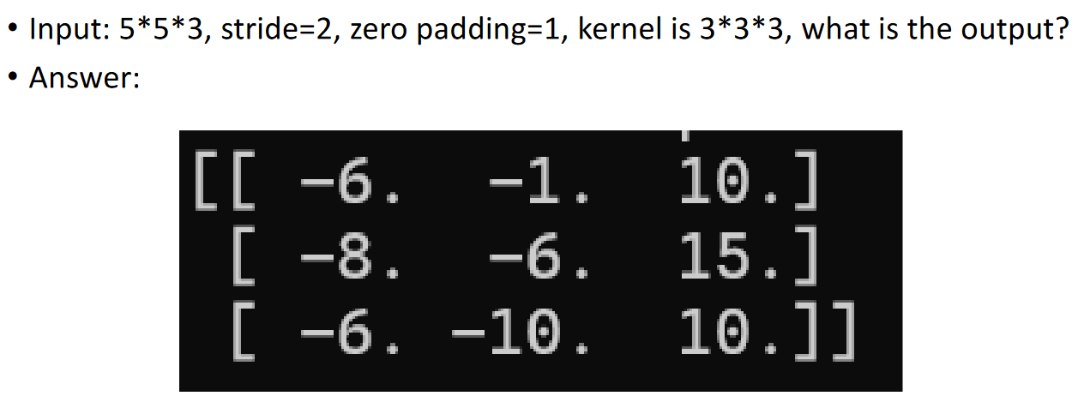
  + What happens if we have a kernel that doesnt have the same value for all the dimensions
    - doesnt matter, thats totally possible, just like all 2D images and kernels have only 1 value for the Z axis

##### convolutional layer

* + applies a series of kernels to the input it receives, then add a bias and apply an activation function
  + the purpose of convolutional layers is to extract features
    - convolution operation with multiple kernels
    - perform activation function
  + THE OUTPUT OF THE LAYER WILL HAVE THE SAME NUMBER OF CHANNELS AS THE NUMBER OF FILTERS IN THE LAYER
  + convolutional layer uses multiple filters
  + 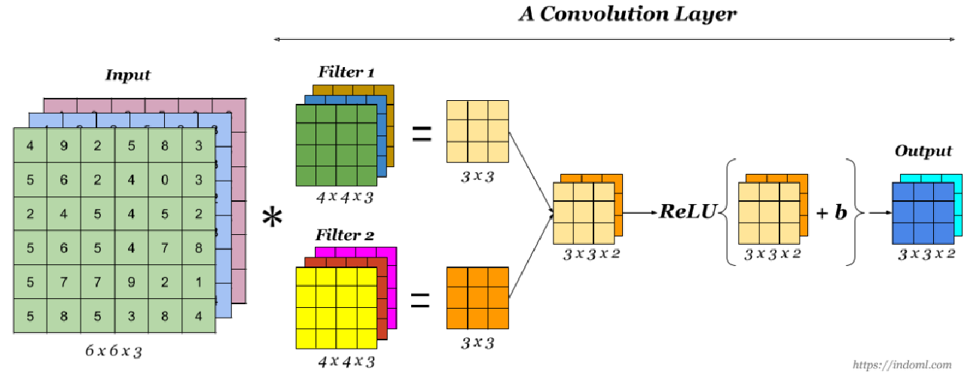
  + multiple filters create multiple features
    - EX: stacking SOBEL and Harris

###### activation function:

* + - mathematical operation applied to each feature map, transforming the linear inputs from the previous layer into nonlinear outputs
    - if you want to use a linear model, it cant match features well
    - this introduces non-lineariarity
    - squiggly graph line instead of straight linear line (x and y 2d graph)
    - non-lnearity allows neural network to learn and model complex patterns, going beyond simple linear relationships
    - common types of activation function:
      * Sigmold
      * softmax
      * ReLU
    - we prefer ReLU in convolutional layers
      * ReLU (x) = max(x,0)
    - b in the diagram stands for bias
  + Summary:
    - input size of W1 * H1 * D1
    - four parameters
      * number of kernels, K
      * kernel size, F*F
      * stride, S
      * amount of zero padding, P
    - output dimension
      * W2 = ((W1 - F + 2P) / S) + 1
      * H2 = ((H1 - F + 2P) / S) + 1
      * D2 = K
    - number of parameters in layer
      * (F*F*D1 + 1) parameters per kernel
        + + 1 is for the bias, always 1
      * (F*F*D1 + 1) * K total parameters
  + example:
    - input 32*32*3, 10 5*5 kernels with stride 1, zero pad 2
    - what is the size of the output feature map?
      * W2 = ((W1 - F + 2P) / S) + 1
        + = ((32 - 5 + 2*2) / 1) + 1 = (31 / 1) + 1
        + = 32
      * H2 = (H1 - F + 2P) / S + 1
        + = ((32 - 5 + 2*2) / 1) + 1
        + = 32
      * D2 = K
        + = 10
      * size of output feature map: 32*32*10
    - number of parameters in this layer?
      * (F*F*D1 + 1) * K
      * (5*5*3 + 1) * 10 = 76 * 10 = 760

##### pooling layer

* + purpose
    - reduce dimensions to calculate faster
    - improve computation of network
  + parameters
    - pooling filter size, P
    - stride, S
  + two types of pooling:
  + max pooling
    - divide the input image into a set of rectangles, each with a size of P*P
    - for each subregion, output the max value
    - 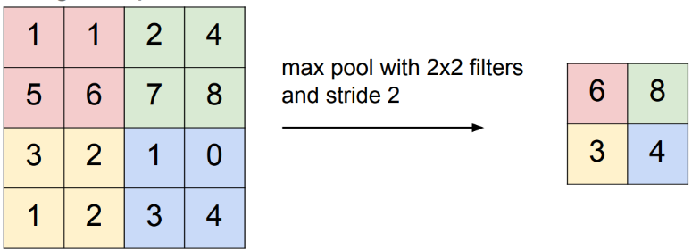
    - 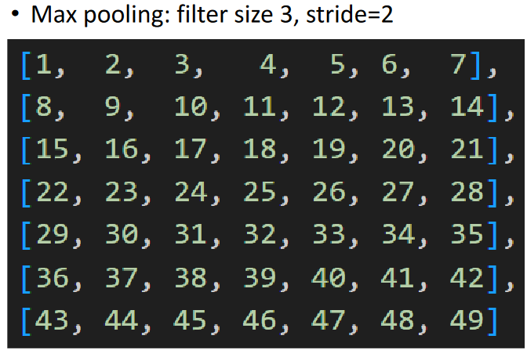 = 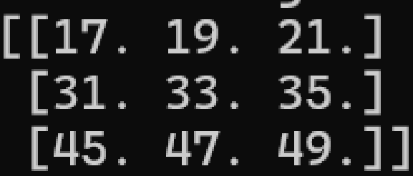
  + average pooling
    - divide the input image into a set of rectangles, each with a size of P*P
    - for each subregion, output the average value
    - 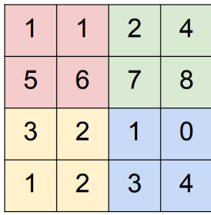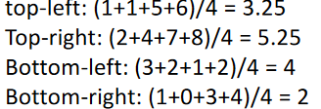
    - 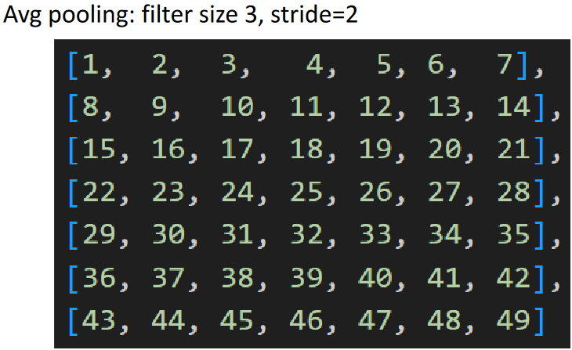 = 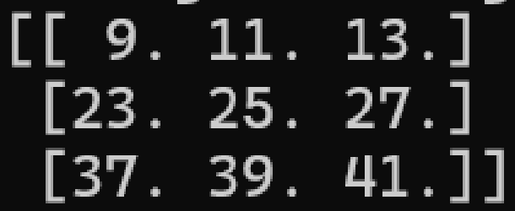
  + Summary:
    - for pooling layer, we reduce dimensions by only keeping the most important features and discarding the rest
      * EX: keep tree in image, discard background
    - introduce translation invariance
      * EX: tree moved in image, but as long as tree is in the same subregion, the tree will always be kept in the image and the background will always be discarded
    - input size W1*H1*D1
    - two parameters
      * pooling filter size, P
      * stride, S
    - output dimension
      * W2 = ((W1 - P) / S) + 1
      * H2 = ((H1 - P) / S) + 1
      * D2 = D1
    - introduce zero parameters since it computes a fixed function of the input
      * during training, dont need to train for pooling layer, but do need to train for convolutional layer
      * pooling layer has no parameters
    - it is not common to use zero padding for pooling layers
  + example:
    - input 7*7*1, P = 3, S = 2
    - pooling layer:
    - W2 = ((7 - 3) / 2) + 1 = 2 + 1 = 3
    - H2 = ((7 - 3) / 2) + 1 = 3
    - D2 = 1
    - output: 3*3*1

##### fully connected layer

* + last part of CNN
  + purpose:
    - make sense of features extracted by convolutional and pooling layers
    - map spatially and abstractly represented features into the final output patterns
    - output depends on the problem
  + input = 1*n vector
  + components = multiple neurons
  + operation:
    - y = f(Wx+b)
      * W =weights
      * b = bias
      * x = input
      * f = activation
  + output: depends on the problem
    - classification → possibility for each category
    - regression → value

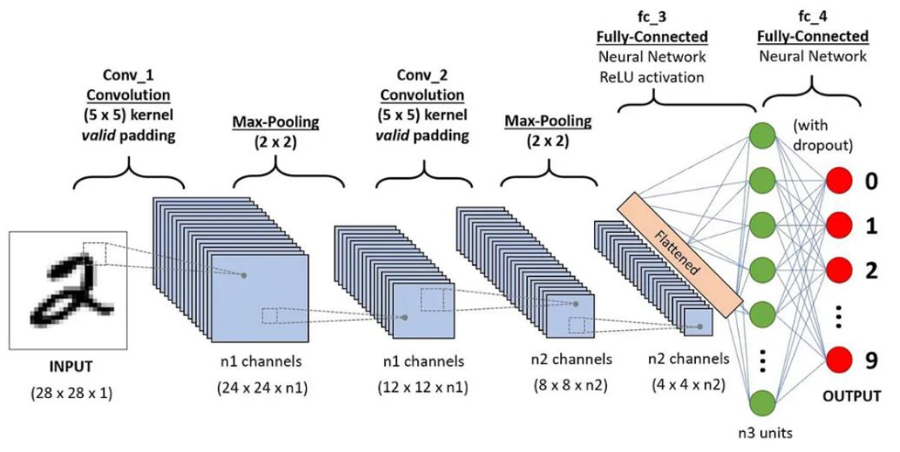

* + flattening the matrix:
    - 4*4 matrix → 16*1 vector (16 long, 1 tall)
    - repeat the process for n2 number of channels by appending each channel to the end of the vector, getting a (n2*16)*1 vector
  + calculating fully connected layer:
    - for each neuron, we need to deal with every input
    - 9 inputs means 9 weights
    - we chose 4 neurons to be the output (weights matrix number of columns), arbitrarily, because it is based on whatever you design it to be

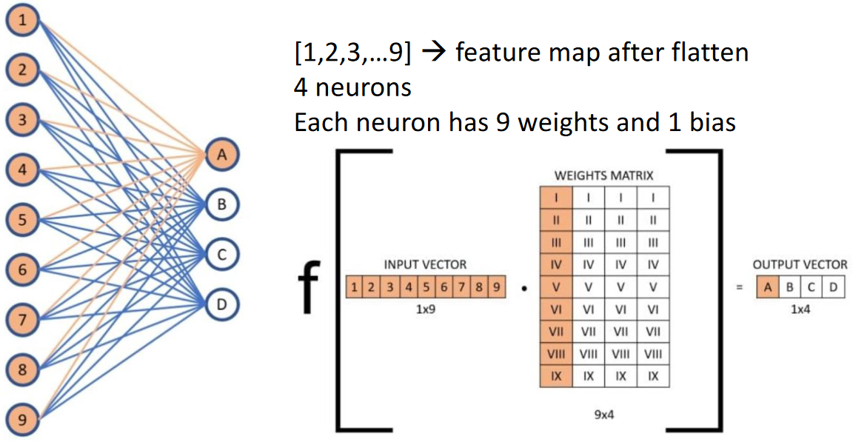

* + fully connected layer is a neep neural network (DNN)
  + example: calculate output vector (do not consider activation function)

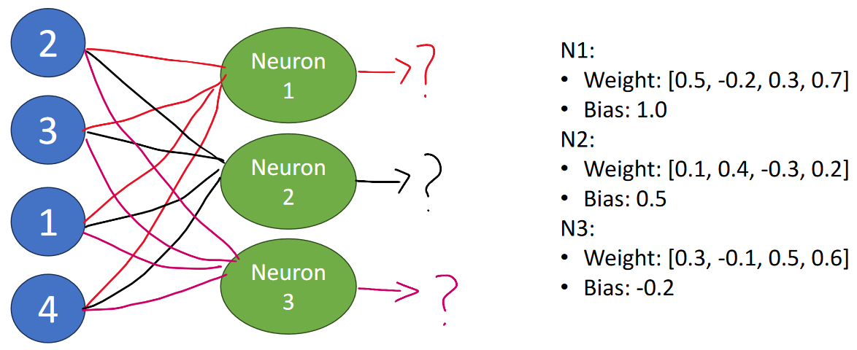

* + - N1 = (2*0.5 + 3*-0.2 + 1*0.3 + 4*0.7) + 1.0
      * (1 - 0.6 + 0.3 + 2.8) + 1.0
      * 3.5 + 1.0
      * 4.5
    - N2 = 2.4
    - N3 = 3.0
  + example: 2 fully connected layers, calculate output vector (do not consider activation function)

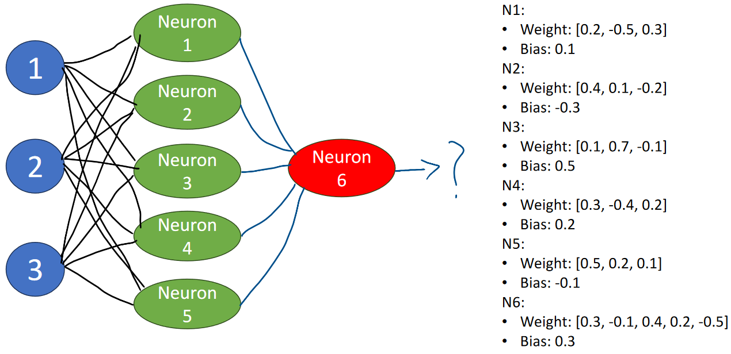

* + - N1 = (1*0.2 + 2*-0.5 + 3*0.3) + 0.1
      * 0.2 - 1 + 0.9 + 0.1
      * 0.2
    - N2 = -0.3, N3 = 1.7, N4 = 0.3, N5 = 1.1
    - N6 = 0.58
  + another image of fully connected layer implementation:

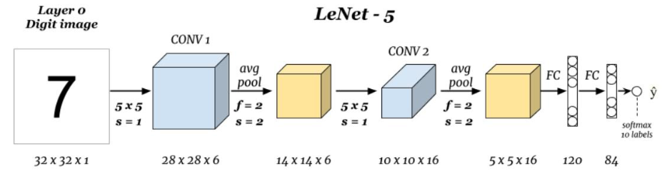

* + convolutional layer purpose is to extract features
  + pooling layer purpose is to reduce dimensions

##### loss function

* + loss function = cost function
    - quantifies differences between predicted values by the model and actual target values from training data
    - lower loss value = good performance
    - goal of training is to minimize the loss value
  + loss function: L(y, ^𝑦, 𝜃)
    - y = labels
      * fixed, decided before the training
    - ^y = prediction
      * if we have a better prediction, lower loss value
      * prediction = results
    - 𝜃 = weights
      * adjust this to reduce the loss value
      * source to make the modifications
  + for each point, calculate gradient for all directions. find sharpest gradient to reduce loss value.
  + calculate gradient for all directions, find most significant gradient, take that direction to reduce the loss value the most
  + 1. back propagation
    - the process of how to calculate the gradient for all the directions and select the most significant direction
  + 2. gradient descent
    - describes how to adjust the parameters along the previous direction to reduce loss value
  + types of loss functions
    - MSE (mean squared error)
      * 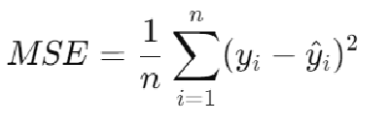
    - BCE (binary cross-entropy)
      * 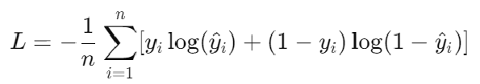
    - CE (categorical cross-entropy)
      * 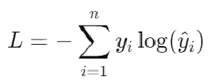
    - other loss functions also exist, can design your own loss function to address the requirements of your specific problem
  + gradient vanishing
    - L = y - ^𝑦
    - cannot find the desired direction because the derivative of the function is a constant
  + binary classification = only two outputs (0 or 1)
    - one image corresponds to only 2 categories
  + multi-class classification = more than 2 categories
    - one image corresponds to many categories
  + multi-label classification = more than 1 label per image
    - ex: tree and house
* 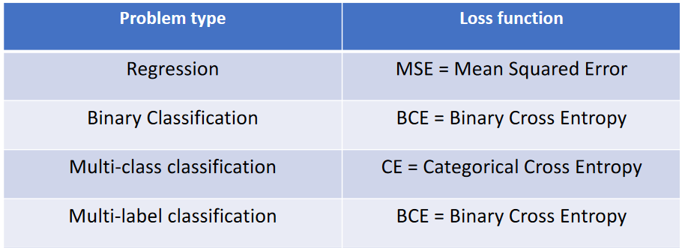
  + ex: face detection
    - if same person, true. if different person, false.
    - binary classification
  + ex: written number detection
    - 0,1,2,3,4,5,6,7,8,9
    - multi-class classification
* two type of parameters for neural networks
  + model parameters
    - learned during training
  + hyperparameters
    - set based on systematic experimentation and used to control the learning process
    - configuration that is external to the model and whose value cannot be estimated from data
    - set before starting the training process
    - like a Constant value in java
      * have to restart the training process if you want to change these values
* common hyperparameters
  + epoch
    - number of times the learning algorithm will work through the entire dataset
    - how many times you read a textbook
    - 50, 100, 200…
  + batch size
    - the number of training examples utilized in one iteration
    - how many pages learned at one time
    - 8, 16, 32, 64…
  + learning rate
    - determines convergence speed
    - graph: y = prediction accuracy, x = epoch
    - straight line = label
    - curve under straight line = prediction correctness with training
    - first epoch, prediction is not very good
    - larger learning rate = faster prediction correctness
      * faster, but worse performance
    - smaller learning rate = more gradual learning
      * slower, but better performance
    - the extent to which you adjust the overall understanding based on what you read in those pages
    - 0.01, 0.001…

#### What do we use to train a CNN?

* + 1. convolutional layer
    - kernel parameters + bias
  + 2. pooling layer
    - no
  + 3. activation function
    - no
  + 4. loss function
    - no
  + 5. fully connected layer
    - neuron weights + bias
* Case Study
  + LeNet-5
    - calculate dimensions of the feature maps (no zero padding)
* 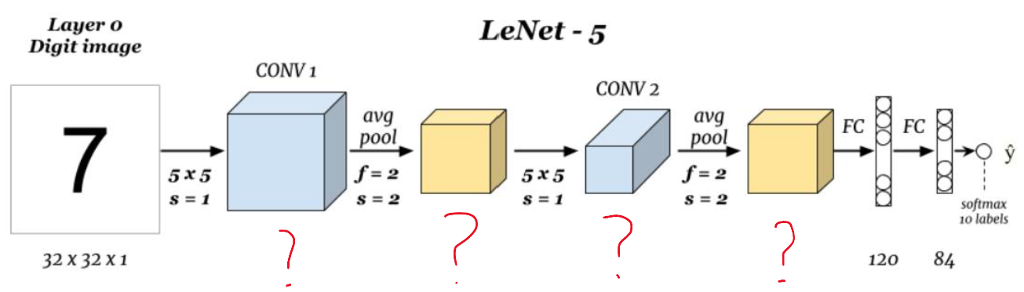
  + conv 1 output:
    - 32x32x1, stride = 1, zero pad = 0, 6 kernels (told in class)
    - W2 = ((W1 - F + 2P) / S) + 1
      * = ((32 - 5 + 2*0) / 1) + 1 = (27 / 1) + 1
      * = 28
    - H2 = (H1 - F + 2P) / S + 1
      * = ((32 - 5 + 2*0) / 1) + 1
      * = 28
    - D2 = K
      * = 6
    - size of output feature map: 28*28*6
  + avg pool 1 output:
    - 28x28x6, stride = 2, ???
    - output: 14x14x6
  + etc.
  + flatten 5x5x16 → several neurons
    - calc weights, multiply by features, generate results
  + last layer is softmax as activation function

#### softmax = activation function

* + used as the final activation function for multiclass classification
  + converts vector of raw class scores into probability distribution
  + each output value of softmax function is in range (0,1) and sum of all output values equals 1
  + ex:
    - in above example LeNet-5 example, 10 categories
    - cat 1 = 1 weight
    - cat 2 = 100 weight
    - cat 3 = 1 weight
    - cat 4 = 100 weight
    - etc.
    - then normalize these

#### CNN pipelines

* 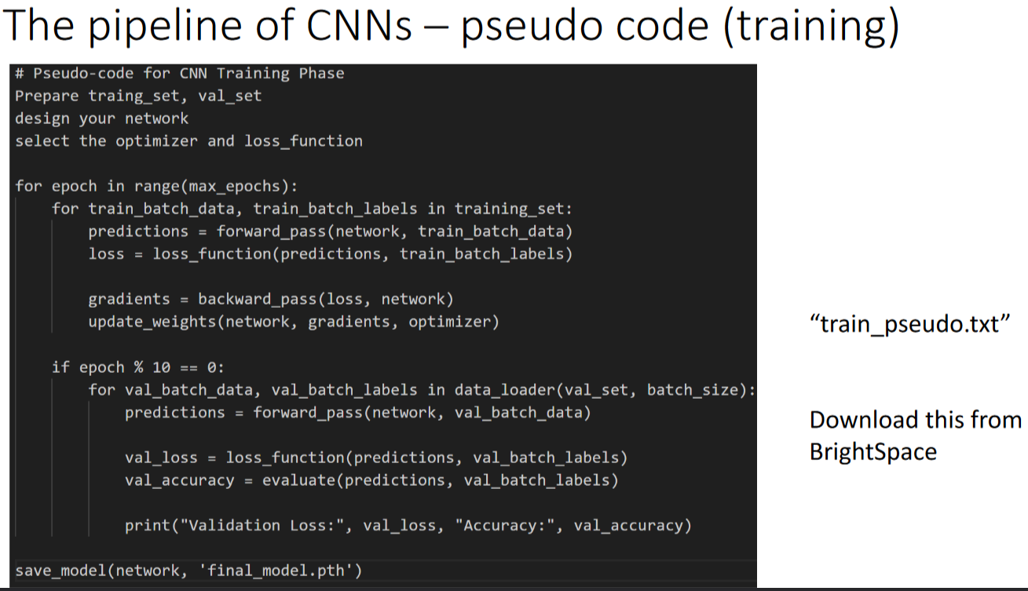
* training phase:
  + prepare the data
    - splitting the training set, validation set and test set
  + model setup
    - optimizer describes how to reduce loss value along sharpest directions
    - choose loss function, select optimize (SDG, Adam, …) which determines how to update the models parameters
    - determine metrics
      * how to evaluate the model (accuracy)
  + training loop
    - nested loop structure
    - outer loop (epochs)
      * how many times to learn the data
    - inner loop (batches)
      * how many pages to learn at one time
      * steps:
      * forward process
        + process data to generate prediction
      * calculate loss
        + compare predictions with labels to calculate loss value
      * back propagation
        + adjusts model parameters to reduce loss value in the future
        + gradient descent
* 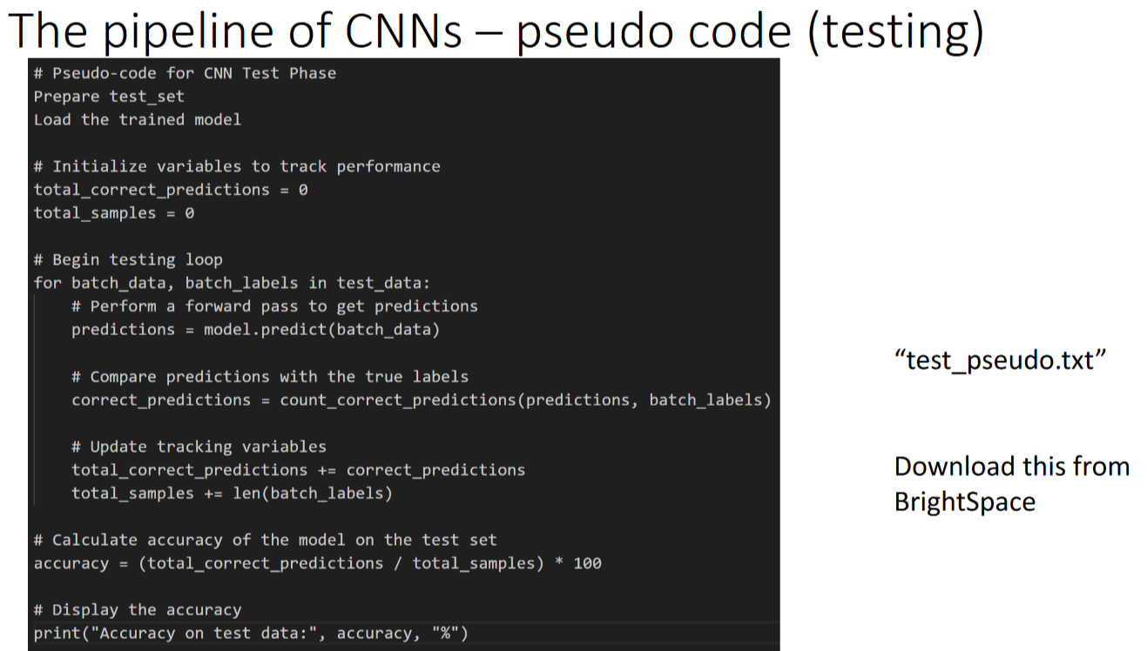
* testing phase
  + testing loop
    - initialize metrics
      * setup counters or variables to track performance metrics such as accuracy
  + iterate through batches
    - for each batch steps:
    - 1. forward pass
      * process the batch to obtain predictions
    - 2. calculate metrics
      * compare predictions with labels to calculate accuracy or other relevant performance metrics
    - 3. aggregate results
      * update overall evaluation metrics based on the batch results
* summary:
  + 1. prepare the dataset
  + 2. design the model
  + 3. select the loss function and optimizer
  + 4. training phase
  + 5. test phase

##### batch normalization

* + ok

### Week 9 P2:

#### CNN Programming

* prepare dataset
* design model
* select loss function and optimizer
* training phase
* testing phase
* if you think model performs well enough, save parameters
  + otherwise revise hyperparamters

#### prepare datasets -- DataLoader

* recommended to use pytorch
  + use “DataLoader”
  + for other deep learning frameworks
    - tf.data.Dataset for TensorFlow
    - ImageDataGenerator for Keras
* What is DataLoader
  + streamlines and magages the process of feeding data into your neural network
  + part of torch.utils.data module
    - so need to include header file
  + handle loading and preparing large amounts of data efficiently without needing to write repetitive code
* why we need DataLoader
  + batching
    - automatically gather data into batches
  + shuffling
    - mixing up data, vital for training neural networks to prevent model from learning order of the data
  + provides built-in classes for common datasets
    - CIFAR-10, MNIST
  + easily create custom classes for custom datasets by inheriting from torch.utils.data.Dataset
    - ex: KITTI*, LFW*, Iris image, Fruit classification
      * * = implement custom class bc provided class has limited flexibility
* DataLoader built-in clases for common datasets
  + • Image dataset:
    - • <https://pytorch.org/vision/stable/datasets.html>
  + • Text dataset:
    - • <https://pytorch.org/text/stable/datasets.html>
  + • Audio dataset:
    - • <https://pytorch.org/audio/stable/datasets.html>
* how to use build-in classes for common datasets
  + import required libraries

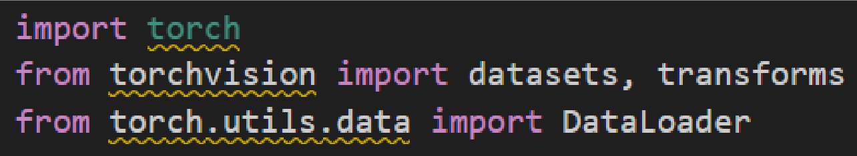

* define transformations
  + <https://pytorch.org/vision/0.15/transforms.html>
  + preprocess data
  + convert to tensor format
  + normalizing
    - helps dataset by inserting rotations and stuff

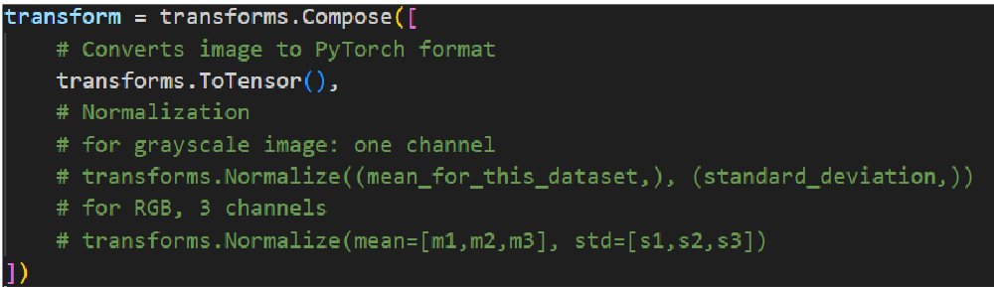

* load the dataset
* Use the “datasets.CLASS_NAME” class to download and load the dataset.
  + • CLASS_NAME: <https://pytorch.org/vision/stable/datasets.html>

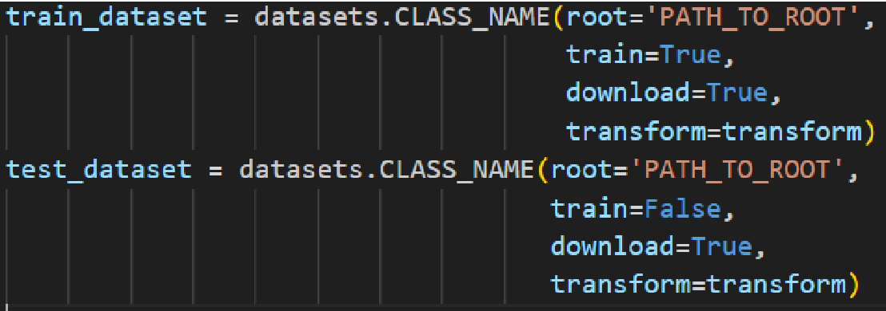

* create DataLoader
  + wrap dataset with a DataLoader that provides batches of images and correspodinging labels, can shuffle the data
* batch size specifies how many pages in a book to learn at once
* shuffle disorders images

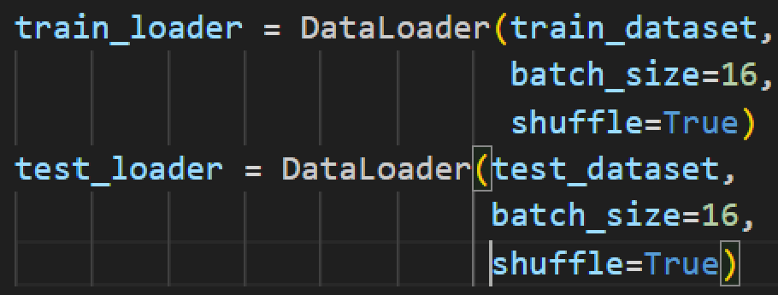

* iterate through the dataloader
* forward training and backwards training
* enumerate generates ID for each item
* I = image
* L = label
* 1_1 = batch 1, ID 1
* () = batch (1, 2, ...)
* [([I1_1, I1_2, ... I1_b],
* [L1_1, L1_2, ... L1_b]),
* ([I2_1, I2_2, ... I2_b],
* [L2_1, L2_2, ... L2_b]),
* ...]

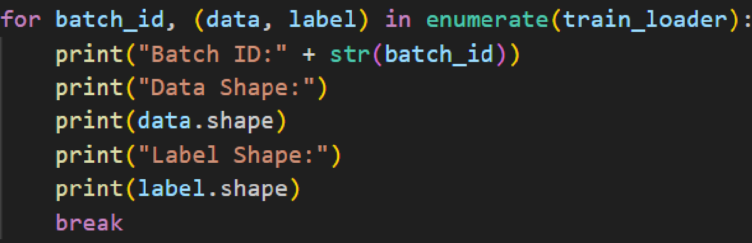

* write DataLoader for MNIST dataset

(look at W0901 and W0902)

import torch

from torchvision import datasets, transforms

from torch.utils.data import DataLoader

transform = transforms.Compose([

transforms.Resize(28),

transforms.ToTensor(),

#google the normalization for the dataset

#dataset mean value and standardization

transforms.Normalize((0.1307,), (0.3081,))

])

#if dont know dataset name, google it

#specifcy parameters

#if used pytorch to download dataset, use following

#dont want to download dataset oursevles, so pytorch will do it automatically (download = True)

train_dataset = datasets.MNIST(root='/data',train=True,download=True,transform=transform)

#implement DataLoader

#first parameter is dataset class

#next is batch size, up to you (hyperparameter)

#shuffle (disorder images)

train_dataloader = DataLoader(train_dataset, batch_size=8, shuffle=True)

#use DataLoader to train or do something

#printing shape of each batch, so not doing forward or backwards

#first is image list, 2nd is labels list

for images, labels in train_dataloader:

print(images.shape)

etc...

#data shape:

16 = batch size

16 images for each batch

1 = channels

grayscale image

32, 32

32x32 image resize

#label shape:

16 = label size

16 labels for each batch

#### Custom DataLoader

* open image and save image as an array

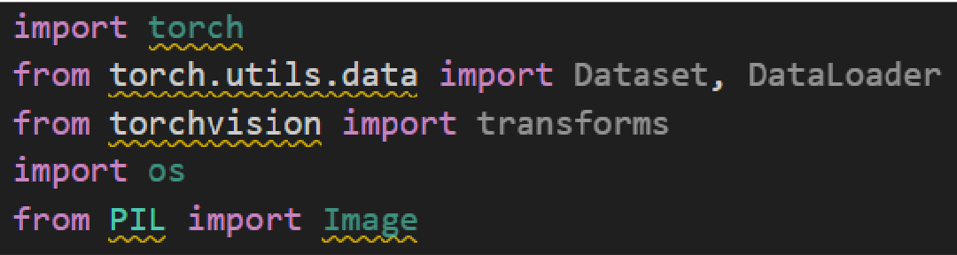

* create class that inherits from torch.utils.data.Dataset
* implement constructor / initialization method
  + define and intialzize any necessary parameters that dataset needs to function correctly
    - paths to data
    - transformation
    - splitting parameters (trianing, testing, validation)
  + override at least two methods
    - __len__ to return size of dataset
    - __getitem__() retrieve item and corresponding label at specific index

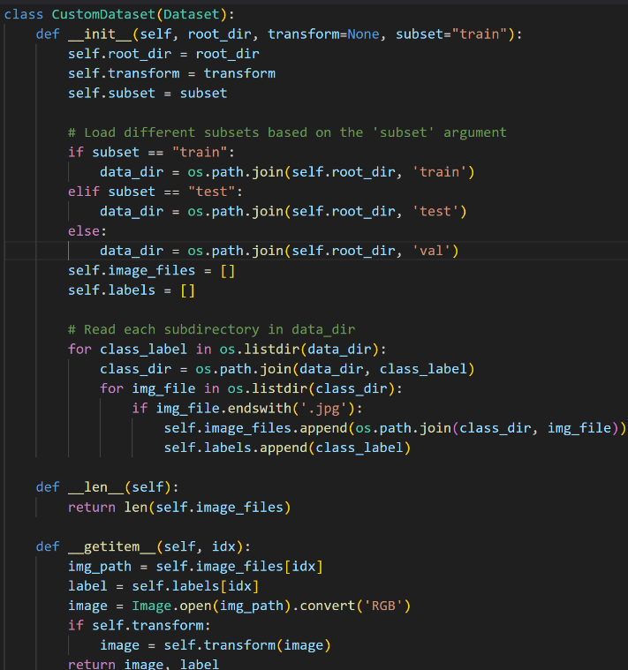

* os.path.join is path for training set, training set, validation set, etc.
* “read each subtrictory”
  + go through target folder
  + store parameters
    - self.image_files -- stores image paths
    - self.labels -- stores image labels
* override __len__
* override __getitem__
  + image path (just a string)
  + convert to RGB bc its a color image
  + apply transforms to image array
    - convert image array to tensor
    - normalization
    - resize
    - etc.
  + image is a tensor, pytorch can directly operate on image
* define transformations
  + similar to built-in dataset class
* instantiate dataset
  + create an instance of CustomDataset

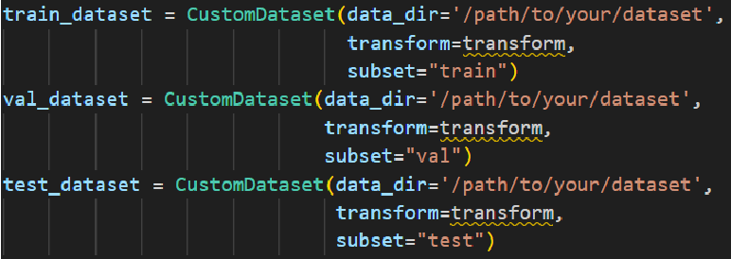

* create DataLoader
  + similar to build-in dataset class
* iterate over DataLoader
  + similar to built-in dataset class

EX: write DataLoader for Fruit dataset

W0901 -- Fruit_DL.py

if you cant search mean and std dev values from the internet, use ithe parameters from imagenet as a starting point (always the same, because its based on millions of images)

mean = [0.485, 0.456, 0.406] and std = [0.229, 0.224, 0.225]

if self.transform:

image = self.transform(image)

converts image array to tensor

label = class_name_id[self.labels[idx]]

uses a dictionary, need to convert class name to class ID

execution results:

Batch ID:0

Data Shape:

torch.Size([32, 3, 224, 224])

Label Shape:

32

<https://www.kaggle.com/datasets/utkarshsaxenadn/fruits-classification>

Write the Dataloader for LFW dataset.

W0901 -- LWF_DL.py

• <https://www.kaggle.com/datasets/atulanandjha/lfwpeople>

Write the Dataloader for KITTI 2015 dataset.

W0901 -- KITTI_DL.py

• <https://www.cvlibs.net/datasets/kitti/eval_scene_flow.php>

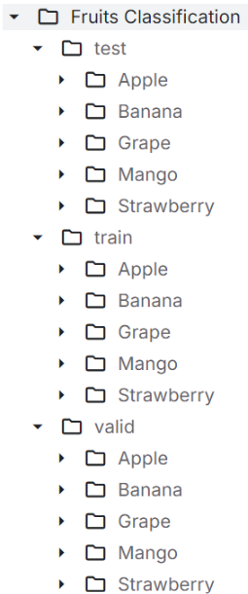

### Week 10 P1:

#### Implement the CNN

* convolutional layer



* activation functions

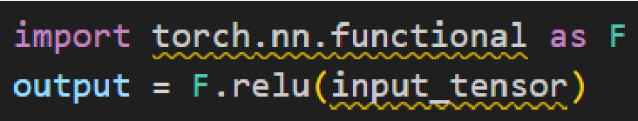

* pooling layers
  + no padding for pooling layer

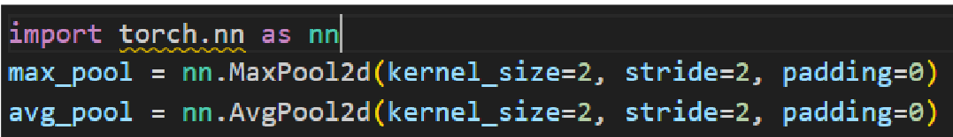

* fully connected layers

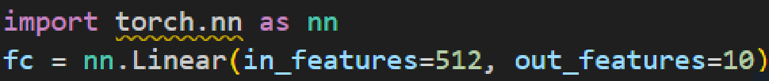

* to implement CNN model in PyTorch, need to encapsulate these components within a class
* CNN model is represented as a class
* our model is a subclass

##### implement CNN

* + 1. create a class by extending the “torch.nn.Module” class
  + 2. define the __init__ method
    - define all layers and components of CNN
    - define should be defined as class attributes
  + 3. define/override “forward” method
    - left to right
    - takes input tensor x and passes it through the layers youve defined, applying operations like activation function between these layers
    - assembly components, follow the orders
    - 1. convolutional layer
    - 2. max pooling
    - 3. convolutional layer
  + see: LeNet5.py
    - * + convolutional layers
    - self.conv1, 1 input channel = grayscale image
      * output channel = 6 bc 6 kernels
      * only 4 parameters bc default of zero padding (1) is used
    - self.conv2, output = 16 bc 16 kernels
      * + fully connected layers
    - self.fc1 = nn.Linear(16*5*5, 120)
      * 16*5*5 = input features, 120 = output features
    - forward method:
      * only write layers with learnable parameters in initialization method

##### select the loss function

* + identify the categories of problems
    - different problems need different loss functions
  + EX: classifying hand-written digits is an example of:
    - * binary, multi-class, or multi-label?
    - multi-class classification
    - 10 digits possible, only 1 label each
    - use categorical cross entropy loss function



##### select the optimizer

* + optimizer is used to update weights of a neural network based on gradients computer during backpropagation
  + different optimizer = different methods to update model parameters
  + just like tuning hyperparameters, experimenting with different optimizers is a key strategy in developing effective machine learning models
  + faster convergency doesnt guarantee better performance
    - faster means less details

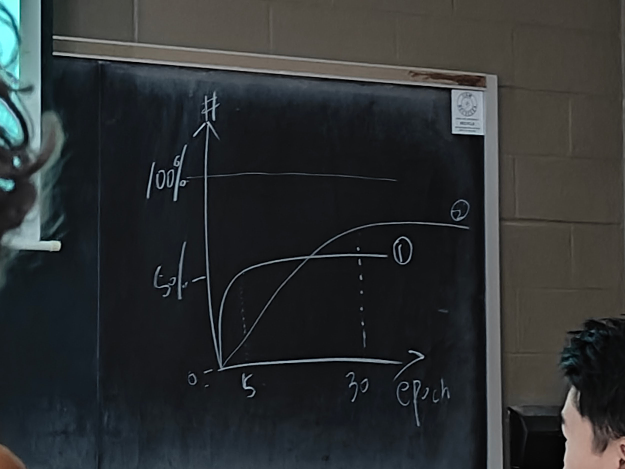

* + common optimizers in PyTorch:

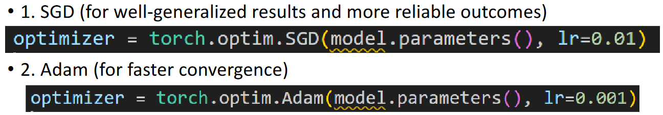

#### train the CNN model

* + switch model’s mode to “training”
  + follow train_pseudo.txt to write the code
    - nested loop
  + save model’s parameters
  + see: trainMNIST.py
  + STEPS:
    - 1. import model
    - 2. load data loaders
    - 3. initialize model
    - 4. loss and optimizer
    - 5. switch to train mode
    - nested for loop
      * run for 10 epoch
      * set variables to monitor performance
      * get data for each batch using dataloader
        + data = image, target = labels
        + simulate forward process

prediction

model() calls forward (simulate process from input to output)

* + - * + simulate backward process

gradient and weights

calc gradient for all directions and select sharpest gradients

* + - * + parse predicted value

predicted for labels

count how many correct and wrong predictions

record accuracy

* + - * print current epoch, avg loss, and accuracy
        + used to monitor performance of model
    - validation step
      * used to validate model for every X number of epochs
      * model.eval() bc want to only know forward, dont want back propagation or update weights, just want to know the prediction
      * if model is accurate enough, save for future use
        + torch.save(model, desired system path for saved model)
      * for validation part, it is flexible
        + no strict rules
        + can reuse the test dataloader for the validation
        + only thing to keep in mind is cannot mix test image into training phase
        + can use test dataloader for validation, but cant use it for training

#### test the CNN model

* 1. load model from static dictionary
  + if model parameters were saved, you can load it here
* 2. switch model mode to ‘evaluation’
* 3. follow test_pseudo.txt to write testing phase
  + testMNIST.py
  + 1. imports, initilize
  + 2. path to saved model
  + 3. load saved model
  + 4. switch to eval mode
  + 5. same loss function
  + 6. clean gradient
    - no back propagation
    - dont need gradient information bc of that
    - in the loop body, only need to do forward process bc dont want to update weights
  + 7. print loss and accuracy to console

EXAMPLE CASE STUDY:

Dataset:

• <https://www.kaggle.com/datasets/jeffheaton/iris-computer-vision>

iris_CNN.py

* when you download dataset, there are 3 subfolders
* each subfolder stands for a category
* if you want to write code to train CNN to train or test, you need to implement the dataloader
* for loop for every subfolder
  + cls is name of subfolder, class name
  + idx is index of subfolder
    - used as a numeric label to train CNN
    - if there is a data imbalance (aka more images for one label or class than the others) then can limit how many images should be used
* getitem fnx:
  + get file
  + convert to RGB
  + get labels
  + apply transform for normalization
  + return image and label
* design CNN fxn:
  + conv2c, fc layers
* forward fxn
  + conv1, maxpool, conv2, maxpool, fc1, fc2, fc3
    - self.conv1(x)
    - F.relu(x)
    - F.max_pool2d(x,2,2)
    - self.conv2(x)
    - F.relu(x)
    - F.max_pool2d(x,2,2)
    - x.view(-1,32*64*64)
      * flattens to 1x
      * provided by PyTorch
      * -1 lets PyTorch detect how many rows there are instead of needing to specify the correct amount
      * if we did 16*64*64, PyTorch would reshape the output vector to have 2 rows instead of 1
    - self.fc1(x)
    - F.relu(x)
    - self.fc2(x)
    - F.relu(x)
    - self.fc3(x)
      * dont apply relu to last layer
      * multiclass uses softmax to convert score to probability
      * but in this case we only want max value for each category so not using a softmax activation function
* transform fxn
  + .Resize((256,256))
  + .ToTensor()
  + .Normalizae(mean=[X,X,X], std=[X,X,X])
    - if cant find values online, use ImageNet standard values
    - [0.485,0.456,0.406], [0.229, 0.224, 0.225]
* DataLoader batch_size is a hyperparameter and can be changed to whatever you want
* SGD is slower but more accurate, ADAM is faster but less accurate
* loss = criterion(outputs, labels)
  + compares output labels to ground truths
* after we get prediction, loss.backward() is back propagation, gradients for all the directions
  + 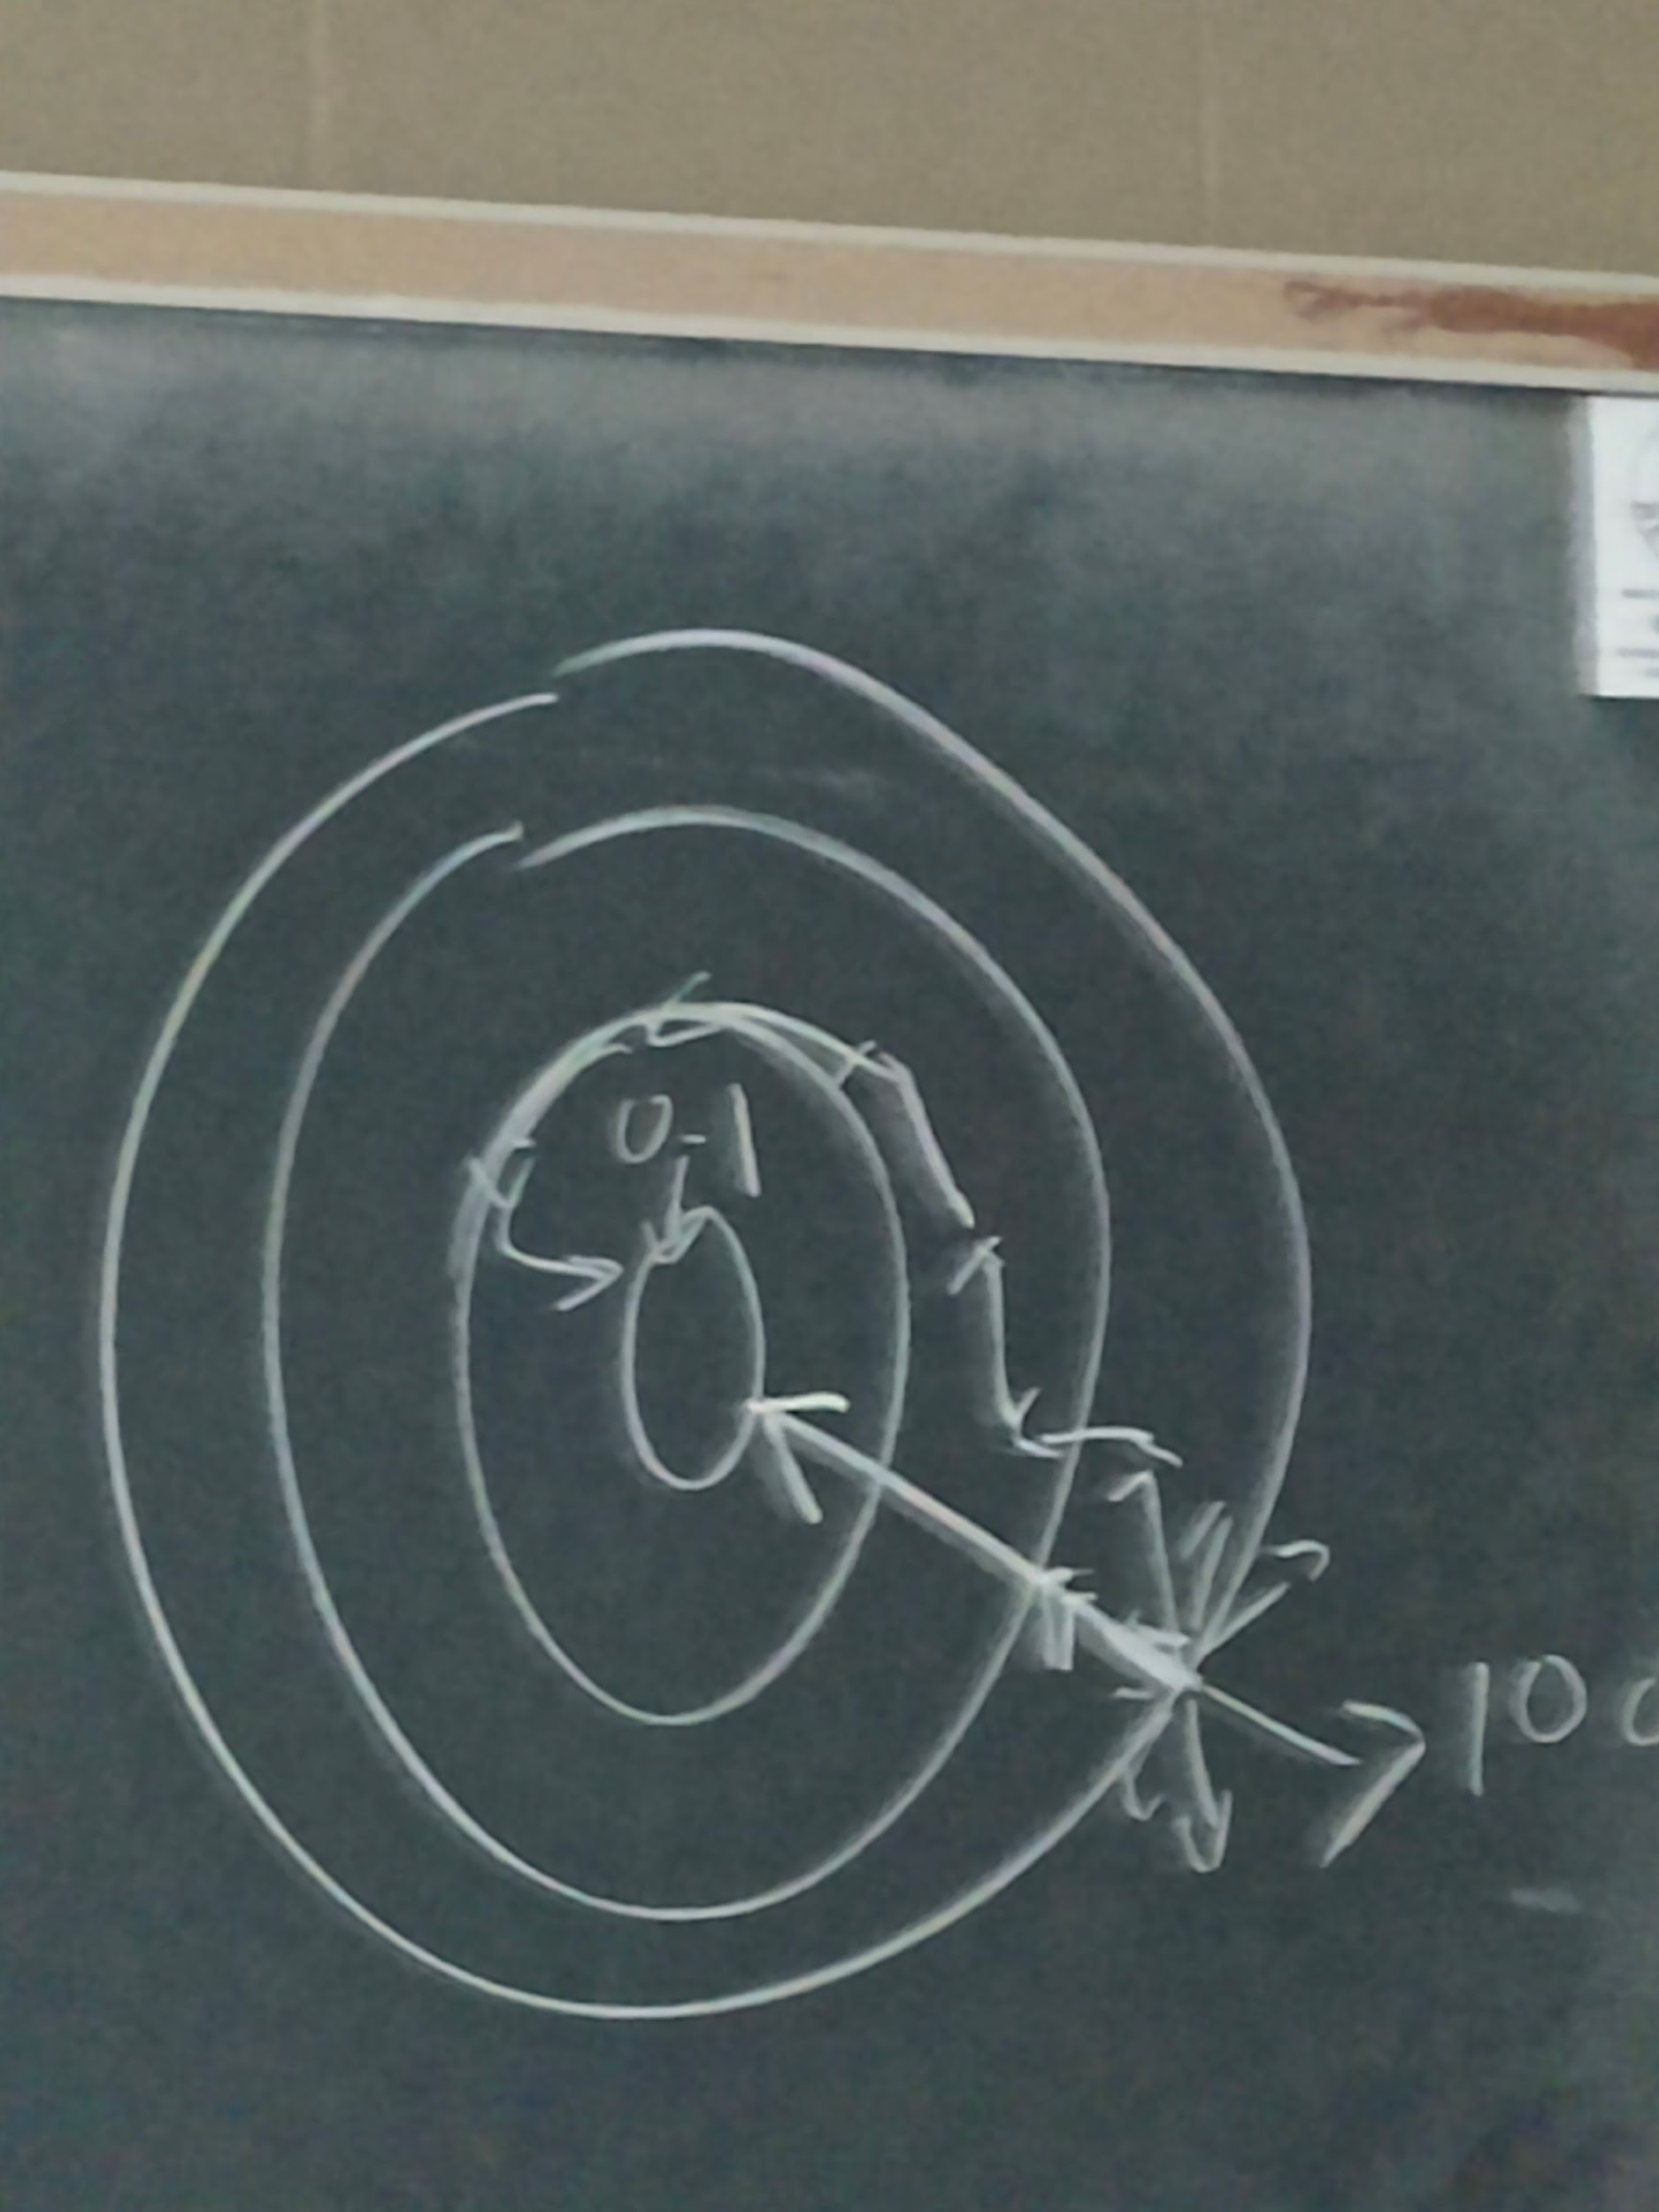
* optimizer.step() updates parameters
* for evaluation, we only want forward process, not backward process or optimizer because we dont want to update the weights

### Week 10 P2:

#### neural network depth

* do deeper neural networks offer better performance?
  + the CNN can extract more features the deeper it becomes
  + deeper by abstraction
  + but if we become too deep we lose information
    - each CNN extracts feature 1 time
    - if we use 100 CNNs, the feature may be modified
    - left = tree, right = house
      * after many convolutional layers, may be abstracted
      * abstract output = T & H
      * this is a loss of information
  + 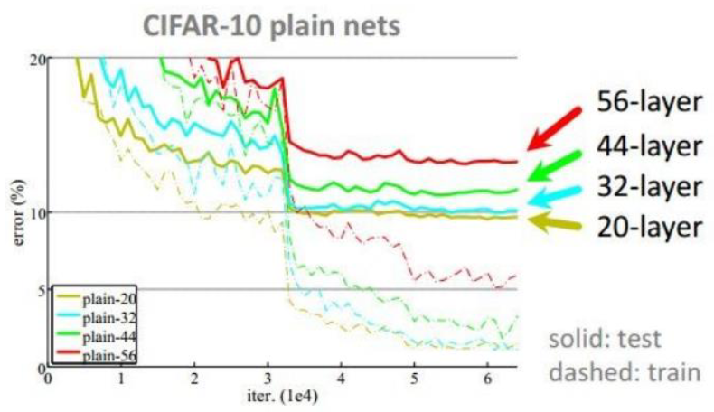
    - deeper CNN may yield worse performance
  + conclusion from 8-9 years ago:
    - within a certain range, increasing the depth of neural network can improve performance
    - but beyond a certain point, further depth can lead to worse performance
* reasons why deeper networks may yield worse performance:
  + 1. information loss during forward process
    - extract features too many times
  + 2. vanishing gradients problem
    - gradient vanish = gradients become very small
    - if all the gradient directions are the same, the network doesnt know how to update the weights
    - gradients tell us how to adjust learnable parameters
    - gradient vanish → parameter updates become minimal → learning process slows down significantly

#### ResNet case study

* 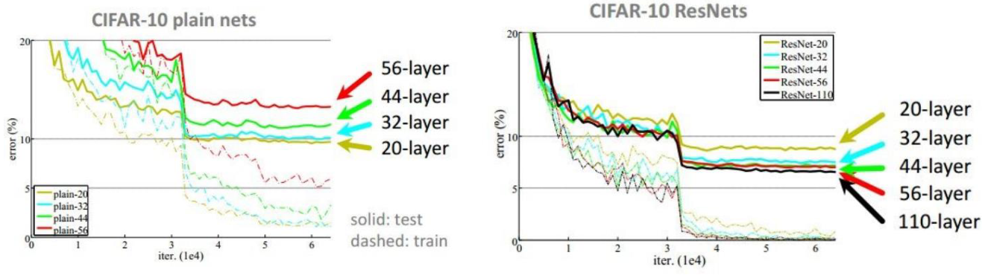
* for ResNet, the deeper neural networks have better performance than shallow neural networks
* traditional neural networks may yield worse performance, but deeper ResNet may yield better performance
  + make neural network deeper to extract more abstract features
  + meanwhile, ensure model does not lose essential information
* ResNet uses:
  + Skip connection
  + batch normalization
  + bottleneck

#### skip connection

* + also called residual connection
  + 1. why do we need deeper networks?
    - 1. more capable of learning complex patterns
      * for each convolutional layer, we can extract features
      * more conv layers, creates hierarchy of features from low level to high level feature
        + age = low level
        + object = high level
    - 2. deeper NN can apply activation functions more to introduce more non-linearity
      * if model is linear, cant match datapoints well
      * to match datapoints well, need nonlinear model
      * 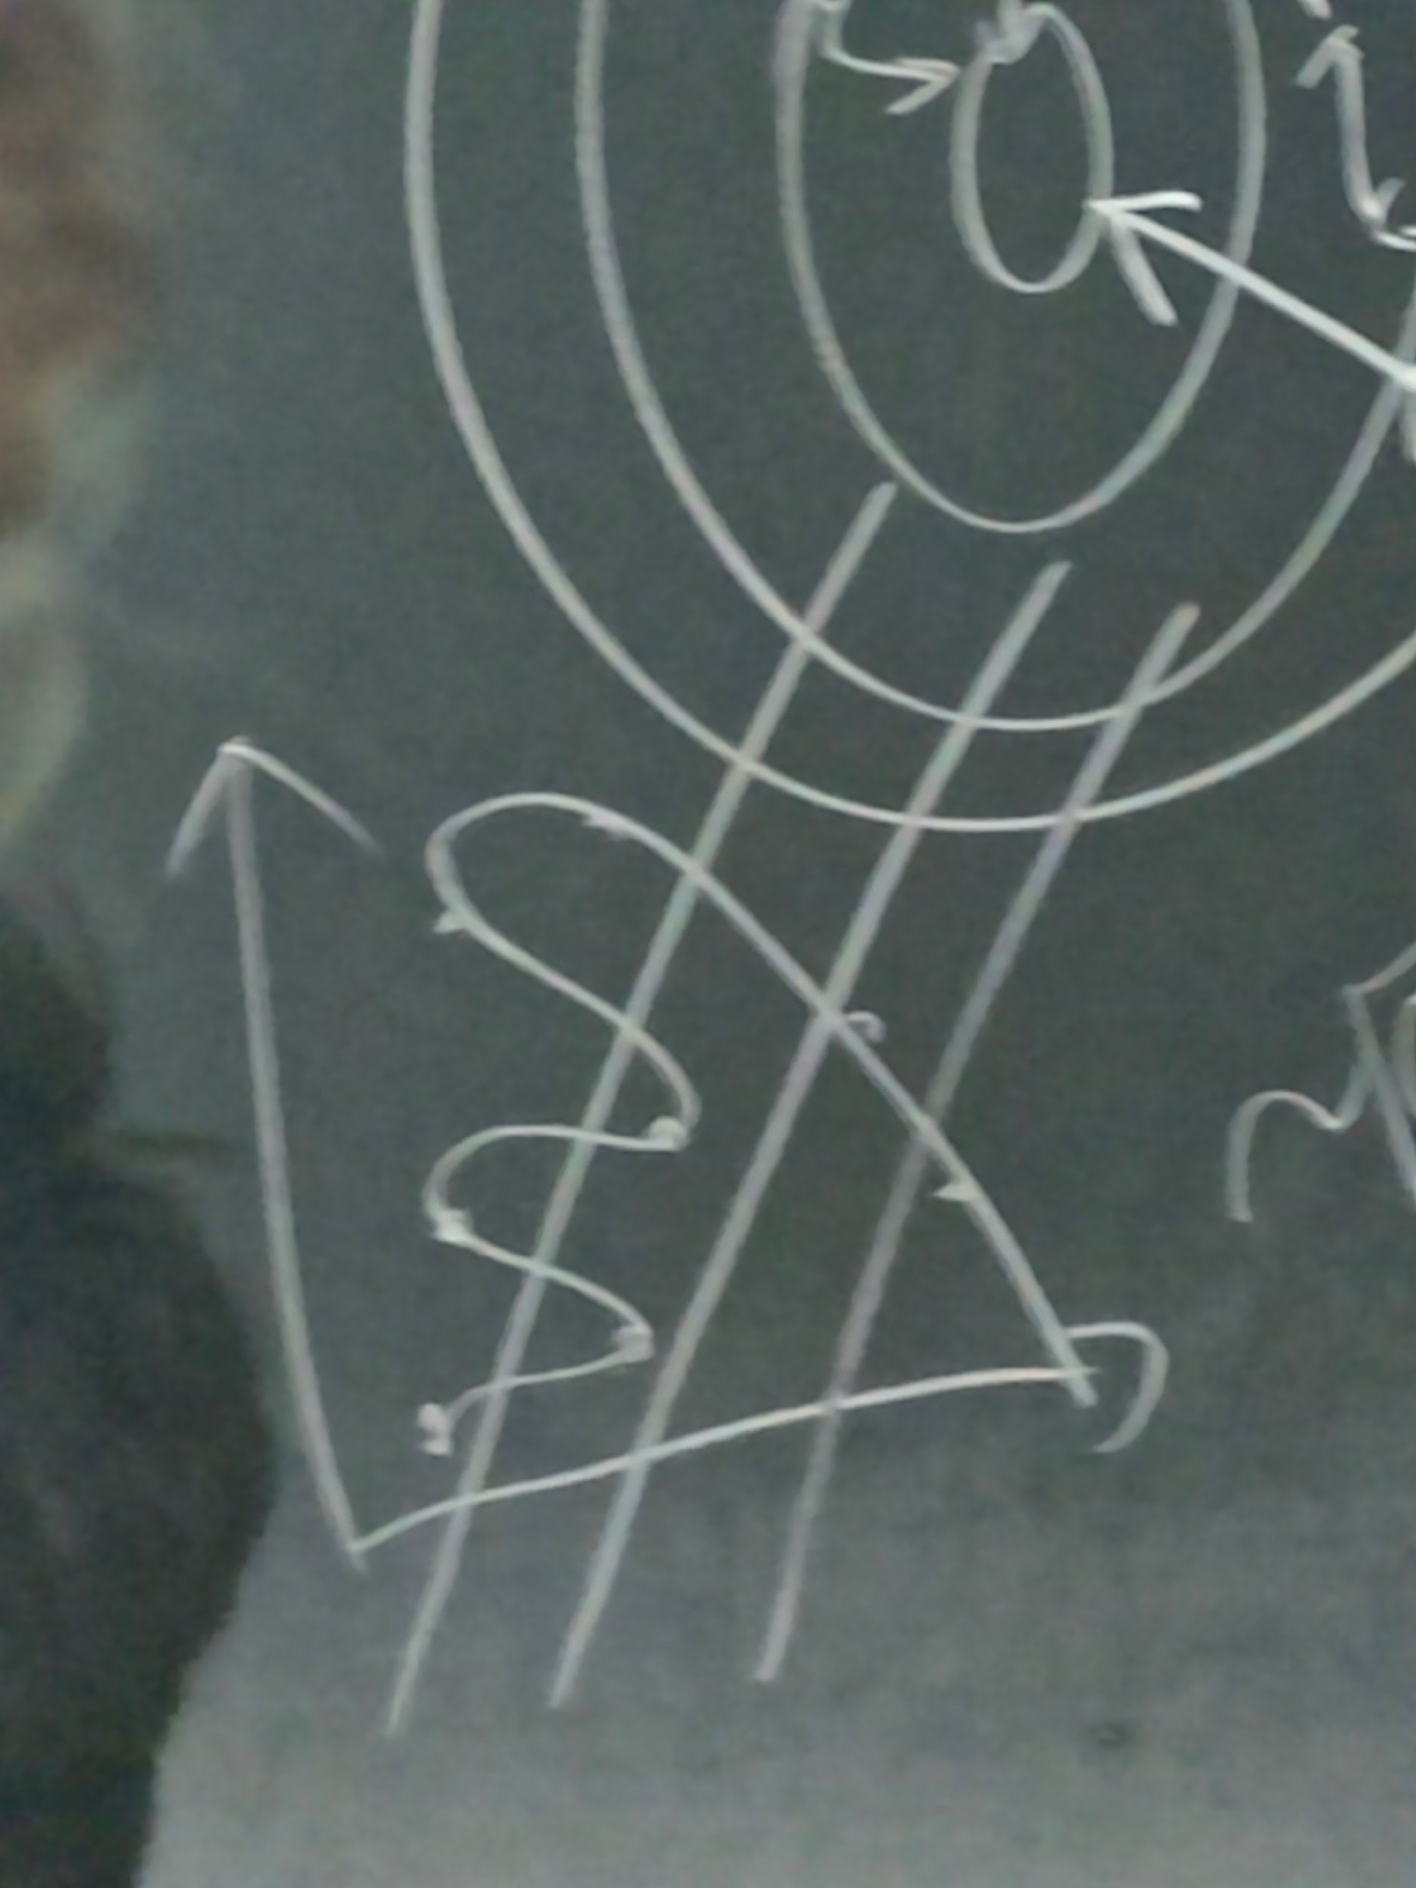
        + squiggly graph line instead of straight linear line (x and y 2d graph)
  + 2. challenge with deeper networks?
    - information loss
  + 3. how to make up for information loss in deep layers?
    - if we think one layer lacks information, we can use the skip connection to make up for the information by directly getting information from a previous layer
      * need to make sure both layers have the same dimensions
* 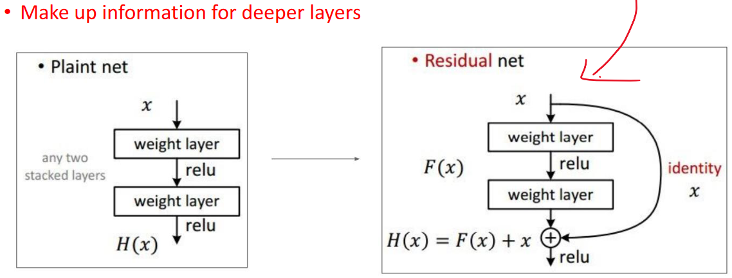
  + - residual block of ResNet = 2 layers and then a skip connection
* 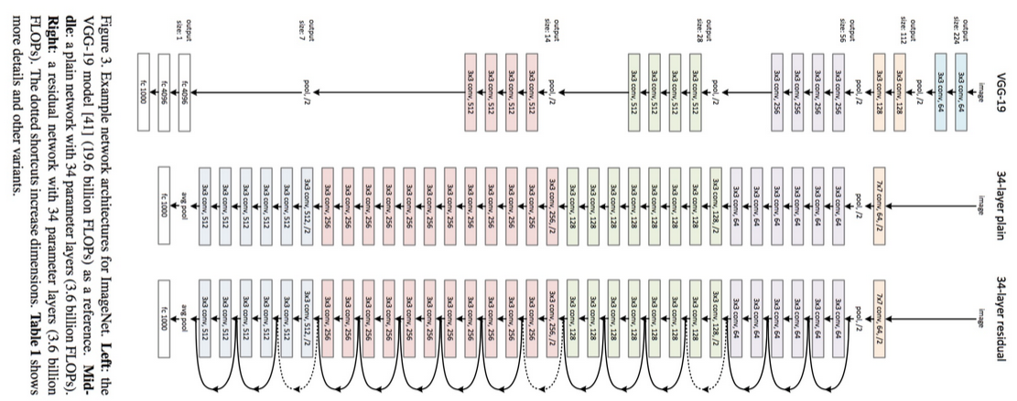
  + dont apply pooling during residual because want to make sure the skip connection has the same dimensions
    - different sections have different dimensions
  + element-wise addition of H(x) = F(x) + x
    - same positions in both matrices are added together
* 
* ResNet has several famous variants

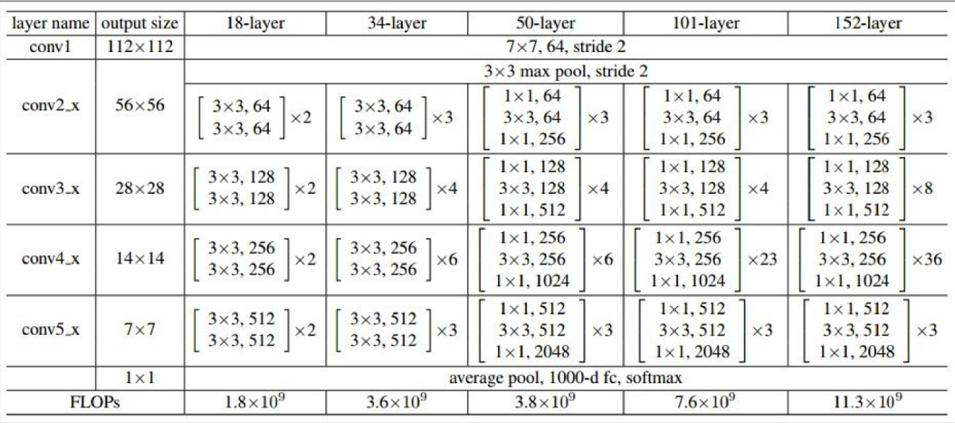

* FLOP = float point operations per second
  + smaller value means better
* the x2, x3, x4, x6, x23, x36 of the tables
  + just means repeat residual block that amount of times
* 
  + ex: right method uses 4 residual blocks
  + the number next to the 3x3 conv means kernel size

#### batch normalization

* batch normalization is after convolutional layer but before activation function
  + conv later
  + batch normalization
  + activation function (relu)
* 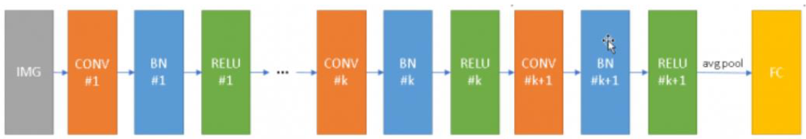
* purpose of normalization is improve noise resistance
  + by taking normalization we reduce noise by changing data from a range of 0-255 to a range of 0-1 (not binary 0 or 1, includes float range like 0.99)
  + if 2 values are 1 and 255, lots of noise there
  + but changing the 2 values to 0.01 and 0.99 has less noise
  + not exactly sure why?
  + 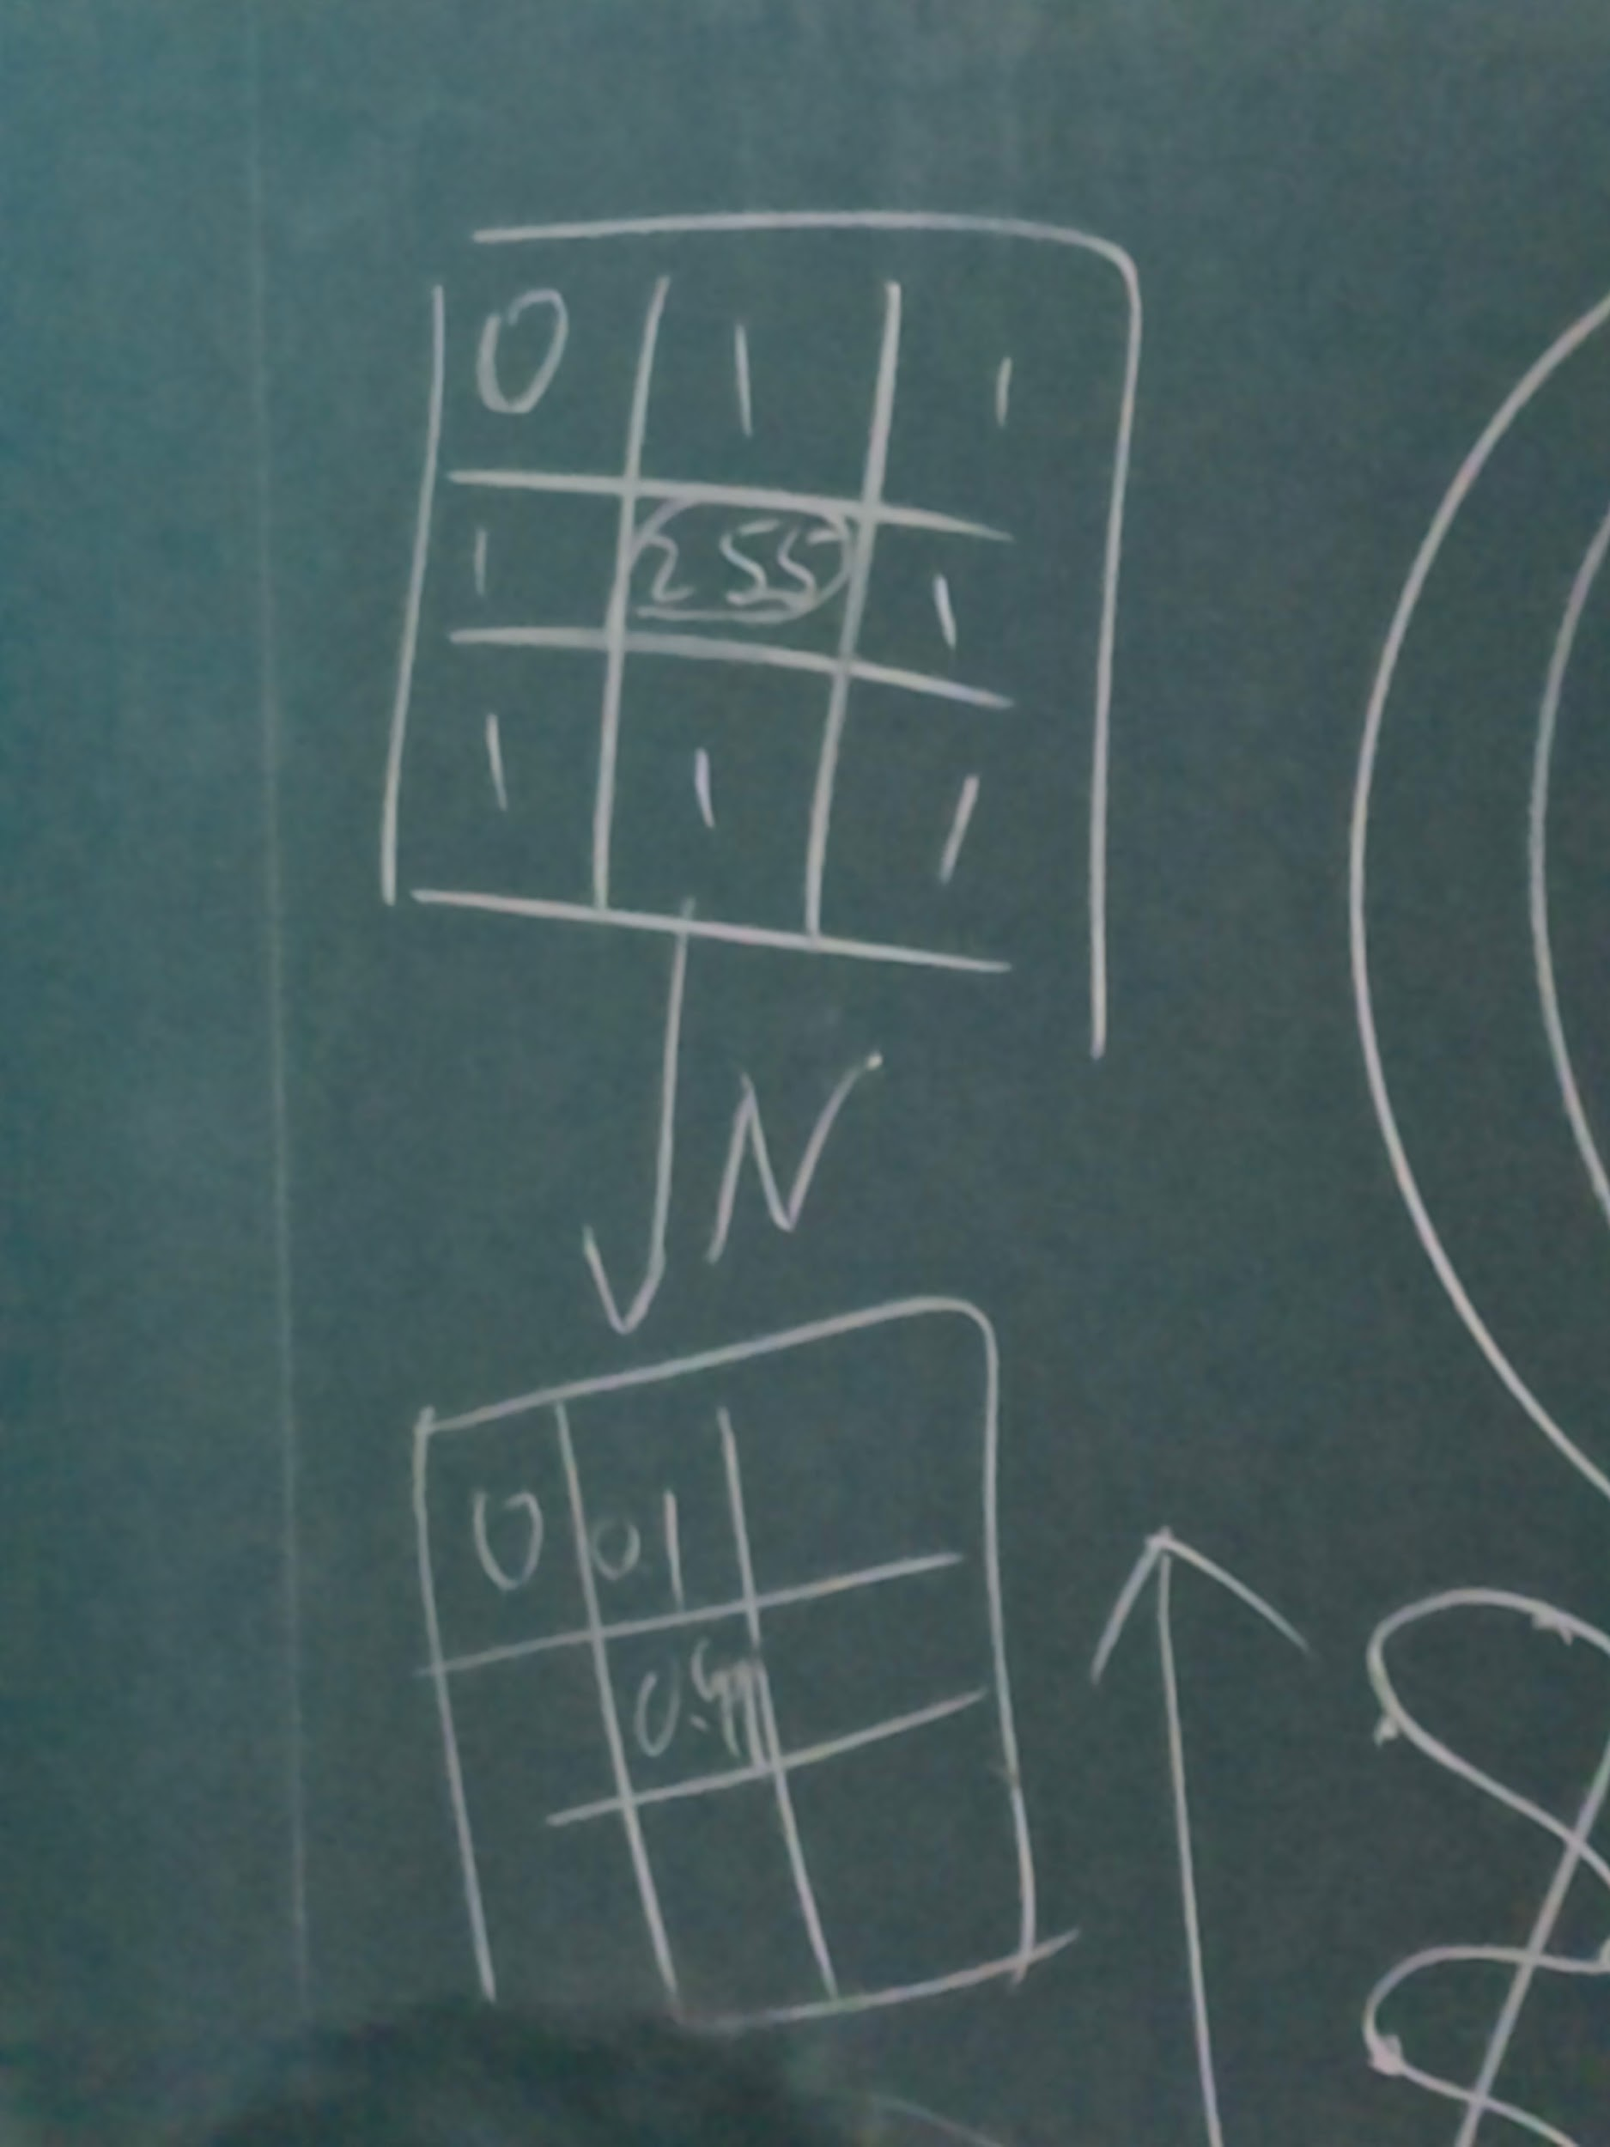
* purpose is also to make feature values on the same scale
* 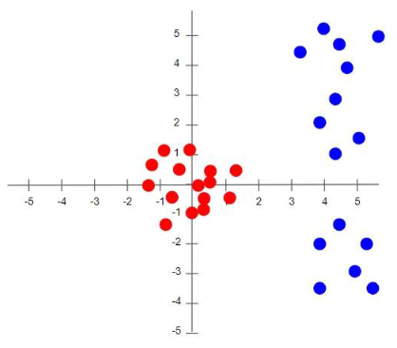
* nprmalization of input data may gradually diminish
  + to avoid this initial normailzation diminishing, normalize output of every convolutional layer by adding a batch normalization after each conv layer
* 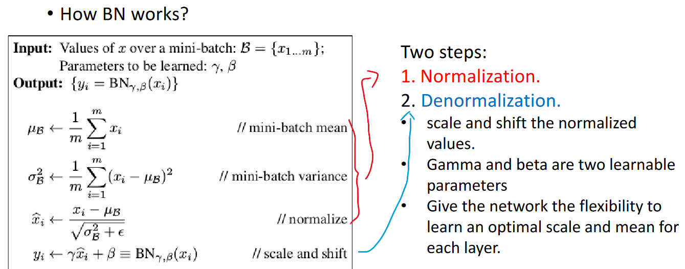
  + undo normalization to create flexibility
  + if model things normalization will impact overall performance, we want to reduce the effect of the normalization with denormalization
  + parameters of batch normalization are gamma and beta

#### bottleneck